**Feb 18 21 - List Discontinued as no topics are being scheduled for zoom meetingss**

**------------------------------------------------**

**Mar 12 - Open Topic, Bring Toys**

* **Moonbot Demo - Camera A.I. directed by signs. Demoed Left 90, Right 90, Unturn, Park, Forward,. Unit also includes ball follow (yellow ping pong ball),color recognition,number recognition, symbol recognition. Esp32 AI camera**
* 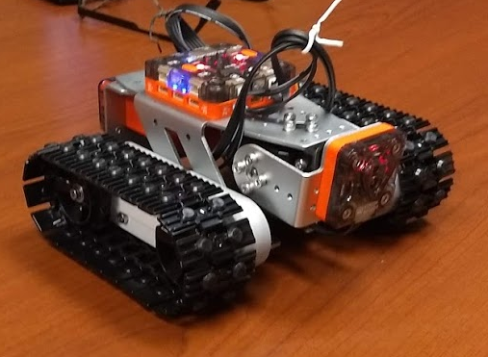

**Mar 6 - Open Topic, Bring Toys**

* **Moonbot Kit - Displayed by LeRoy**
* **Hinks and Kinks of Poo Bah’s 3500 Lumen dusk to dawn flood lamp**
* [**TP-Link Omada N300 Outdoor Wireless Access Point – Waterproof, Dustproof, Lightening Protection, Seamless Roaming, Gigabit, PoE Powered, Free PoE Injector, Free Managing Software(EAP110-Outdoor)**](https://www.amazon.com/gp/product/B07CG3YRTR/ref=ppx_yo_dt_b_asin_title_o00_s00?ie=UTF8&psc=1)

[**Link to Amazon**](https://www.amazon.com/gp/product/B07CG3YRTR/ref=ppx_yo_dt_b_asin_title_o00_s00?ie=UTF8&psc=1) **Poo Bah**

**Feb 27 - Open Topic, Bring Toys - LeRoy Miller**

* **Enhanced Huskey Lens AI cameras by DF Robot used to Guide Robot Demo  
  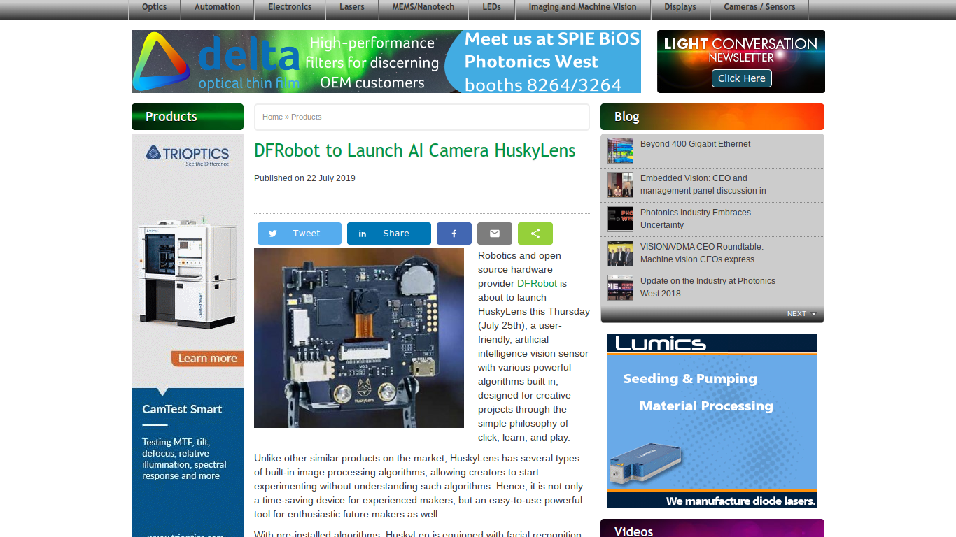**

**Quick Notes from last week:**

**Cfghtml -**

**Dpackage -**

**get/selections**

**Clug.org**

**Vpn winscribe $2 per month**

**Google encripted dns LeRoy**

**Ip.stevejonescomputers - steve**

**Micro Python - Vicente - Presentation**

**Deek motor shield for nano - LeRoy**

* **QIS Fit Watch - Blood Pressure, Heart Rate, ECG - Review Screens/Use Results**

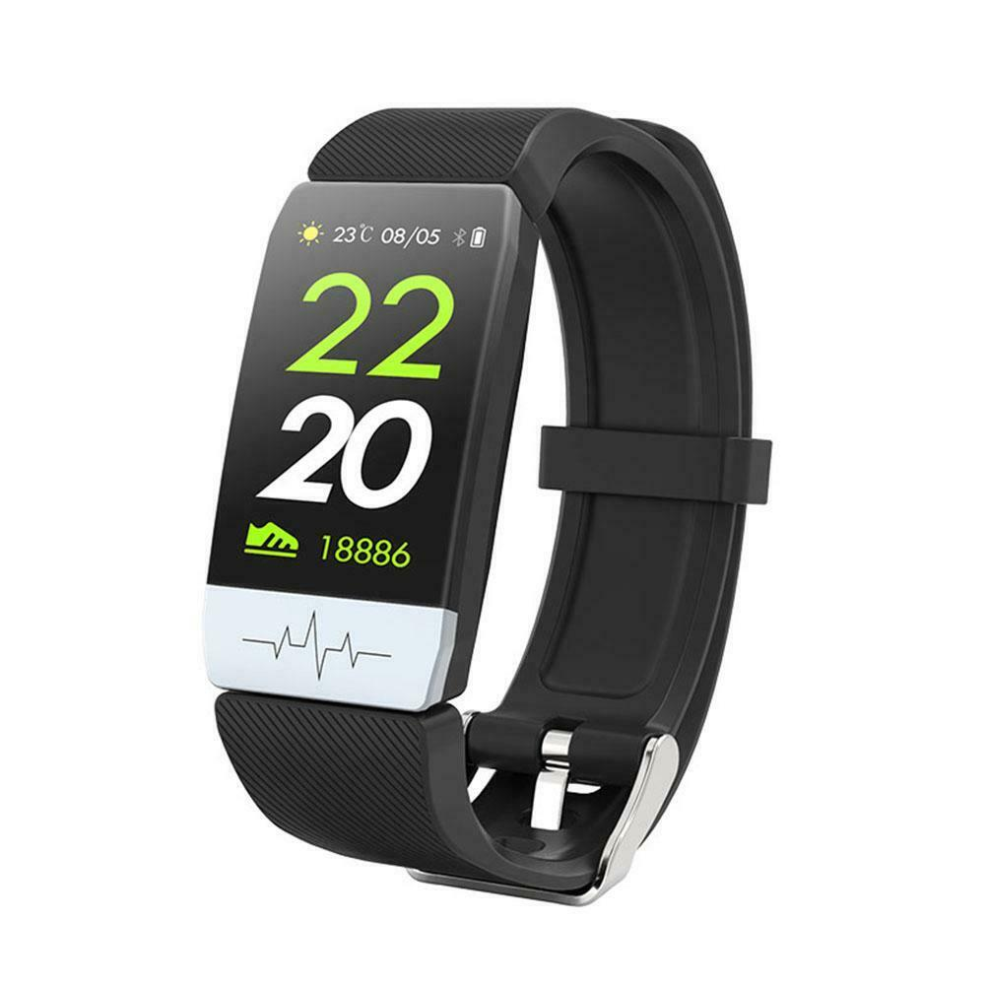

#### [**Q1S IP67 Fitness Tracker ECG PPG Smart Watch Blood Pressure Heart Rate Monitor**](http://www.ebay.com/itm/153741855900)

[Slide Show on Q1S Fit Watch](https://photos.app.goo.gl/BbmBMCQCo2Th1pAa7)

* **Reolink 5mp fixed POE ONVIF security camera update**
* **Cat/Dog detector video link (courtesy Vicente)** [**https://www.youtube.com/watch?v=0rR0tf9nZ1U&t=188s**](https://www.youtube.com/watch?v=0rR0tf9nZ1U&t=188s)

**Lansweep - Steve Gave Demo - See dos ver, Machine type, phone number,host name, help desk, predictive fail on drives, types of drives, siz, ram siz,**

**Yearly backups**

**(Last Meeting Tidbits ) 2/20/2020**

**LeRoy**

* **Huskey Lens AI cameras by DF Robot used to Guide Robot Demo  
  **

**2/13/2020 (Last Meeting Tidbits )**

**Grand Poo Bah**

**RLC-420-5MP Reolink Camera, Fixed, Indoor/Outdoor, 5mp, ISPY, Android**

**SD Storage**

**Select Alarm Zones on Screen**

**Audio Listening**

**15 sec start/end buffer**

**Downloadable files**

**Loop over old pics**

[**Amazing Graphene Products**](https://www.dezeen.com/tag/graphene/) **While Graphene development is slow, some products are poping up in amazing places!**

**Cannot Get to Logon at McDonalds or Panera WiFi or Privacy Error- Connection is not Private**

**Neverssl.com**

**Example.com**

* [Cheap Digital Appliance Timer - Woods](https://www.amazon.com/Woods-Polarized-Automating-Decorations-Christmas/dp/B005WQIDHY/ref=sr_1_8?crid=3GSWMSCRC2EQH&keywords=digital+timers+for+electrical+outlets&qid=1578006267&sprefix=ditital+timer%2Caps%2C167&sr=8-8)
* **Can your chromebook be used as a print server for a usb printer** (nope, the usb port does support memory, keyboards, mice, but no printer support). Steve says it looks like you can do it with a strawberry Pi. [The Hitchhiker’s Guide To Chromebook Printing](https://chromebook.net/chromebook-printing.htm)

**Mini Topics: (Previous Meeting)**

* [Text to Voice on Your Android Phone (pretty good actually)](https://docs.google.com/document/d/1vzhwV5g3qq4dGwKJATe0zgGNCx_N9n-AyO8gu8TPGv0/edit?usp=sharing)

* Have your own Cloud Server! (Steve) Lenox - Centos Netserver.org nextcloud

**Jan 30 - LeRoy - AI Camera Demo + Bring Toys**

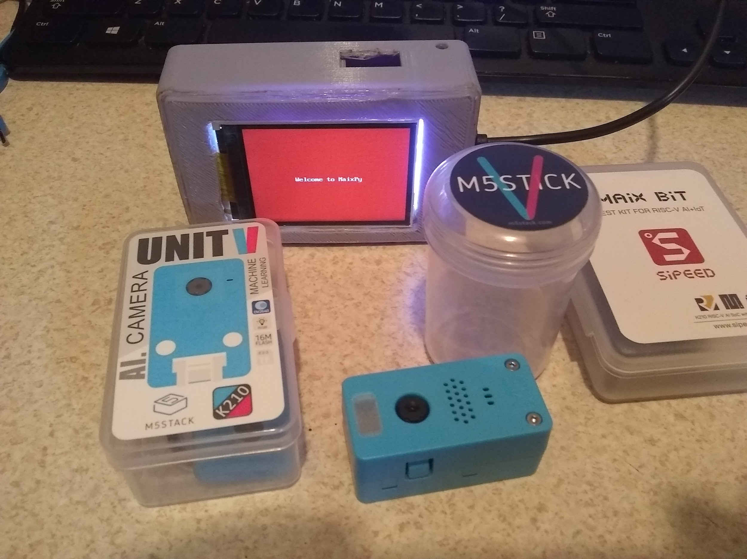

**Pictured above, 2 Sipeed Maix Bit cameras (both in cases), a M5StickV and a M5 UnitV Ai camera**

Both have the Kendryte K210 Machine Vision system on chip (soc), and use microPython - both cameras are under $30 U.S. - The M5StickV and Maix bit both have screens on them, the Unit V is a cheaper model, with no screen and missing a lot of features of the M5StickV

M5StickV information page: <https://m5stack.com/collections/m5-core/products/stickv>

UnitV AI camera page: <https://m5stack.com/collections/m5-unit/products/unitv-ai-camera>

Sipeed from SeeedStudio info page:

<https://www.seeedstudio.com/Sipeed-MAix-BiT-for-RISC-V-AI-IoT-1-p-2873.html>

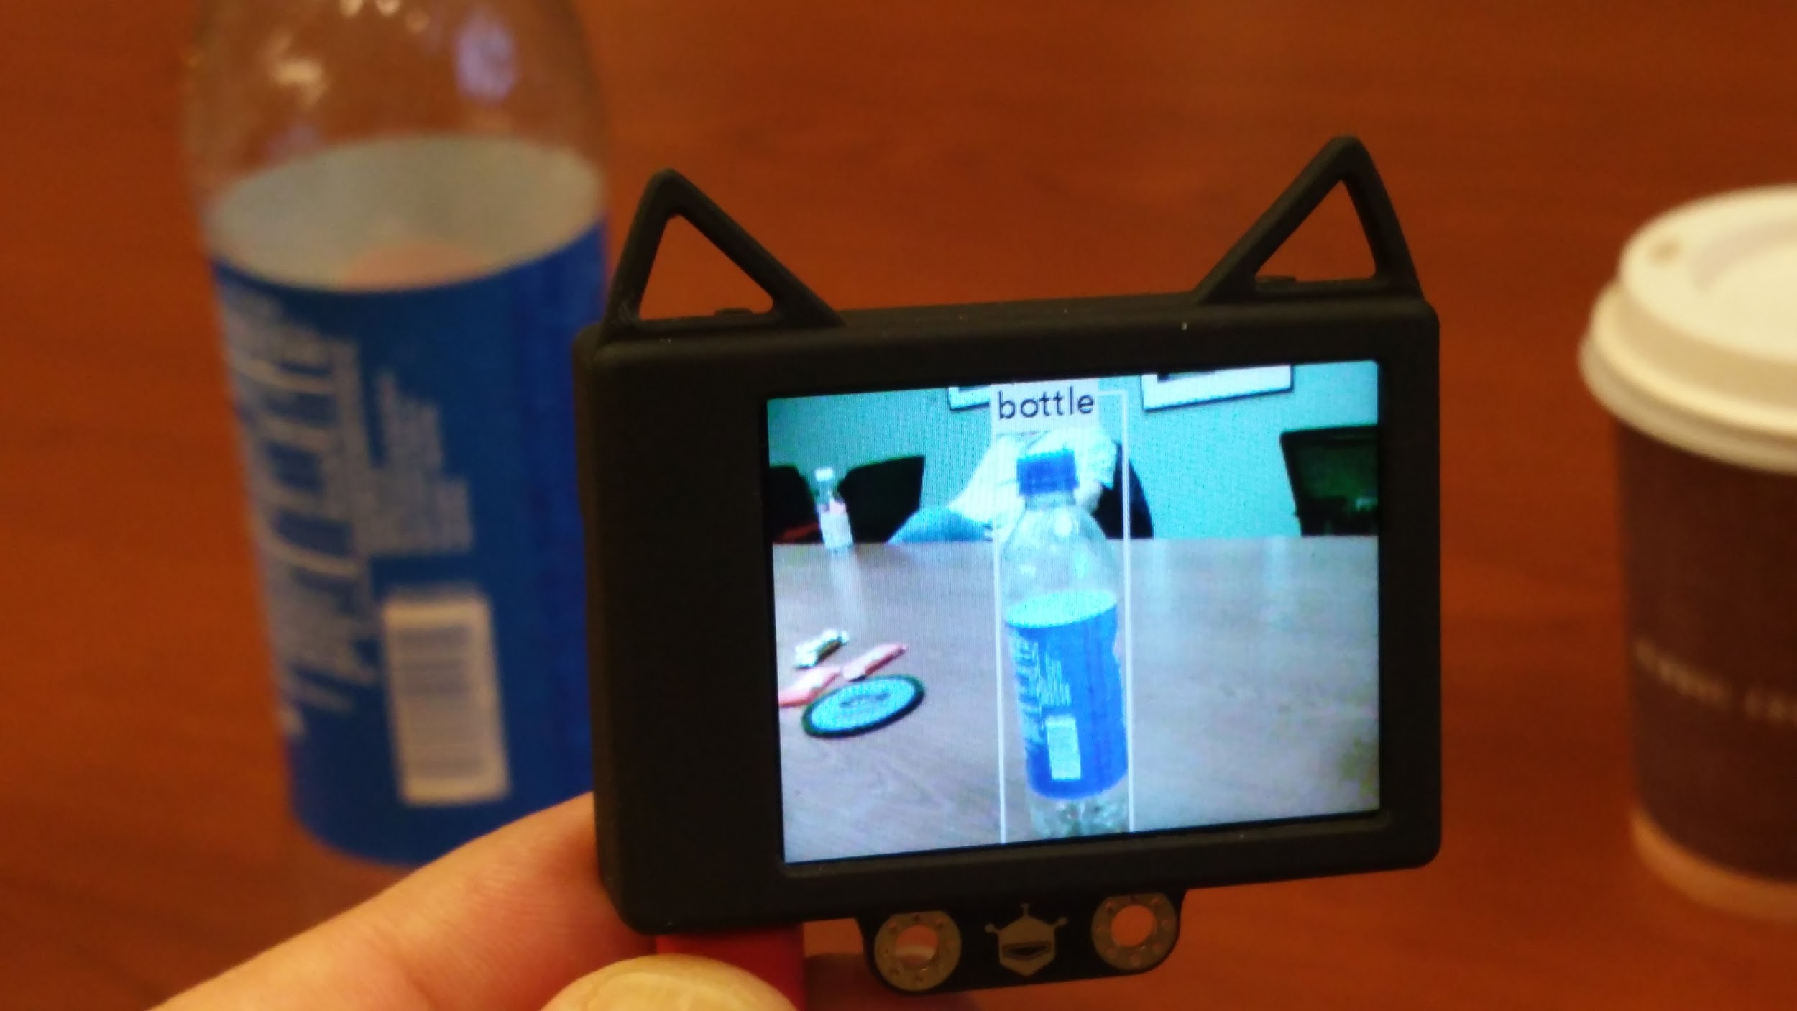

**Toys List:**

**GrandPooBah has added a Reolink 5mp fixed POE ONVIF security camera.**

**(Last Meeting Tidbits)**

**DEC 26 - Open Meeting Topic - Bring Toys**

**Mini Topics:**

[Text to Voice on Your Android Phone (pretty good actually)](https://docs.google.com/document/d/1vzhwV5g3qq4dGwKJATe0zgGNCx_N9n-AyO8gu8TPGv0/edit?usp=sharing)

* Free 12V UPS batteries for club members! 6 x 2.5 x 3.75" WDH
* Have your own Cloud Server! (Steve) Lenox - Centos Netserver.org nextcloud
* Good Book “Content” - All about Digital Rights Management / copywrights etc/
* Wireless Finger mouse - The finger mouse takes the guts out of a wireless mouse and allows you to mount it on your finger. You put your finger on a surface and slide. Left/right click with scroll works.

No setup for USB mini puck, not bluetooth. Works on windows 10 and chromebook. You have the typical led lamp on the end of the mouse. Led is on left end of finger mouse shown below. Click and drag does function on this unit.

Ebay ~ $8 Wireless USB Finger Mouse Bluetooth Optical Handheld Mice Fit for Laptop PC

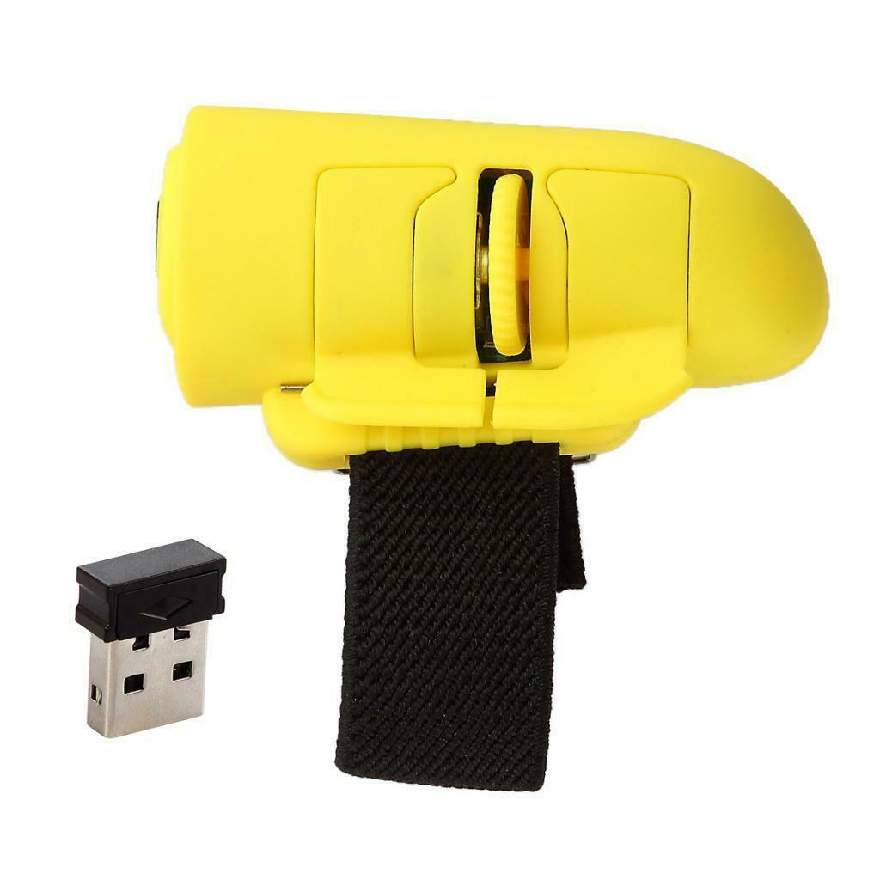

**12/12/2109 Marcus Christmas Lights +Open Topic Meeting - Bring Toys**

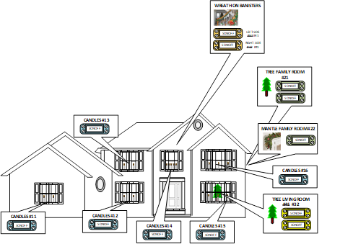

**Oct 10, 2019 Gand Poo Bah Discussion Topic - Hoverboard Motor - AC or DC Motor?** [**Hoverboard Motor - AC or DC Motor?**](https://docs.google.com/document/d/1UW3sY9eQwRTNr002rwbR15y-WXJCAsnnGReNujAt7KI/edit?usp=sharing)

**Bah is looking for someone to “splain somethin” to him: (he thinks this is english).**

# In BLDC motors, the stator coils are wound trapezoidally, and the back-EMF produced has a trapezoidal wave form. Because of their trapezoidal waveform, direct current is required in order to get the best performance form BLDC motors. In contrast, synchronous AC motors are wound sinusoidally and produce a sinusoidal back-EMF, so they require sinusoidal drive current in order to achieve the best performance.

**Sept 12, 2019** - ESP8266 8x8 LED Matrix Display demo and information from Marcus.

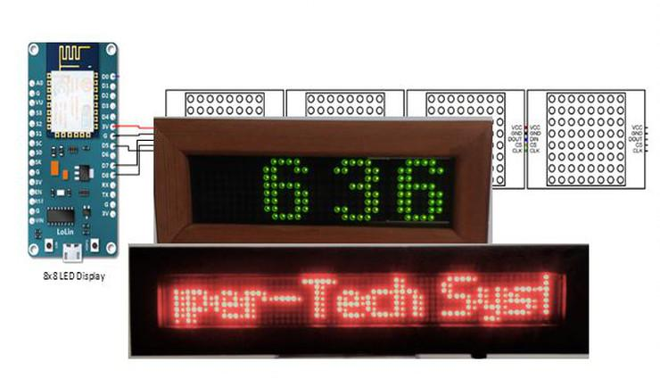

Marcus created two projects around the ESP8266 and 8x8 LED matrix display modules. One is a LED clock which also displays the date following each minute update. The second project is a scrolling message display that utilities eight (8) 8x8 LED matrix display modules. Following the following link for code and additional project information <http://wix.to/D0CgAy8>

Ray may be bringing a robot that uses the HM-10 Bluetooth, and LeRoy will bring a new lidar based robot from M5Stack. And of course you can bring your own toys in if you need more than about 10-15 minutes for a demo please let us know and we can schedule a full demo for another meeting.

**August 22, 2019** - **Open Topic Meeting - Bring Toys - 3D printing Shoe lace ties with the Monoprice Mini Delta 3D printer**

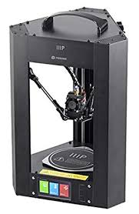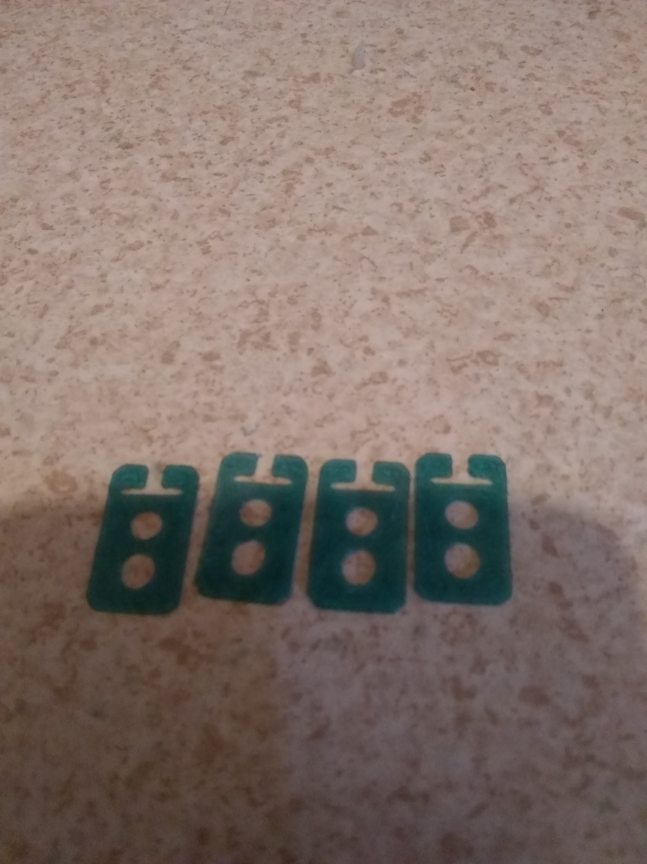

Last Week Mike put out the challenge to 3D print shoe lace ties - Pranav took the challenge and ran with it - creating the STL file (the file needed for slicing on the printer).

He asked me (LeRoy) to print them out and see what I thought - I printed them on the Mini Delta and they turned out great - I printed them on the i3 and they (well….) got destroyed when I tried to get them off the print bed.

So I’ll bring the mini delta, and we can print “while we wait”. They take 4 to 7 minutes to print 3 of them, should be fun times.

Pranav is quite an artist and we only made a small change, which I think will make them work a little better (at least a little easier to print).

GBAH’s Toy

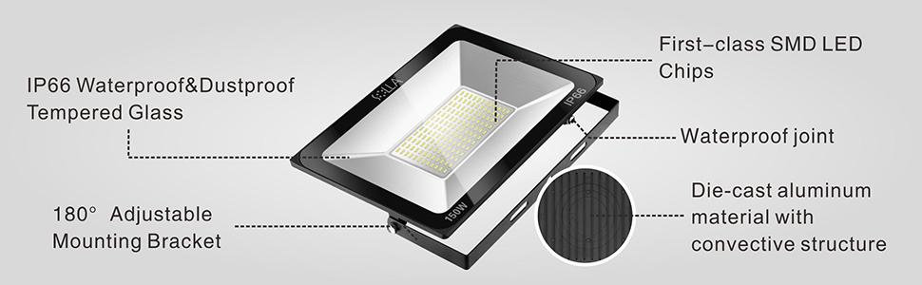

### **Specification:**

Net Weight: 5.06lb  
Product Dimension: 14.6x11.5x2.0 in  
Color Temperature: 3000K Warm White  
Operating Temperature: -4~+131℉/-20~+55℃  
Material: Die-cast aluminium, Tempered Glass  
Power: 150W  
Luminous Flux: 12000LM  
LED bead quantity: 144PCS  
Beam Angle: 140°  
Power Source: Corded-electric  
Power Factor: ≥0.90  
Voltage: 90~140V  
Frequency: 50/60Hz  
Efficacy: >80lm/W  
Average Life: 50000H

**August 15, 2019** - **Open Topic Meeting - Bring Toys and Optical Flow Robot Demo**

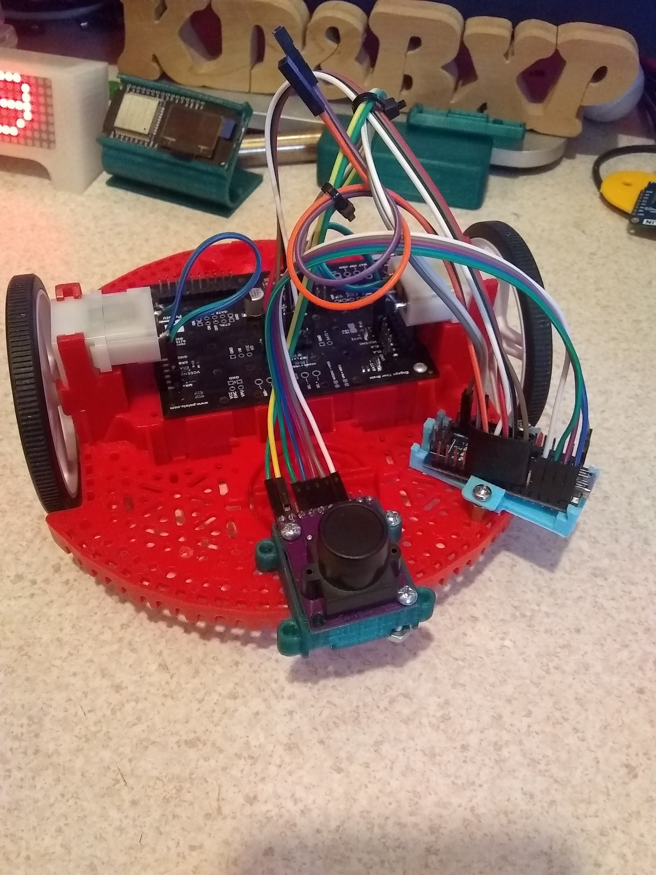

[**Automation Technology Club Forums hosted at Yooco.org**](http://automationtechnologyclub.yooco.org) **(possible replacement for G+)**

[**MeWe Group**](https://mewe.com/join/automationtechnologyclub)  **(another possible replacement for G+)**

**Vicente Suggested trying WhatsApp - Here is a** [**link to join us.**](https://chat.whatsapp.com/invite/LdurobTHPuYFsdGWhdHnvZ)

Or maybe a Telegram Group Room (with a Bot) - [Here is the link](https://t.me/joinchat/KcAKXxPe6k0vAy5XC0I2JQ)

July 11, 2019: IoT Project - Installed System Review - Marcus

**IoT Project - System Operation Review**

**It has been over a year since I introduced the group to my Internet of Things (IoT) project design. I have finally released many of the sensors into the wild. So this week we will discuss the pros, cons, and lessons learned from the IoT implementation.**

**(See Marcus’s Folder - Link on Meeting Announcement)**

6/20/2019

Pranav demonstrated Ultrasonic Backup Distance Alarm (~13 inches) Arduino

*Mike Sullivan shared this with me [Accuracy of a print head sensor in a DIY linear drive](https://www.youtube.com/watch?v=YfBkddVJksw)

### 6/13/2019

### 

### WiFi Location/WiFi Time of Flight Information

In Short, there are a number of different types of WiFi Location, some work now with the current WiFi routers (B/G/N/AC), and some work only with (AC but only if the firmware support it).

There is a way to get a very rough guess of where you might be - about 10 meter accuracy, it uses a method of triangulation, and a look up table of a router database.

There is a way to calculate the angle of arrival, and there is time of flight - which uses a clock sync, and a clock frame - on reading the accuracy is still not great but better about 2 meters.

There is also a round-trip-time method, that claims to have better accuracy, but isn’t supported by many routers. Here are the links to what I read. From what I’ve read WiFi 5 (AC) routers are able to do round-trip-time - but most firmwares don’t have that feature.

<https://en.wikipedia.org/wiki/Wi-Fi_positioning_system>

<https://www.wi-fi.org/discover-wi-fi/wi-fi-location>

<https://www.netspotapp.com/what-is-wifi-rtt.html>

**LAST MEETING: June 13 - Yet Another MQTT Demo, & Open Meeting, bring your something to share**

MQTT WiFi Clock Display

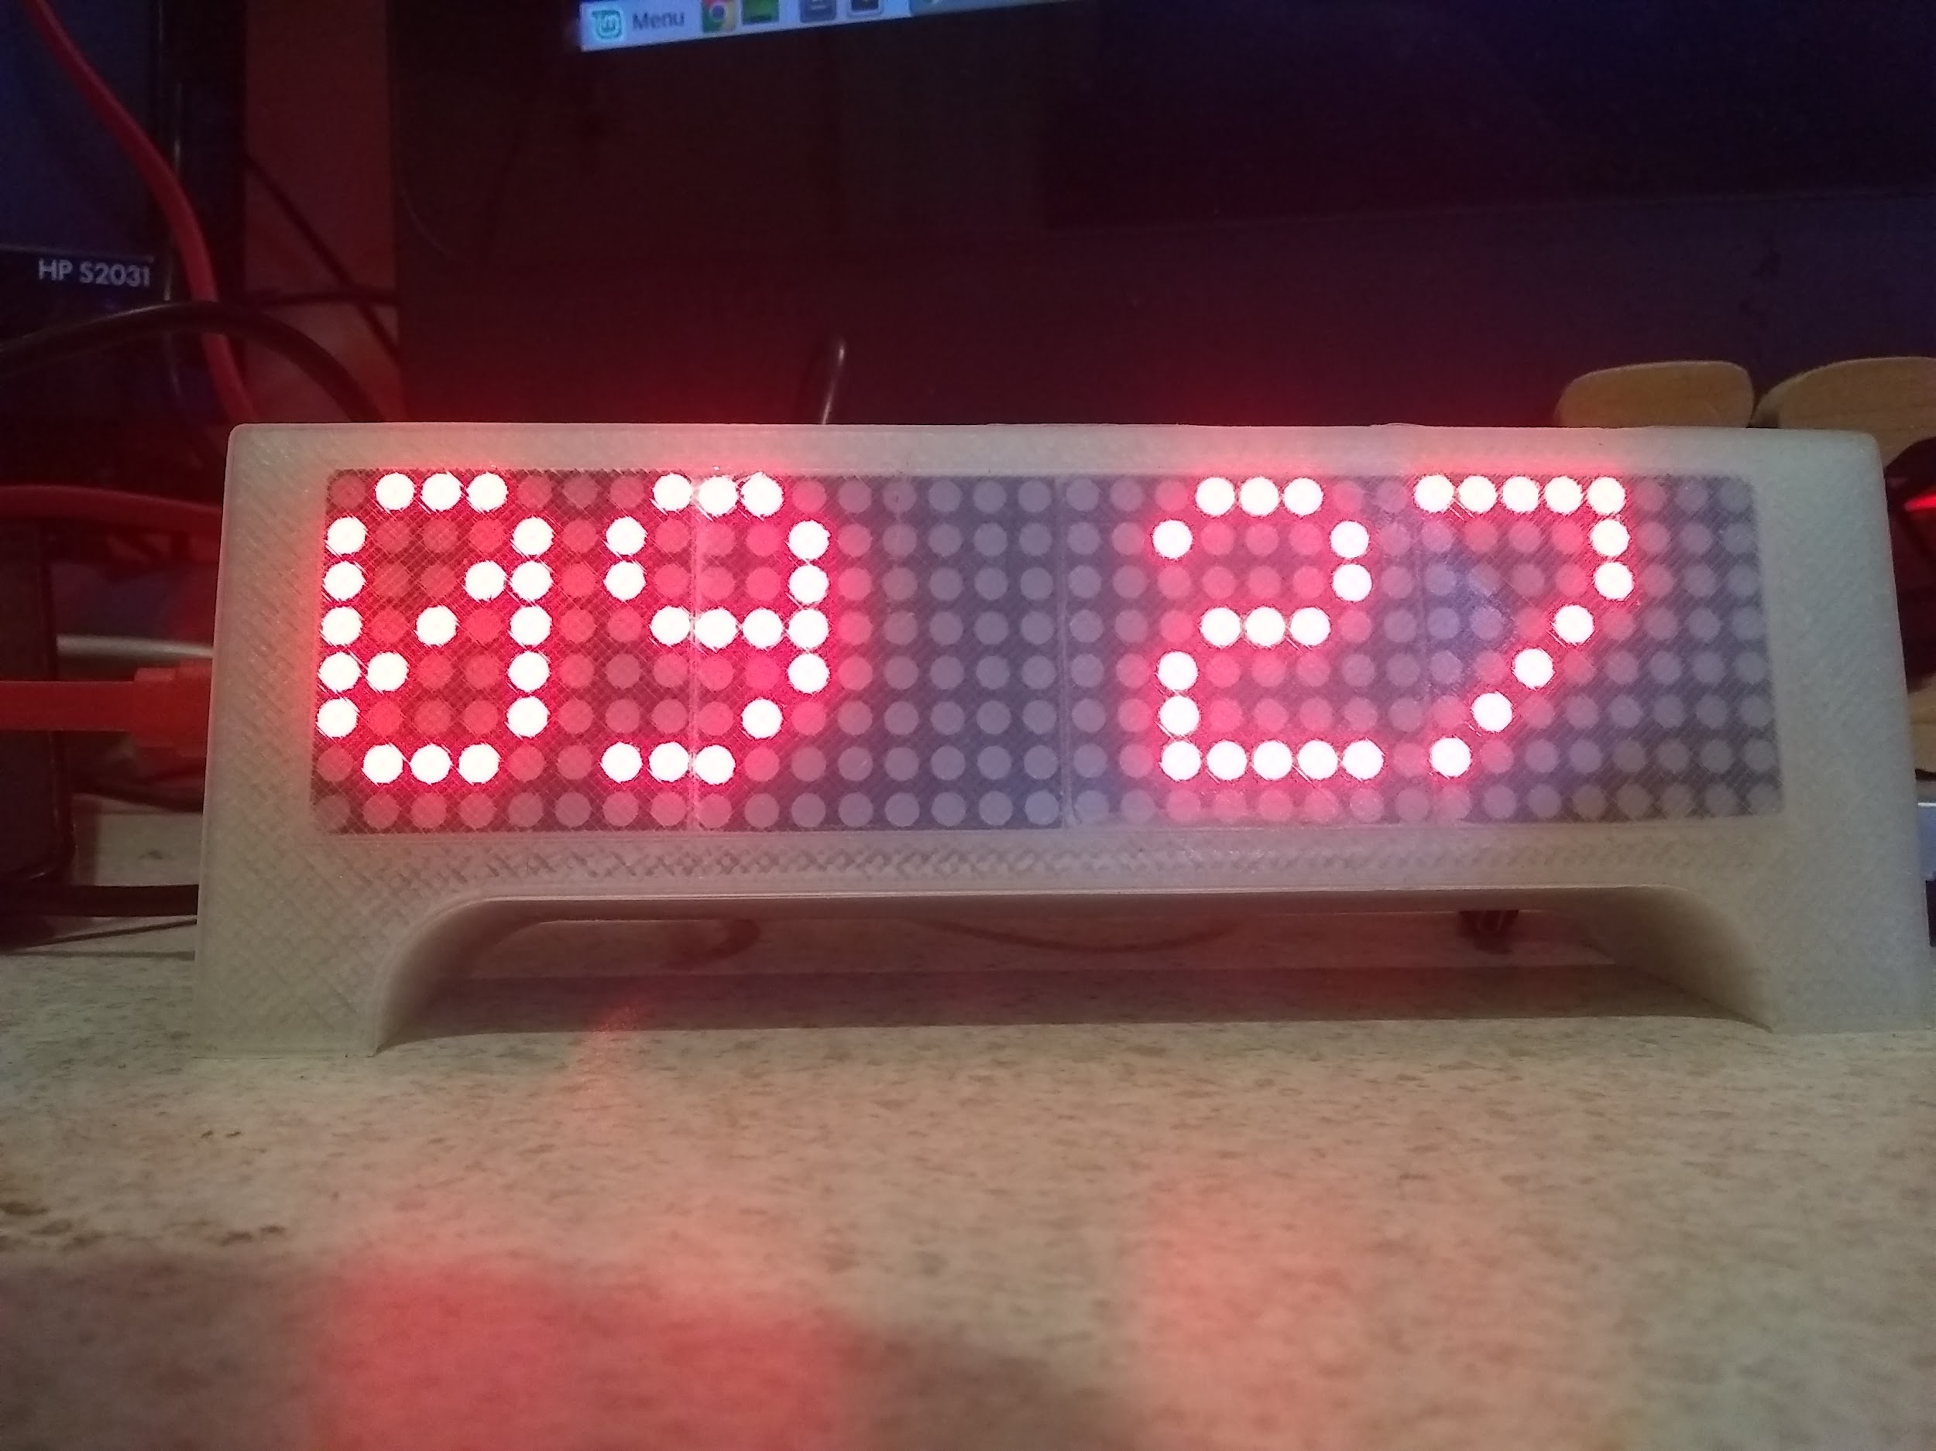

LeRoy has updated a MQTT display, and learned a few new tricks that might be of interest to the group. (Including using SPIFFS for a quick configuration file, and using ArduinoOTA for updating devices over the air), It should be a quick demo, so others are encouraged to bring in some of their toys. Code can be found here: <https://automation-technology-club.github.io/Yet-Another-MQTT-Demo/>

Info: [SPIFFS and JSON to save configurations on an ESP8266](https://www.youtube.com/watch?v=jIOTzaeh7fs)

[ESP8266 SPIFFS Uploader](https://github.com/esp8266/arduino-esp8266fs-plugin/releases)

**May 23, - Bluetooth Low Energy Presence Detection System, By Marcus**

Teaser from Marcus: Beacon Presence Detector System

I while ago I presented my over-all Internet of Things (IoT) project which encompassed from devices (things) to the analytic cloud-based system (Microsoft Azure).

This week we will take a deep dive into the Beacon presence detector subsystem. We will check out how an off-the-shelf beacon can be used to identify individuals as they enter and exit a space.

The solution utilizes Bluetooth Low Energy beacon, Raspberry Pi-s. MQTT Broker, Emic2 Text-to-Speech Processor, ESP8266, etc…

**May 2 - LeRoy - LoRA 915mhz 2019 Demo**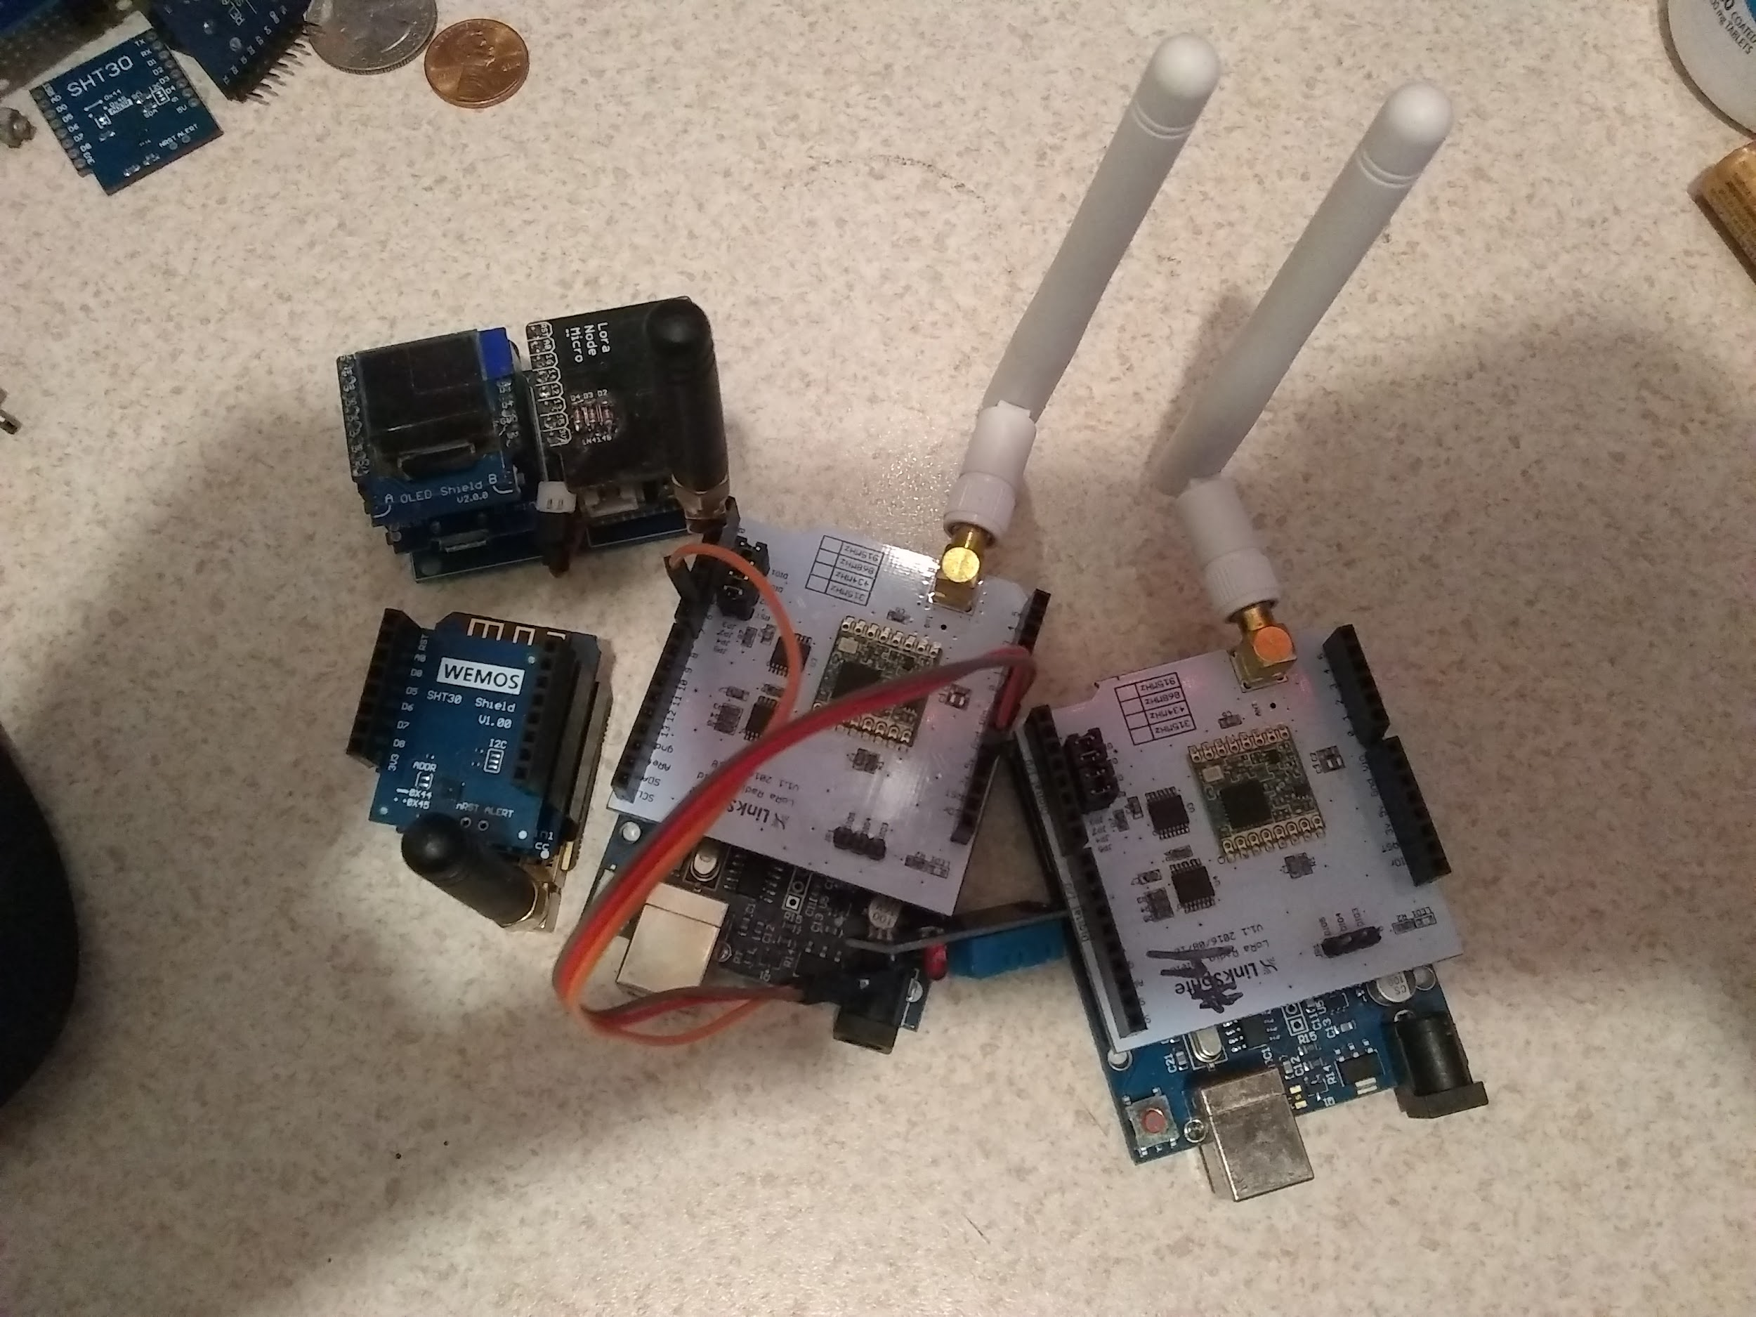

**Code for the demo can be found:**

**Previous demo code can be found here:**

**<https://github.com/automation-technology-club/Wireless-Demo-July-19-2018>**

**2019 Demo Code will be found here: (This is the current demo code):**

[**https://github.com/automation-technology-club-LoRa2019Demo**](https://github.com/automation-technology-club-LoRa2019Demo)

**We will doing this demo a bit different this year - I’ll have three nodes setup with temperature sensors, and one node setup with a display.**

**One node will be left in the car, and we will see if we can get information from it inside the library.**

**The other two nodes will be inside.**

**I’ll be using two ESP8266 Wemo D1 boards with custom LoRa 915Mhz (RFM9x/SX127x multi-mode, we are using LoRa) boards. And Two UNO boards with LinkSprite LoRa 915Mhz (RFM9x/SX127x) shields. We should be able to explore the differences, and see just how well LoRa can (if it can) penetrate into the library.**

**LoRa - There is a lot of information about LoRa - but don't confuse it with LoRaWAN they really are two very different things.**

**Some General Information can be found here:<https://www.seeedstudio.com/RFM95-Ultra-long-Range-Transceiver-Module%2FLoRa-Module%2Fsupport-868M-frequency-p-2807.html>**

High lights from above:

* 168 dB maximum link budget.
* +20 dBm - 100 mW constant RF output vs. V supply.
* +14 dBm high efficiency PA.
* Programmable bit rate up to 300 kbps.
* High sensitivity: down to -148 dBm.
* Bullet-proof front end: IIP3 = -12.5 dBm.
* Excellent blocking immunity.
* Low RX current of 10.3 mA, 200 mA register retention.
* Fully integrated synthesizer with a resolution of 61 Hz.
* FSK, GFSK, MSK, GMSK, LoRa™ and OOK modulation.
* Built-in bit synchronizer for clock recovery.
* Preamble detection.
* 127 dB Dynamic Range RSSI.
* Automatic RF Sense and CAD with ultra-fast AFC.
* Packet engine up to 256 bytes with CRC.
* Built-in temperature sensor and low battery indicator.
* Module Size：16*16mm

APPLICATIONS:

* Automated Meter Reading.
* Home and Building Automation.
* Wireless Alarm and Security Systems.
* Industrial Monitoring and Control
* Long range Irrigation Systems

[Techno Scraps](https://docs.google.com/document/d/1L2L7ClzRDfQbvfBBrfURPkC7WitGkVjYZVwW5FOgyOI/edit?usp=sharing)  
[TCT - Trash Can Transport Project History](https://docs.google.com/document/d/1koA0WJjWyKAG-vjHsyozhaI0ZF366umkIMaSW3G2N-4/edit?usp=sharing)  
[Bitty Rover Links](https://docs.google.com/document/d/1wnMYuAMPABdN0H_UdD8afTjSMGiu9HTQmq5hGyXPVAY/edit?usp=sharing)

**Apr 18**

[Cincinnati Mini Maker Faire Topic at Yooco](http://automationtechnologyclub.yooco.org/forum/cincinnati_mini_maker_faire_sat_april_13-4932083-t.html#4932083) (Mini Maker Faire April 13, 2019)

**Mini Maker Fair AT Club**

**April 13 Pictures from the event:** [**https://photos.app.goo.gl/4Pz7YZYNDCm37qVQ9**](https://photos.app.goo.gl/4Pz7YZYNDCm37qVQ9)

**Woodgears.ca**

**Mini Maker Fair Post-Participation Discussion**

**Mini Maker Fair AT Club**

**April 13 Pictures from the event:** [**https://photos.app.goo.gl/4Pz7YZYNDCm37qVQ9**](https://photos.app.goo.gl/4Pz7YZYNDCm37qVQ9)

**Mini Maker Fair Pictures from Maker Faire** [**https://photos.app.goo.gl/4Pz7YZYNDCm37qVQ9**](https://photos.app.goo.gl/4Pz7YZYNDCm37qVQ9)

[Video Slide Show From Mini Maker Faire](https://photos.google.com/share/AF1QipMHMoBCldPrgThgESivBh26sovVF-4B7twMdCL33EGjggsK4kI5hewGGTZQ02cVlQ/photo/AF1QipMaDdQXgea1o5ORs3kQp9vtOOylBoxc0is3WYZd?key=eUpILTh6NEc1V1M0SDhmY205bnRyZW1oa0hLSWF3)

**Apr 11 - Arduino Elevator and Rotating Head Demo**

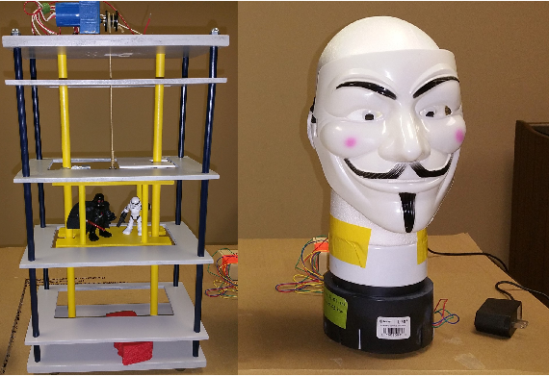

**Mini Maker Fair Participation Discussion**

**Mini Maker Fair**

**April 13? 10 am to 5pm Not much noise allowed**

**Group meets un termiing - front parking lot 8:00 am in front of the big radio ezer charles load up is 7-9 load out at 5:00**

**Fair start is 10:00 - 5**

**Door on south part of building for load out.**

**Schedule**

**LeRoy - 10-5**

**LeRoy’s phone: 513 299 7022**

**Mike1: 10-5 open**

**Vicente:**

**Jim:**

**Marcus**

**Steve**

**Grand Poo Bah - Found and available in trunk of car.**

**Cycleing power point - focal Mike 1 - send PP files to: sullivan_j_m@yahoo.com**

**LeRoy - Heathkit hero robot**

**Steve - hd projector**

**Marcus IOT**

**Elevator - Vicente (send to to V)?**

**Talking Pumpkin - Video? Vicente?**

**Train track balance - Vicente?**

**Ball balance (air) - Vicente?**

**3d cube light/ flashy lights**

**Steve Projector & Hand Out**

**Apr 4 - Mini Maker Fair Participation Discussion + Open Topic**

**Mini Maker Fair**

**April 13? 10 am to 5pm Not much noise allowed**

**Grand Poo Bah - Look for edges for tables**

**Cycleing power point - focal Mike 1 - send PP files to: sullivan_j_m@yahoo.com**

**LeRoy - Heathkit hero robot**

**Steve - hd projector**

**Marcus IOT**

**Elevator - Vicente (send to to V)?**

**Talking Pumpkin - Video? Vicente?**

**Train track balance - Vicente?**

**Ball balance (air) - Vicente?**

**3d cube light/ flashy lights**

LAST WEEK: - **Open Topic - SciFi Book Reviews - Bring your Favorites**

Recommended? [Club List of Favorite SciFi Books](https://docs.google.com/spreadsheets/d/11gyAGHXJ7niskX-3BJysul7xuEpqPKqZI5KdjmoIu98/edit#gid=0)



Suggested?



[Link to Full Spreadsheet](https://docs.google.com/spreadsheets/d/11gyAGHXJ7niskX-3BJysul7xuEpqPKqZI5KdjmoIu98/edit?usp=sharing)

| Do Androids Dream of Electric Sheep | Phillip K Dick | 5 star - Ebay |
| --- | --- | --- |
| [Splinter of the Mind's Eye](https://ohdbks.overdrive.com/media/580756) | [Alan Dean Foster](https://ohdbks.overdrive.com/search/creatorId?query=484860&sortBy=newlyadded) | 3.5 Ohio Ebook |
| [Red Mars](https://ohdbks.overdrive.com/media/2902090) | [Kim Stanley Robinson](https://ohdbks.overdrive.com/search/creatorId?query=499746&sortBy=newlyadded) | 94 |
| Science and Scientists | David Angus | 95 |
| People Are Idiots and I Can Prove It! | [Larry Winget](https://ohdbks.overdrive.com/search/creatorId?query=1792&sortBy=newlyadded) | 97 |
| [Red Rising](https://ohdbks.overdrive.com/media/1377473) | [Pierce Brown](https://ohdbks.overdrive.com/search/creatorId?query=657485&sortBy=newlyadded) | 4.5 Ohio Ebook |
| [Ender's Game](https://ohdbks.overdrive.com/media/85215) | [Stefan Rudnicki](https://ohdbks.overdrive.com/search/creatorId?query=521977&sortBy=newlyadded) | 4.5 Ohio Ebook |
| [I, Robot](https://ohdbks.overdrive.com/media/105225) | [Isaac Asimov](https://ohdbks.overdrive.com/search/creatorId?query=228821&sortBy=newlyadded) | 5.0 Ohio Ebook |
| [The Martian](https://ohdbks.overdrive.com/media/1381708) | [Andy Weir](https://ohdbks.overdrive.com/search/creatorId?query=659166&sortBy=newlyadded) | 4.5 Ohio Ebook |
| [The Moon Is a Harsh Mistress](https://ohdbks.overdrive.com/media/121792) | [Robert A. Heinlein](https://ohdbks.overdrive.com/search/creatorId?query=491539&sortBy=newlyadded) | 5.0 Ohio Ebook |
| [Leviathan Wakes](https://ohdbks.overdrive.com/media/3288774) | [James S. A. Corey](https://ohdbks.overdrive.com/search/creatorId?query=122945&sortBy=newlyadded) | 4.5 Ohio Ebook |

Mar 14 -Vicente - [**AltairDuino - Altair 8800 Simulator**](https://meet.meetup.com/wf/click?upn=pEEcc35imY7Cq0tG1vyTtwOTrZ6JljCxKpTsfzoCLqsygBtv9Gp74xw9Y2FP3s4A9hYaaMzbBKkBRR5vy1H3bbXrEaZDU0sIUVmSA-2BPGZo6U7LxjRXF9aVN6NHOF0ktiNFxpseUa17E6yci7wQf-2BsbeW5urvK0slR9gQNGBjKTnjRBJvHK-2BSeXApzyIc8iYdMlWNlL7Ltl-2FqSzt3MF4ZcL6vt0pOl41wZ7x8mBP6cG-2FxborN7qcOn-2BEUXTD8FQHd6uYEpyklgsRjyH6t8Y2tfMoBu6ZeoLM-2F3Am64-2FbVA8ftOel83IEeWyczDPZ1meHeqKB6aWtalJOIGZQIQjqAKjBsNLsstD8iK8aeMFq9j6w-3D_4czxo56BylayZbnQ9REvlvcxHg3hZfl5lbFkXJDSkCw7GJ0hSIRxOejl9yDWjWqMP-2B-2F3kECPDD4XX1-2BSpx1WYpPhY6RAkmnGJON8VKcUXJaH55DdRguQ2nau2hLbPA7QfAzWxJFGsTIOYyRdDz5wD2-2BPWW-2FKB-2BPptITyIbNWtUxmlqkquSmbOC2oRRv2OupAX-2FSih9cdl-2BBfCMOFyx2kQ3p5JRPT4CnDeTrXQqRtkvA-3D)

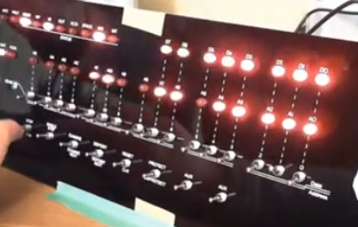

Feb 28 -LeRoy - Omni-Wheel Robot

**Adeept Omni-Wheel Drive Robot Demo**

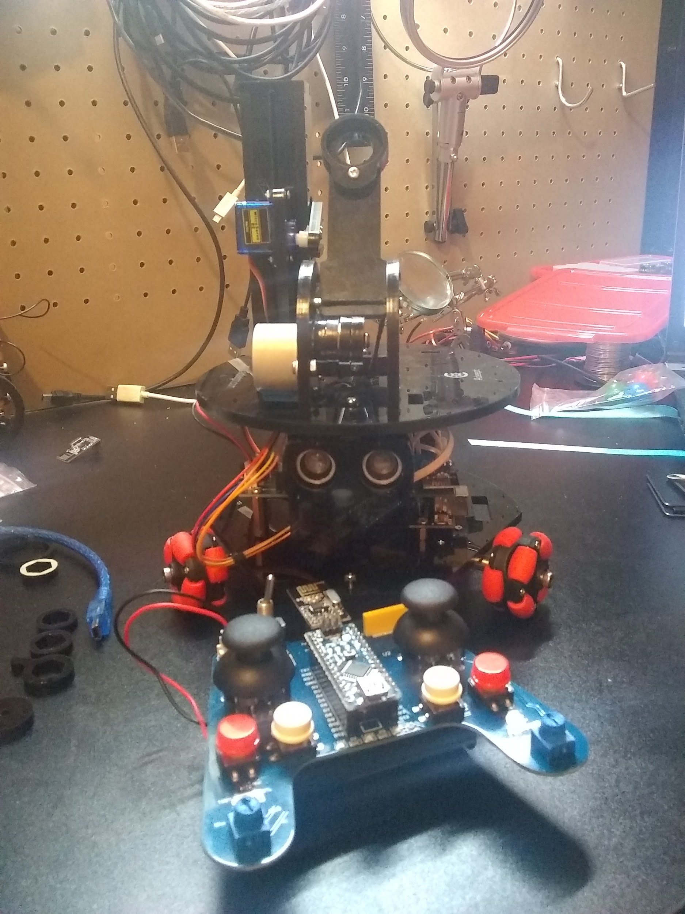

Feb 21 -LeRoy- Google Home Custom Skills

Feb 14 -Marcus- Alexa Custom Skills

This week we will look under the hood to take a closer a look at how to create custom Amazon Alexa skills. An Alexa skill is how capabilities are added to Alexa enabled devices; like the Amazon Echo Dot, Echo and Echo Show to name just a few. The smart speaker market has hit 20% of U.S. households with Wi-Fi.

For additional information on Amazon Alexa Skill Development click the following link:

<https://developer.amazon.com/alexa>

Jan 17 - LeRoy - PixyCam2 “Fetch” Robot

Pixy Cam 2 “Fetch” Robot - based on this Project:

<https://www.hackster.io/gatoninja236/making-a-robot-play-fetch-657ebc>

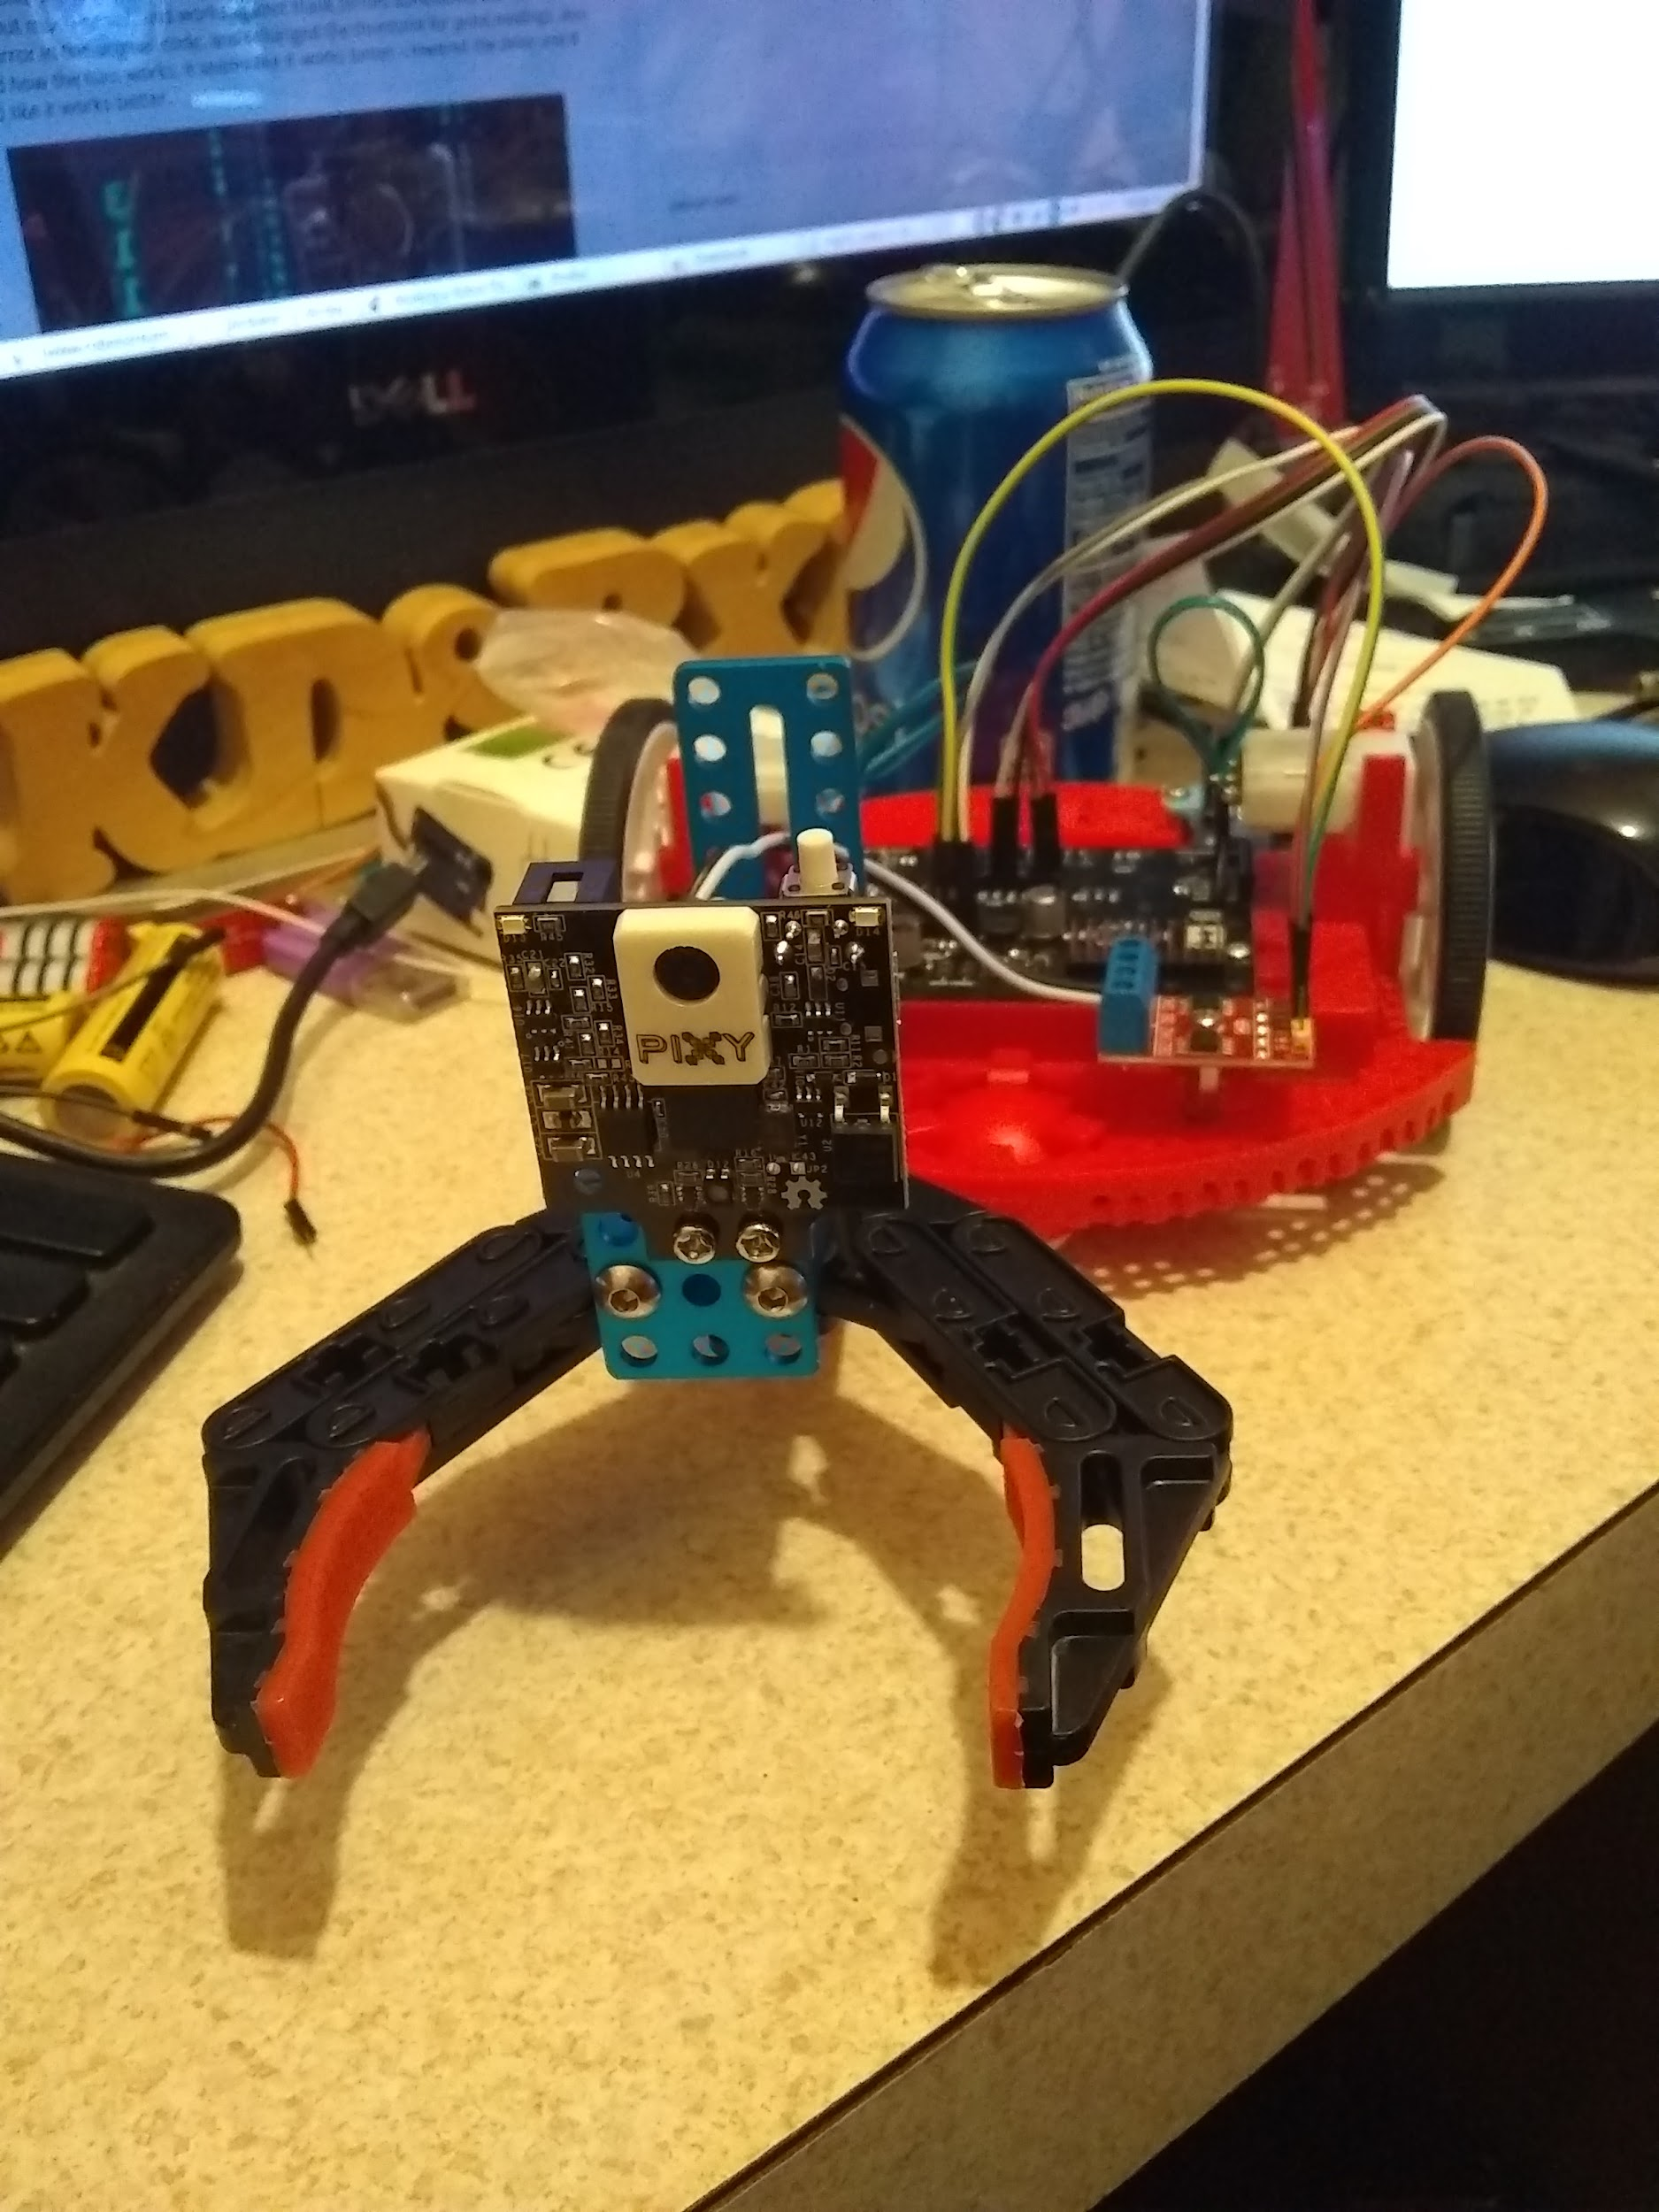The idea is for the robot to move to a colored object (in my case, it would be light blue), The gripper will close, the robot will back up and drop the object and stop.

This works but is picky sometimes about the colors it see.

My chassis is a Pololu Romi chassis, with Pololu Romi motor driver/power board, the gripper is a Makeblock robot gripper (This gripper uses a small dc motor, so requires a drive to make it work, it’s a 5v to 12v motor). I also have a L9110 motor drive for the gripper (using only one channel), and a Arduino Nano, and of course the PixyCam2 - I’ve limited myself from 3D printing a bunch of stuff for this robot - The nano mount is left over from the LiDar Robot, I did 3D print a light blue block for the robot to grip.

I’ve swapped the Front and Back of the robot, (so the front is the back, and back is the front). The whole thing is running on 6 AA batteries.

I’ve not published the code for this yet.

Jan 3, LeRoy: V2 LiDar Robot

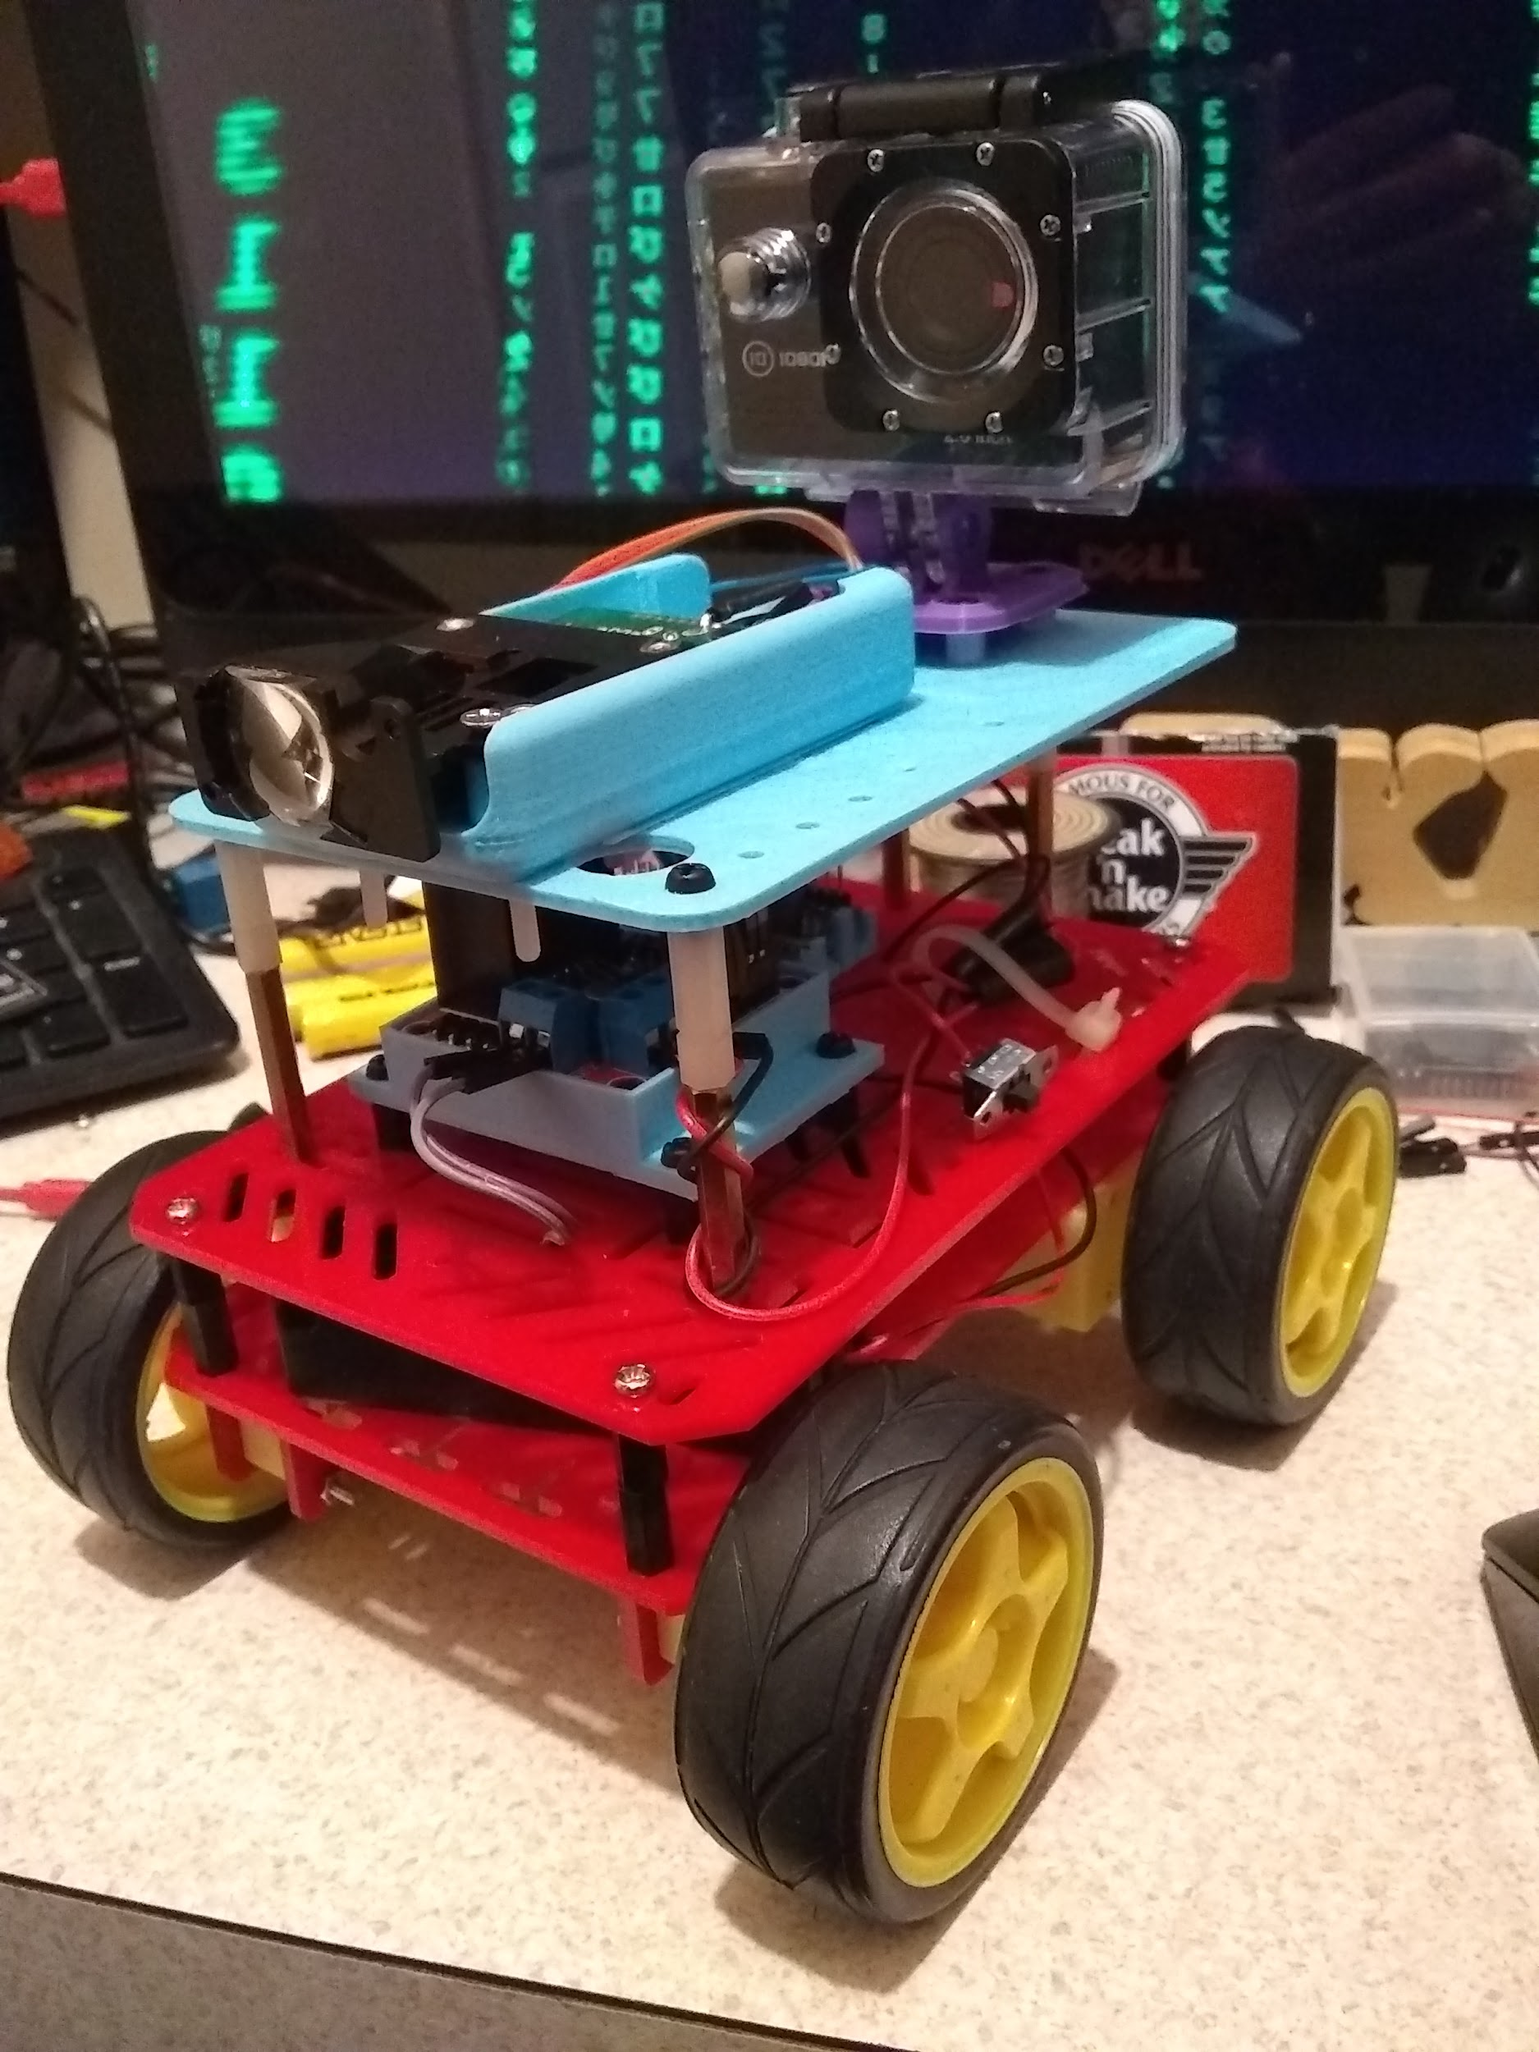

Still testing, made a number of physical changes, There will be a number of code changes as well.

Dec 27: **LiDAR Equipped Robot** 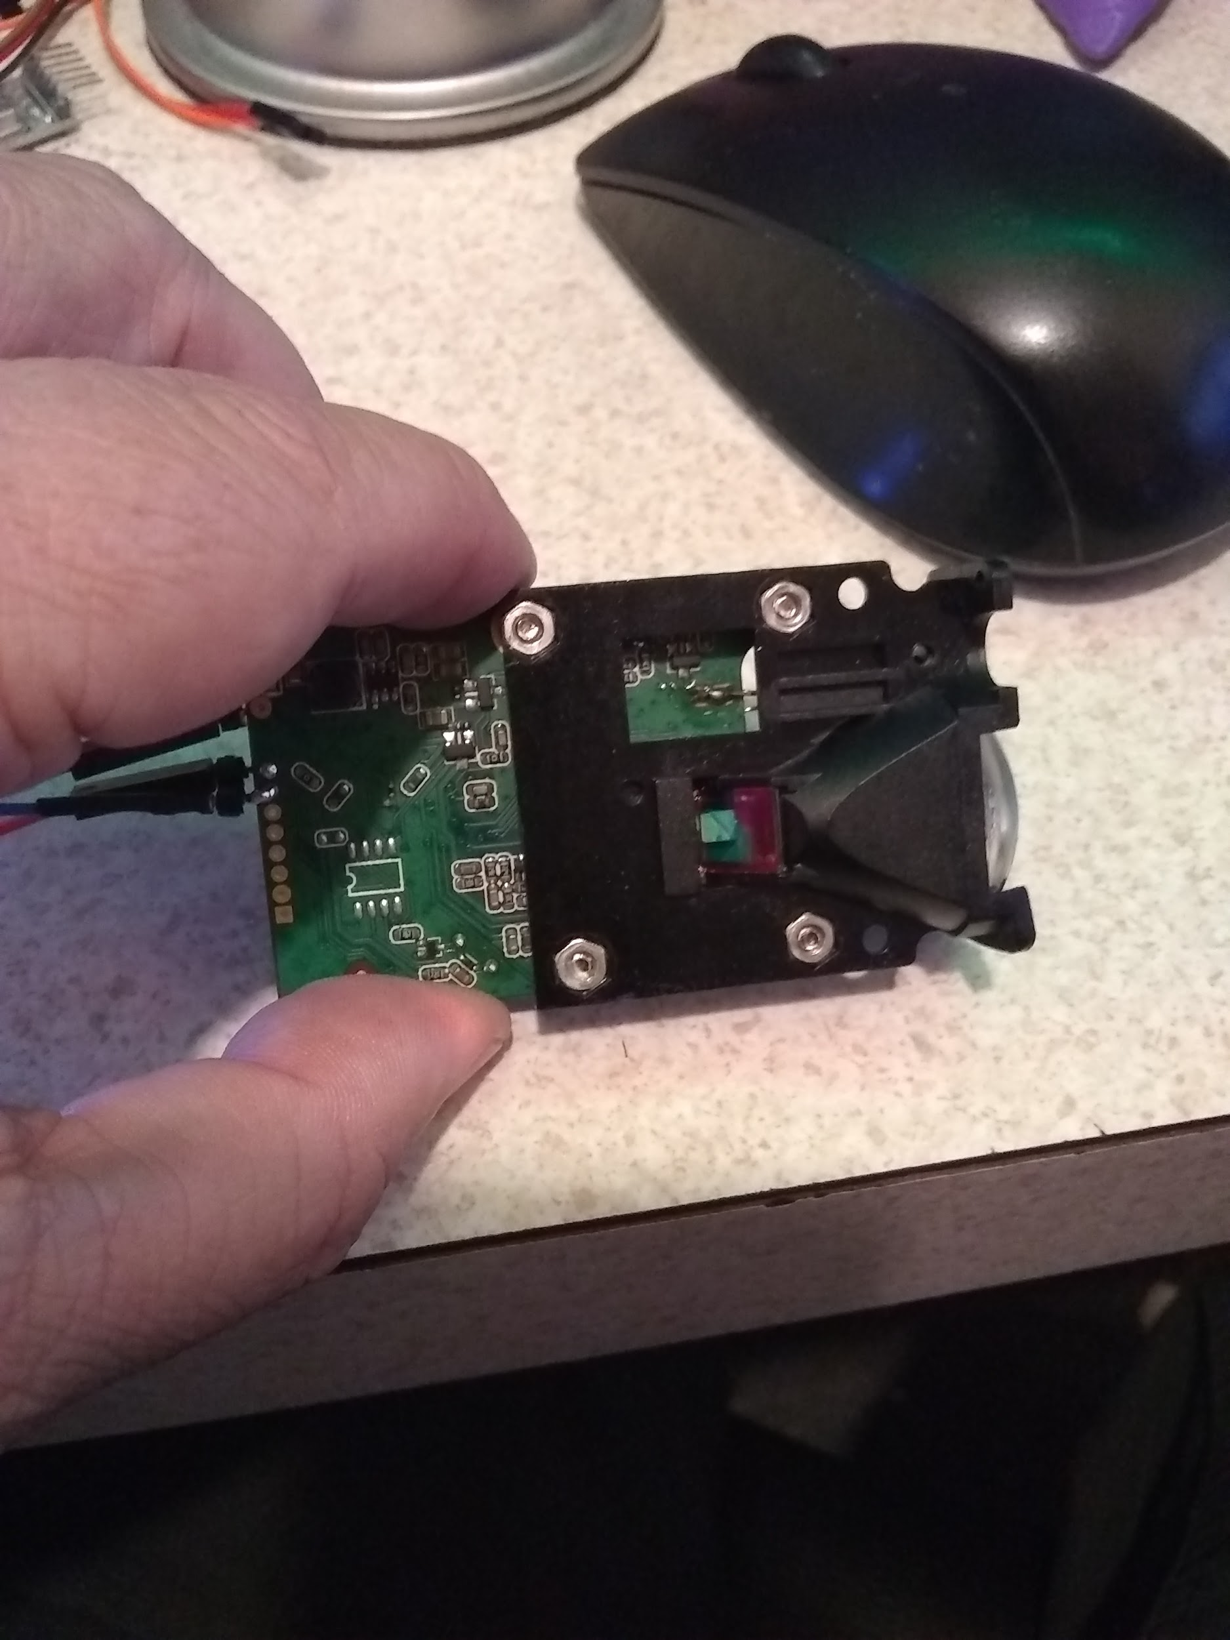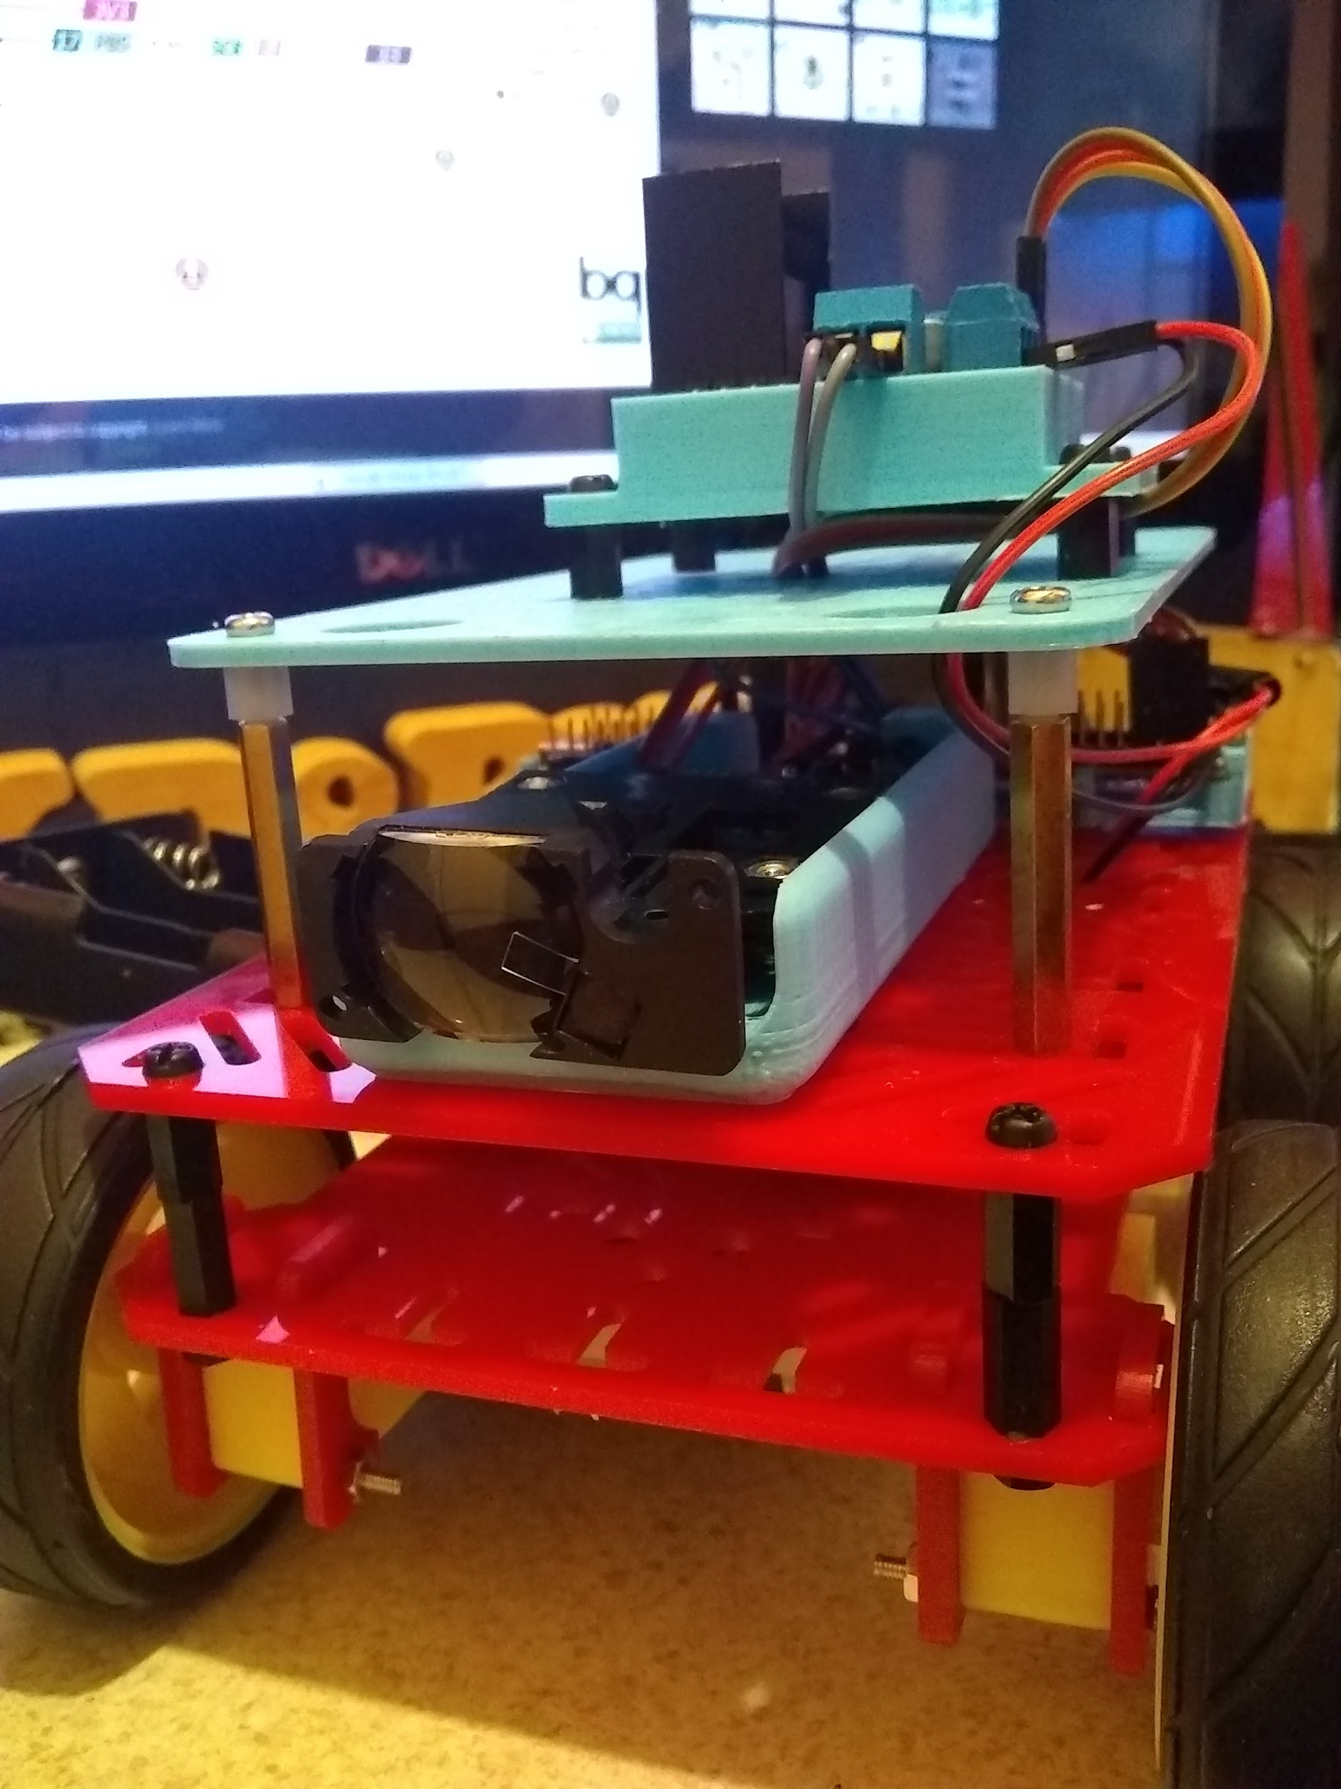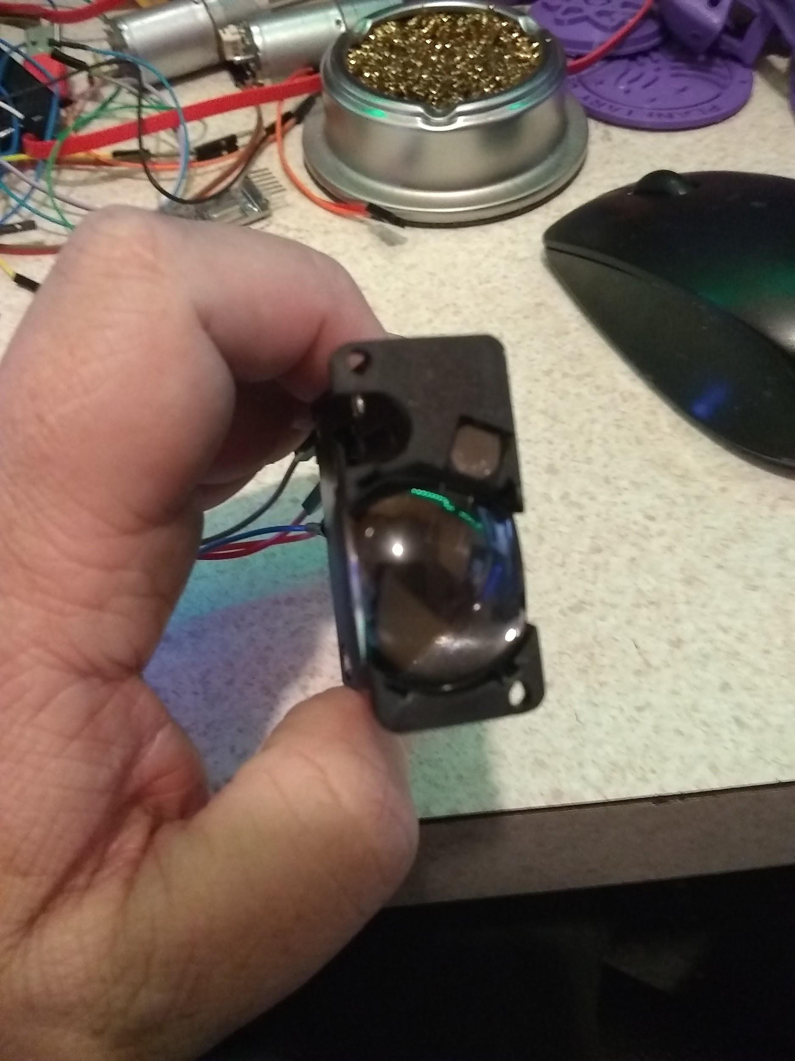

Working on the code, this link is for the project last week.

Code: <https://github.com/kd8bxp/100m-Lidar-Sensor-Arduino-Code>

Lidar from Aliexpress: <https://www.aliexpress.com/item/100M-Laser-ranging-module-digital-sensors-Distance-Measuring-serial-port-USB-to-RS232-TTL-signal/32702749857.html?spm=a2g0s.9042311.0.0.79de4c4dSlT78Y>

Laser Type: 635nm, 1 mw (red)

Range: 0.02 to 100 meters

Typical accuracy: +/- 2mm (0 to 40, indoor 20 meters white walls; through correction can be up to +/- 1.5mm)

The LiDar will replace an Ultrasonic, under my current design I am using a 4 wheel chassis, 2 Arduino Nanos, one for motor drive, and one get get updates from the LiDar.

I am using a L298 motor driver, and 3 18650 batteries. The chassis is a Dagu Magic Chassis, with additional 3D printed 3rd layer, and 3D printed mounts for the L298, LiDar, and Arduino Nano.

I am planning on using I2C for communication between the two Nanos.

CURRENT: Dec 20 - **100 Meter LiDAR Range Sensor**



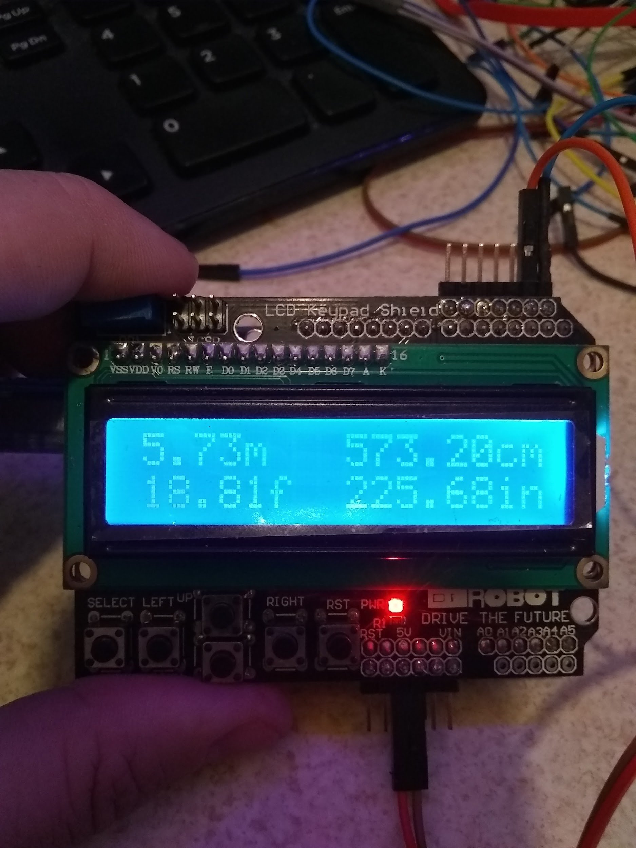

Code: <https://github.com/kd8bxp/100m-Lidar-Sensor-Arduino-Code>

Lidar from Aliexpress: <https://www.aliexpress.com/item/100M-Laser-ranging-module-digital-sensors-Distance-Measuring-serial-port-USB-to-RS232-TTL-signal/32702749857.html?spm=a2g0s.9042311.0.0.79de4c4dSlT78Y>

Laser Type: 635nm, 1 mw (red)

Range: 0.02 to 100 meters

Typical accuracy: +/- 2mm (0 to 40, indoor 20 meters white walls; through correction can be up to +/- 1.5mm)

The laser can be turned on or off (assuming for aiming reasons), reads can be “automatic”, fast (less accuracy), and slow (more accuracy) - “automatic” appears to be about medium speed.

The laser can also display it’s temperature and voltage levels. The output of the sensor is in the format of a String, a typical reading may look something like this:

“12.345m,0079” which tells the distance, and signal quality. Signal quality a lower number is better. This is good for display, and easy to use for display, but it’s a problem if we need to compare the numbers, or if we are using this on a robot and need the robot to stop at a distance.

Luckily - there is a way to remove the unwanted information from a string, and turn that string into a float - it’s not pretty, and a lot of code to do it, but it can be done.

In my demo, I’ve converted the distance from meters to feet to cm to inches. I’ve dropped the signal quality - but it can be pulled out and used as well.

The demo, will display if the laser is on, or off, the temperature and voltages (default temperature is celsius, and I convert it to faheinght), formated for the display I am using.

I’ve setup 5 buttons, one for normal reading, one for fast, one for slow - one will toggle the laser on or off, and one will display voltage, temperature.

An expanded demo would be to use this on a robot for distance/obstacle avoidance.

(under my less than scientific tests, I’ve only been able to get a reading of 32.x feet or about 10 meters - anything greater than 32 feet gives either a reading that is just wrong, or an error. Is it possible that I have a bad unit, or that it really is 10 meters not 100 meters (which would mean it was listed wrong to start with)? )

**From Wikipedia, the free encyclopedia**

**Lidar** (also called **LIDAR**, **LiDAR**, and **LADAR**) is a [surveying](https://en.wikipedia.org/wiki/Surveying) method that measures distance to a target by illuminating the target with [pulsed laser](https://en.wikipedia.org/wiki/Pulsed_laser) light and measuring the reflected pulses with a sensor. Differences in laser return times and wavelengths can then be used to make digital [3-D representations](https://en.wikipedia.org/wiki/3D_modeling) of the target. The name *lidar*, now used as an acronym of *light detection and ranging*[[1]](https://en.wikipedia.org/wiki/Lidar#cite_note-NOAA-1) (sometimes *light imaging, detection, and ranging*), was originally a [portmanteau](https://en.wikipedia.org/wiki/Portmanteau) of [*light*](https://en.wikipedia.org/wiki/Light) and [*radar*](https://en.wikipedia.org/wiki/Radar).[[2]](https://en.wikipedia.org/wiki/Lidar#cite_note-Oxford-2)[[3]](https://en.wikipedia.org/wiki/Lidar#cite_note-James_Ring_p._672-3-3) Lidar sometimes is called **3D laser scanning**, a special combination of a [3D scanning](https://en.wikipedia.org/wiki/3D_scanning) and [laser scanning](https://en.wikipedia.org/wiki/Laser_scanning). It has terrestrial, airborne, and mobile applications.

Lidar is commonly used to make high-resolution maps, with applications in [geodesy](https://en.wikipedia.org/wiki/Geodesy), [geomatics](https://en.wikipedia.org/wiki/Geomatics), [archaeology](https://en.wikipedia.org/wiki/Archaeology), [geography](https://en.wikipedia.org/wiki/Geography), [geology](https://en.wikipedia.org/wiki/Geology), [geomorphology](https://en.wikipedia.org/wiki/Geomorphology), [seismology](https://en.wikipedia.org/wiki/Seismology), [forestry](https://en.wikipedia.org/wiki/Forestry), [atmospheric physics](https://en.wikipedia.org/wiki/Atmospheric_physics),[[4]](https://en.wikipedia.org/wiki/Lidar#cite_note-cracknell-4) [laser guidance](https://en.wikipedia.org/wiki/Laser_guidance), airborne laser swath mapping (ALSM), and [laser altimetry](https://en.wikipedia.org/wiki/Mars_Orbiter_Laser_Altimeter). The technology is also used in control and navigation for some [autonomous cars](https://en.wikipedia.org/wiki/Autonomous_car).[[5]](https://en.wikipedia.org/wiki/Lidar#cite_note-5)

CURRENT: Dec 13 - **Speech Synthesizer Exstrangazana**

Marcus and LeRoy - Marcus has a speech synthesizer demo this week, and LeRoy will supplement with a XFS5152CE Chinese Speech Synthesizer (low cost, ok voice quality, TTL UART/I2C and SPI interface, has a slight Chinese accent), also a much more expensive EMIC 2 synthesizer made by Parallax to compare. Time permitting, the BIG buddy talker - which is prerecorded with 1000 or so words, and a few sounds - uses a simple SPI interface, and a Raspberry Pi Zero W running espeak. The XFS5152CE, Big Buddy Talker, and Raspberry PI are all lower cost alternatives to the Parallax EMIC2.

In 2015 LeRoy made a document outlining some low cost speech synthesizers - it need to be updated, but still has some good info in it.

<https://docs.google.com/document/d/1ZlXH9ujGUugDQO4uj2PVtsOMV8t2pJdzrhB_tNSIyB4/edit?usp=sharing>

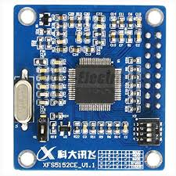The XFS5152CE Chinese/English Speech Synthesizer

Demo code will be uploaded to github shortly…..

<https://github.com/automation-technology-club/Speech-Synthesizer-Demos>

CURRENT: Dec 6

**LeRoy: Take 2: AruCo Makers using JeVois camera and Arduino Robot (MK2)**

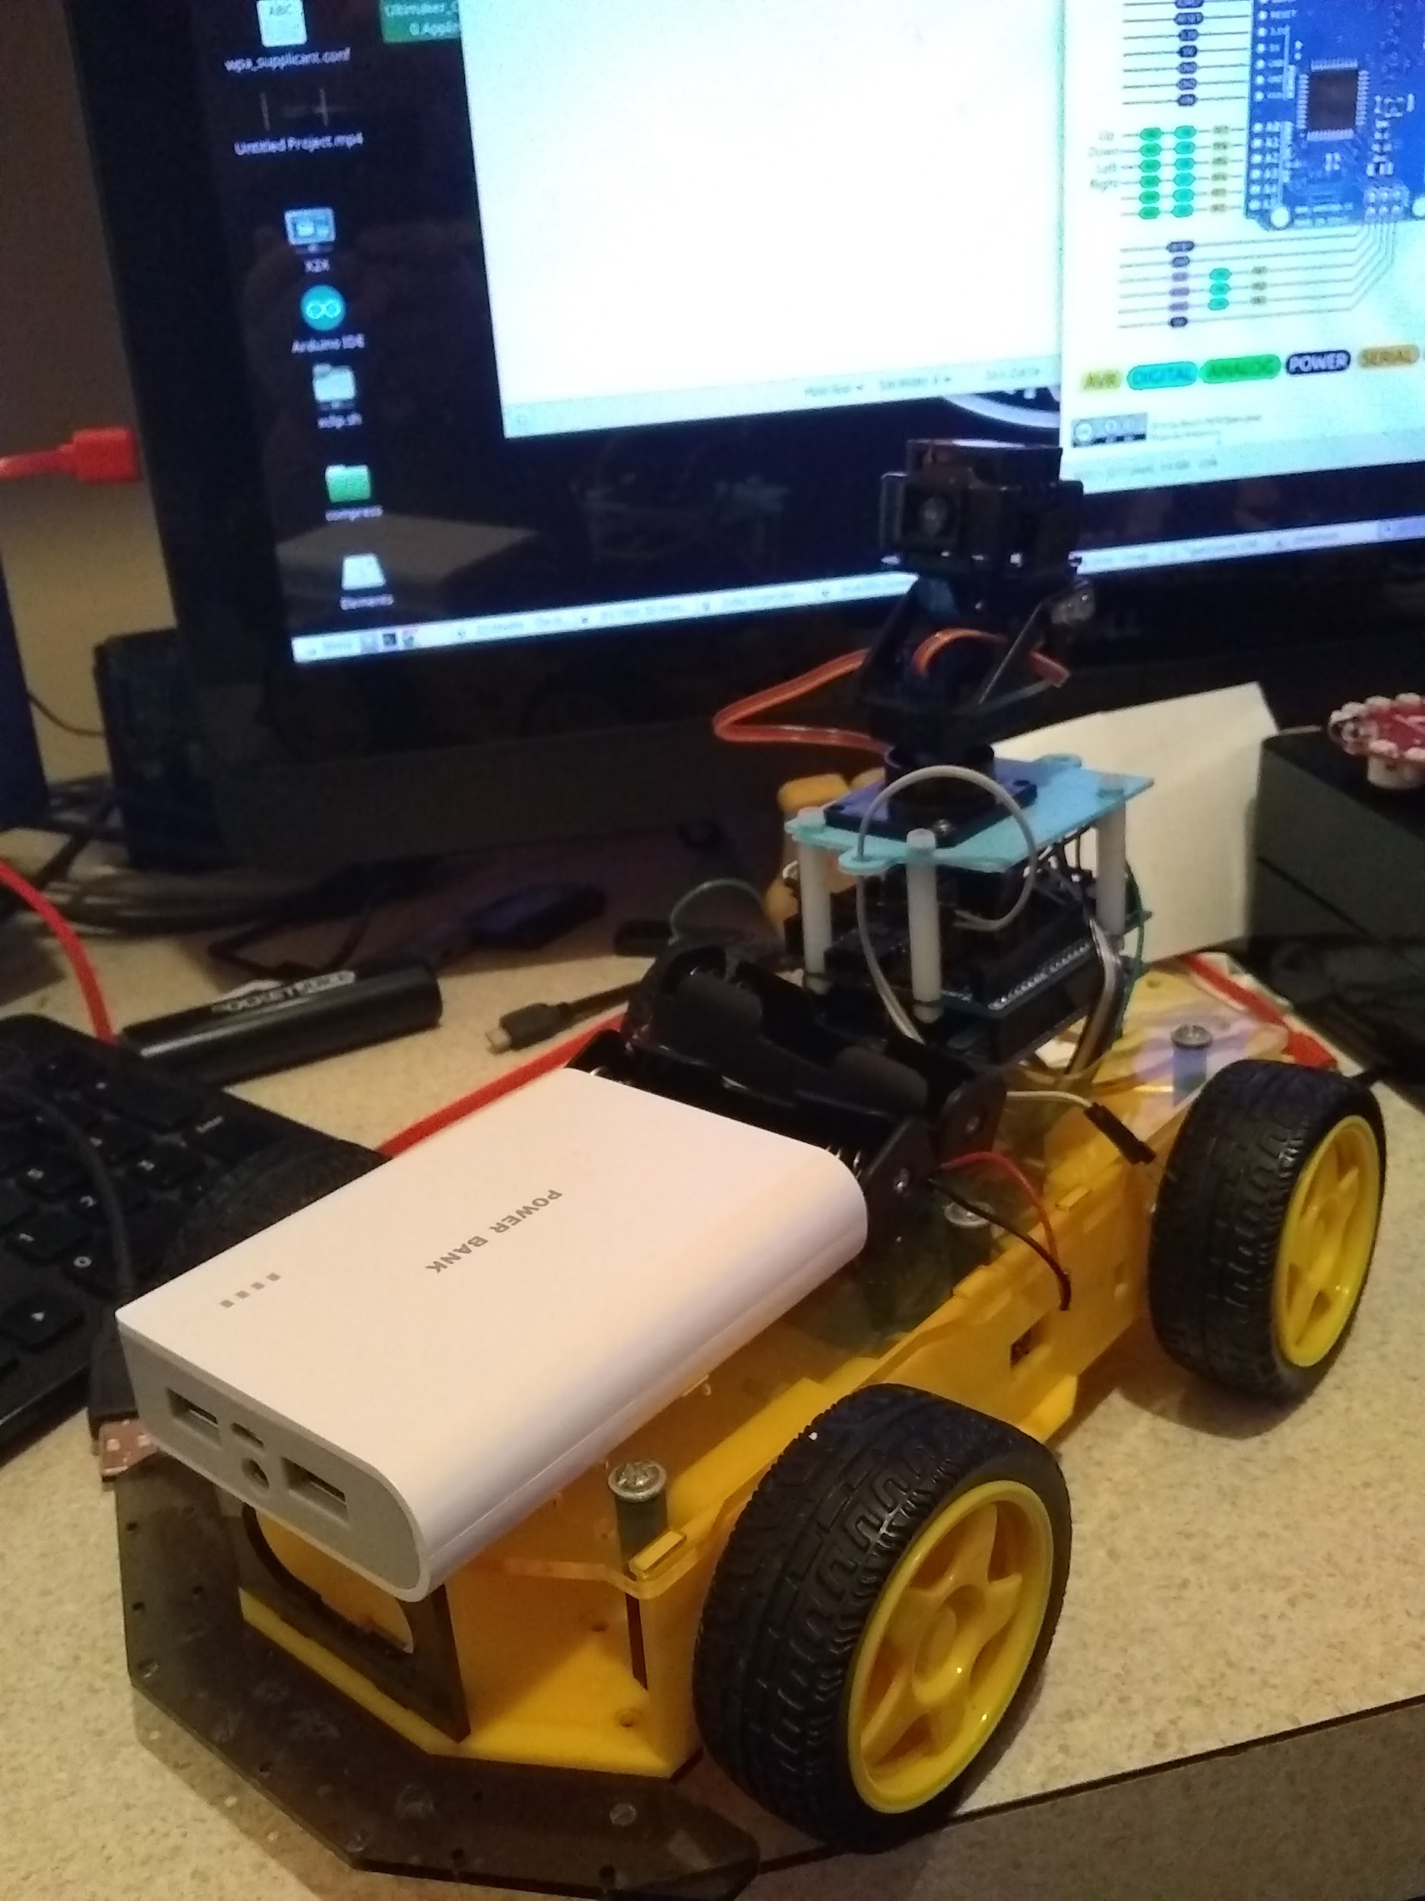 And it works….. See below for the initial project.

This robot is closer to the original JeVois project, with the biggest different being the motor driver (and 4 wheel drive). The original software was only modified slightly for some of the small changes in hardware. Software can be found here:

<https://github.com/kd8bxp/JeVois-ArUco-Marker-Experiments>

Nov 29

**LeRoy: AruCo Makers using JeVois camera and Arduino Robot**

What is an AruCo Marker? An ArUco marker is a synthetic square marker composed by a wide black border and a inner binary matrix which determines its identifier (id). The black border facilitates its fast detection in the image and the binary codification allows its identification and the application of error detection and correction techniques. The marker size determines the size of the internal matrix. For instance a marker size of 4x4 is composed by 16 bits.

Looking something like this:



I’ve modified one of the JeVois Camera demos (The Follow me demo) for use with a robot made my Ray (Rabbit Robots) - I’m still working on the final, but so far things are working. <http://jevois.org/tutorials/UserRobotCar.html>

The JeVois camera is a open-source machine vision camera, with a quad-core CPU, running a very striped down version of linux, and openCV - That can detect a number of objects just by using the demos already on the SD card.

Including, Faces, objects, QR codes, AR markers, ArUco Markers, roads, and more. The cost is $50.

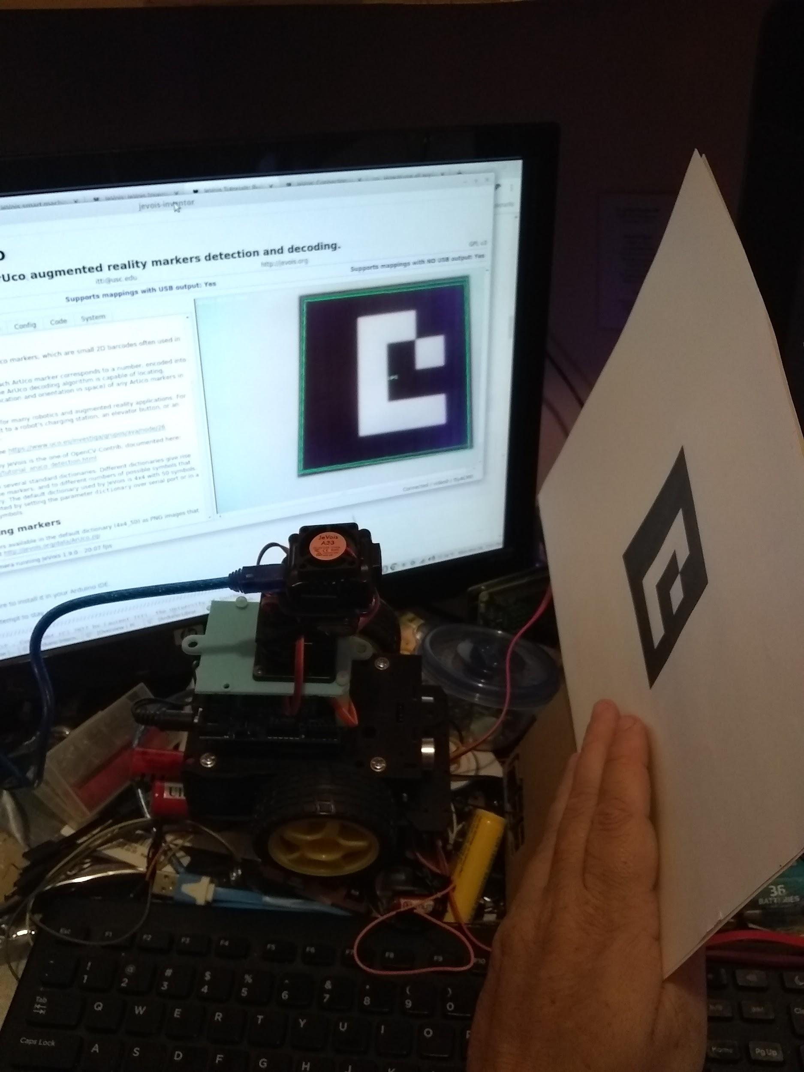Here is some early testing.

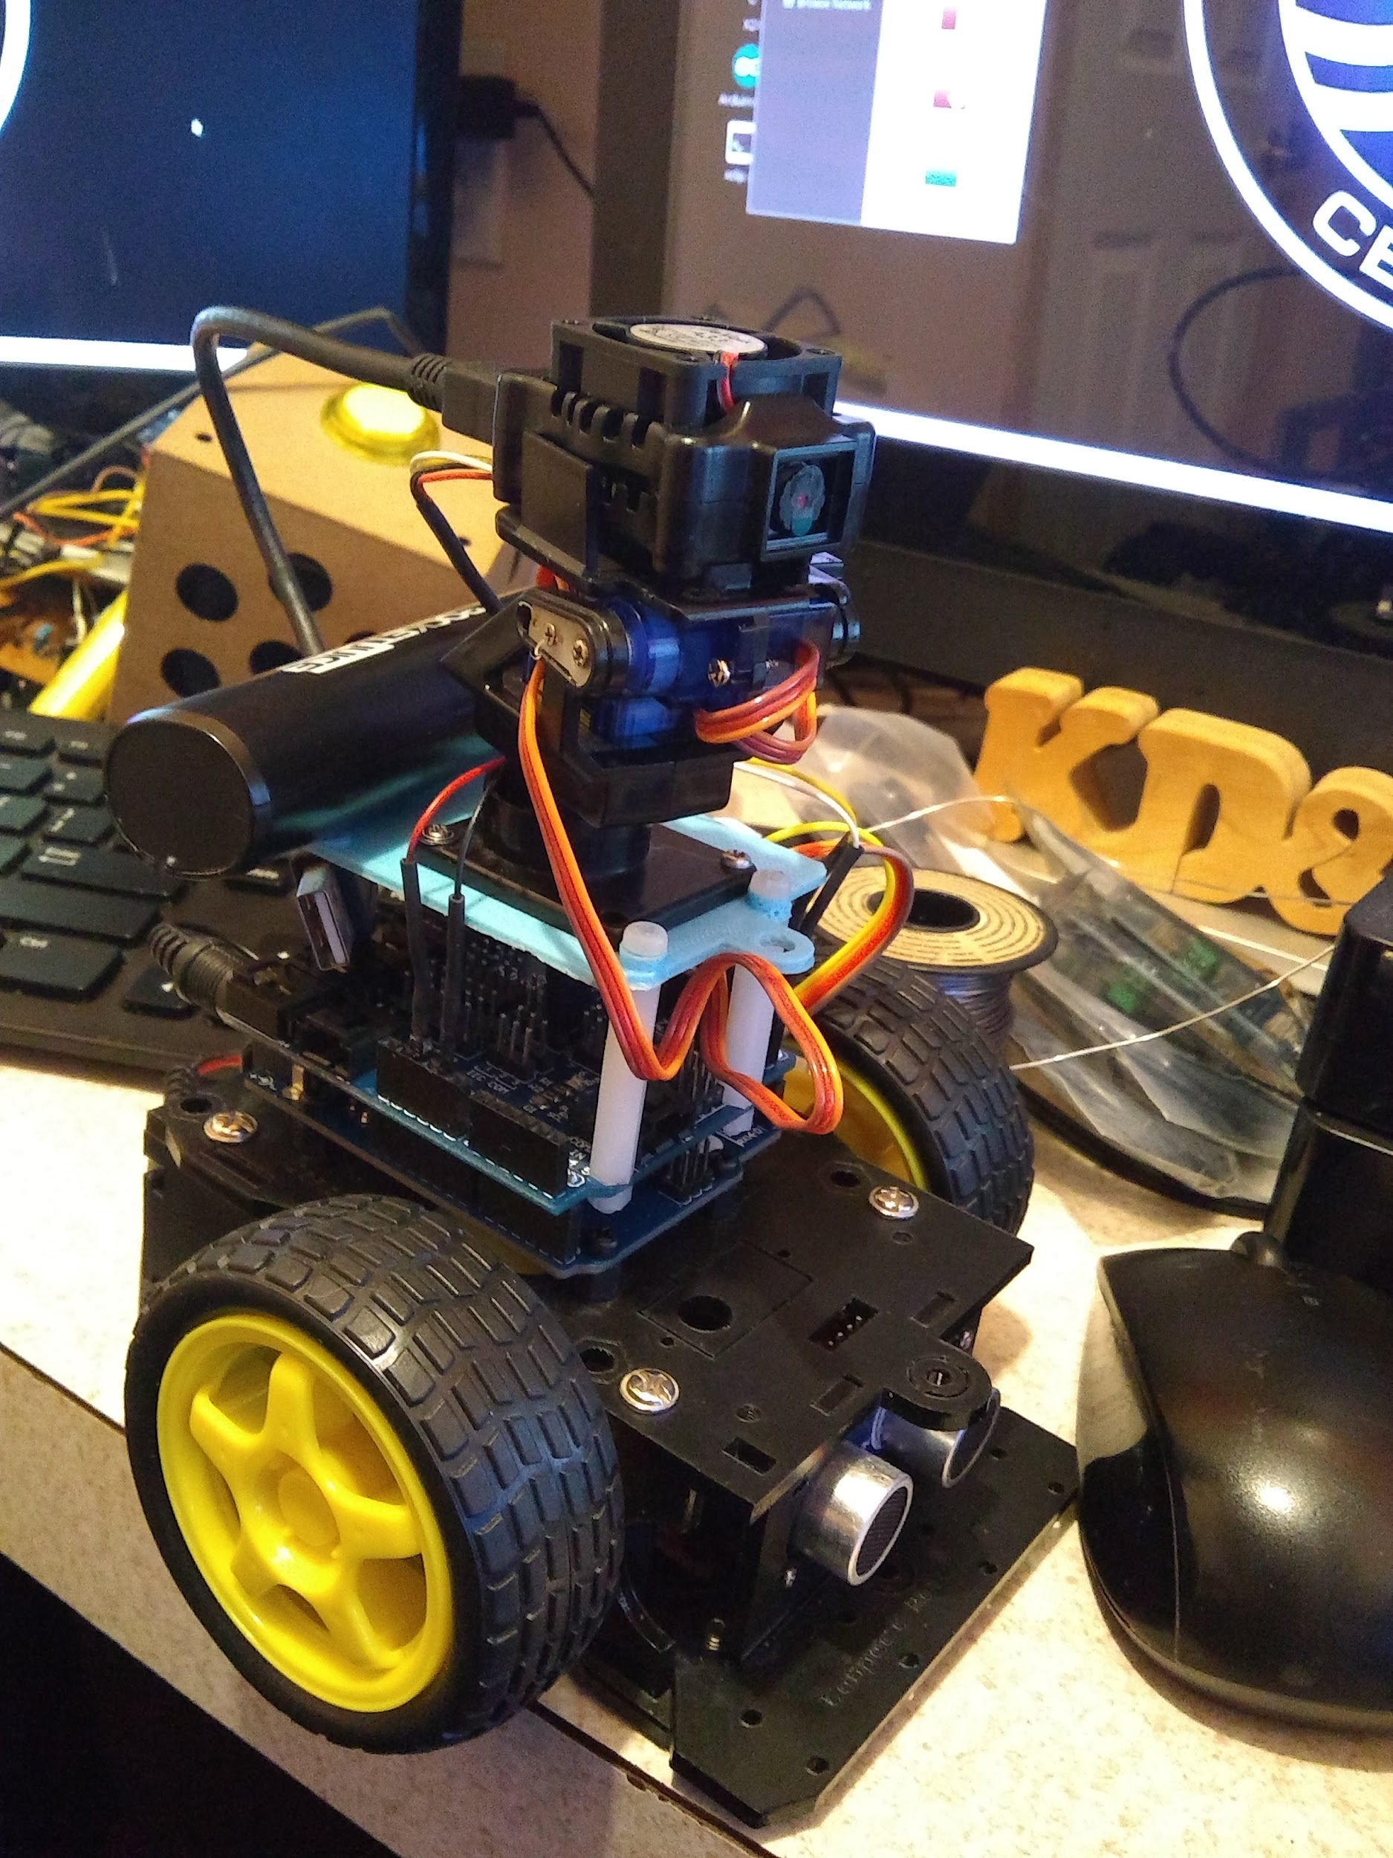 And the final robot.

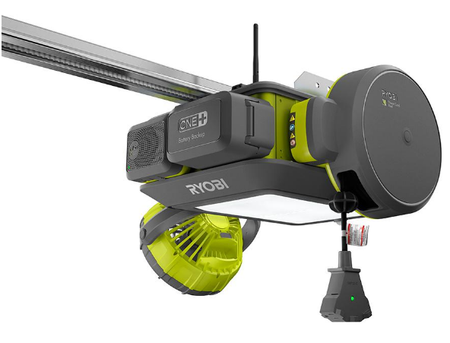

**Nov 15 - Grand Poo Bah - RYOBI Garage Door Opener GD-201 Introduction and surprises**

[RYOBI Garage Door Opener Introduction](https://docs.google.com/document/d/1eLVsiN_w-e9aUWGd2E_pjGU1OH5P6bxmn3wCoMZa-gg/edit?usp=sharing)

The Grand Poo Bah has assembled one of these (if he did it, anyone can). Old Bah reveals additional details buyers do not know. You get extra widgets! What you need to know before buying one etc. See the linked article to find out about the $100 bonus item.

**Nov 8 - LeRoy - Raspberry Pi Robots**

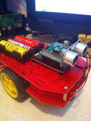

**Nov 1 - Frank - The Shift to Mobile First Design - What you Should Know**

Today the greatest influence on Web Application Development is the advent of small footprint devices (tablets, phones and watches). This presentation will examine the move toward Mobile First which dictates that web applications and web sites should be compatible with small footprint devices. Greater than 50% of internet traffic is generated from mobile devices. Trade-offs between competing technologies.

**Vicente - Pumpkin Eyes Arduino**

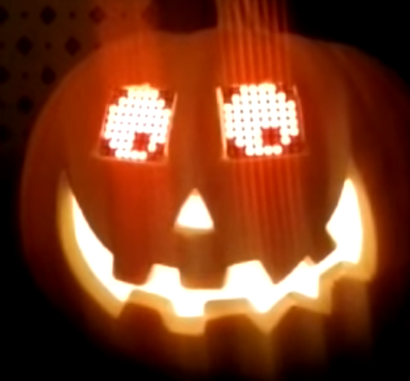

**Oct 25 - LeRoy - LiDar Sensor** [***Lidar Sensor - $32.99***](https://www.ebay.com/itm/TFmini-Single-Point-Micro-Ranging-Module-Lidar-Range-Finder-Sensor-for-Pixhawk/282831882455?ssPageName=STRK%3AMEBIDX%3AIT&_trksid=p2060353.m2749.l2649) **30 cm to 12 meters**

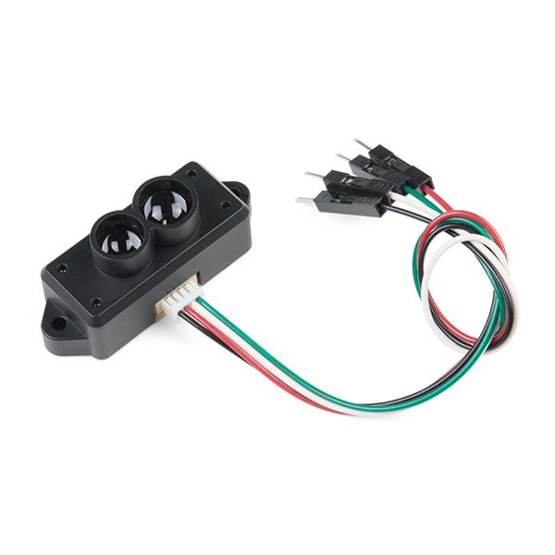[**Sparkfun General Information**](https://www.sparkfun.com/products/14588)[**Arduino Library**](https://github.com/opensensinglab/tfmini)

**The TFMini is a ToF (Time of Flight) LiDAR sensor capable of measuring the distance to an object as close as 30 centimeters and as far as 12 meters! As with all LiDAR sensors, your effective detection distance will vary depending on lighting conditions and the reflectivity of your target object, but what makes this sensor special is its size. Measuring only 42x15x16mm, the TFMini allows you to integrate LiDAR into applications traditionally reserved for smaller sensors such as the SHARP GP-series infrared rangefinders. The TFMini is easy to power at only 5V and easy to talk to using a 3.3V UART at 115200 baud.**

* **Replacement of Google Plus Club Tool**

[**Link to Desirable Traits for New Tool**](https://docs.google.com/spreadsheets/d/1VRLjcHWPf1d9Dezcmiok4nP_wkqJnOprJfR9jLIEthE/edit?usp=sharing)

[Collabroation Tools (Updated Oct 8, 2018) - LeRoy Miller](https://docs.google.com/document/d/137TbmM0O1GYnhj8Z5RJzYxPHczfgUDwk_Lq_ru3uxmE/edit?usp=sharing) (Updated Oct 14-16 with additional Social Networks)

[PROs and CONs to SLACK and TWIST](https://docs.google.com/document/d/1nt8PjQZ2nm0Vh9JJigPjrgghlSgsbSJLP7bCDAcyE6c/edit?usp=sharing) (LeRoy Miller updated Oct 24, 2018)

***Twist -*** [***Tips on using Twist***](https://docs.google.com/document/d/1NHOHP1jL0Q2kmeMo6waZr_QztogWIk46w4IQ0mdAe9g/edit?usp=sharing)

*CLUB CONTEXT:(from the club web pages)*

*WHAT ARE WE ABOUT?*

We are hobbyist. We mainly here for technical fun! Our focus is giving hobbyist an hour or so of technical entertainment. Those into serious development desires find us an interested audience and an outlet for sharing their creations and knowledge.

- Cost: Free

- All Volunteer. All participants volunteer their time (selflessly)

- Provide knowledge sharing opportunities for everyone.

Positive Attitudes - We promote a positive, sharing environment, promote member success and growth.

Respect for Others

Avoid talking when another member has the floor

Allow each member to have their time speaking (what was your total speaking time in the meeting?)

Avoid interrupting someone

Try to keep comments on topic and brief (1).

Try to schedule presentations (although we enjoy for impromptu topics if we have time).

Education - We enjoy developing useful, educational projects that:

Are easily accessible to the public

Are designed for a wide variety of skill levels (a young person could implement it, without problems).

Promote the general welfare -

Support spinoff clubs and groups for equally positive purposes.

*WHAT ARE WE NOT ABOUT?*

- Self Promotion (we like humble).

- Distribution of member information (Grand Poo Bah has exclusive dictatorial control of member information).

CURRENT: 

* **Oct 18 - Adam- Tiny Tiny Stepper Motor with Controller with RC Submarine Background**

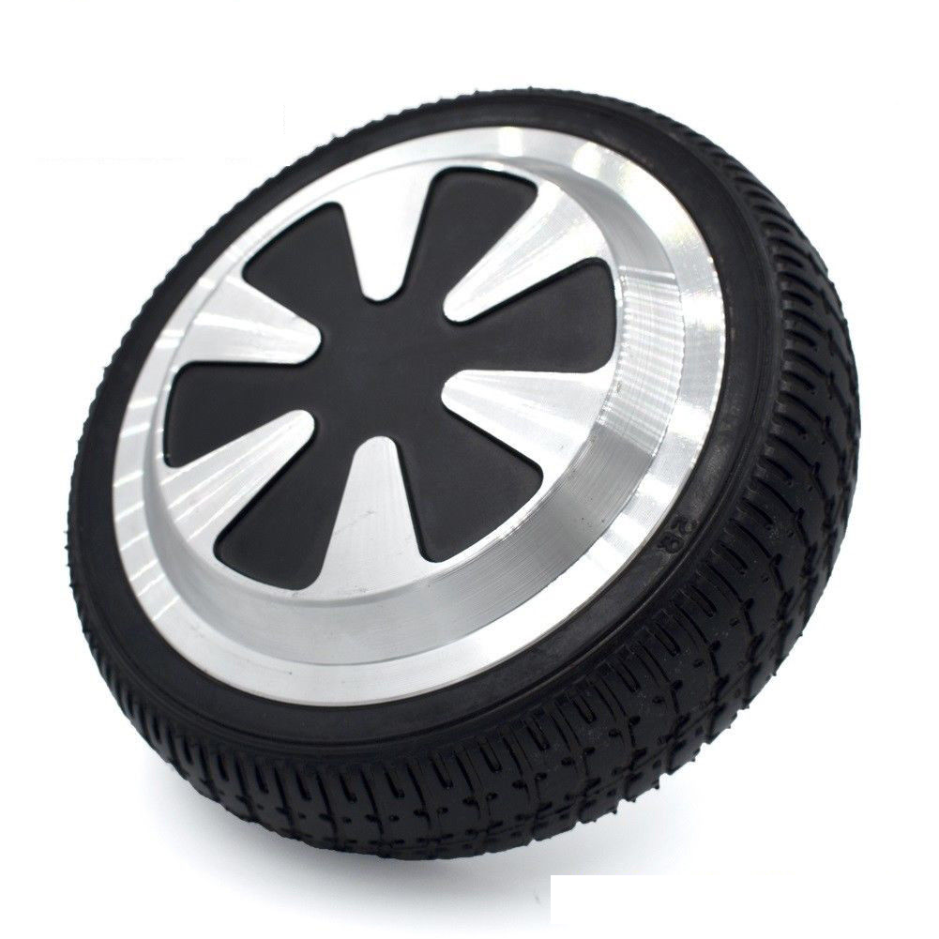

**Oct 11 - - Robotic Wheel Motor Propulsion Using Hover Board Wheel Motor + Telephoto Security Camera Update**

**Robotic Wheel Motor Propulsion Using Hover board Wheel Motor**

**We will be discussing the use of a hover board style wheel motor for large size robotic propulsion. We have been looking at hover board style motors for the club TCT (Trash Can Transport) project (Poo Bah's infinity project - Poo's expected delivery date).**

**Pro's**

**Cheap**

**One moving part device**

**no chains belts to align - reduces mechanical issues**

**Controller is cheap and available**

**Embedded Hall Effect Transducers for speed control**

**Simple Mounting**

**Con's**

**Heavy**

**Requires Controller**

**Oct 4 - LeRoy - Using the DF Robot Micro Maqueen Micro:Bit Robot Platform With the Arduino IDE**

**The DF Robot micro Maqueen Robot Platform is a great little inexpensive robot that uses the BBC Micro:Bit micro-controller for it's brains. This project is an attempt to duplicate the examples DF Robot provides for Makecode - but using the Arduino IDE. (For those of us that don't like Scratch, or Makecode).**

**For full disclosure DF Robot provided the Maqueen, a BBC Micro:Bit, and a micro:Gamepad (which in the end I did not use in this project, but will still explain how to use it with the Arduino IDE - super easy to do).**

**I also added a HC-SR04 ultra sonic sensor, which is somehting that I already had, and can be found in a number of different on line stores.**

**For this project the following is need:**

**micro:Maqueen Robot Platform** [**https://www.dfrobot.com/product-1783.html**](https://www.dfrobot.com/product-1783.html) **about $20.90 US**

**BBC Micro:bit** [**https://www.dfrobot.com/product-1587.html**](https://www.dfrobot.com/product-1587.html) **$14.90 or**

**BBC Micro:bit Go KIT** [**https://www.dfrobot.com/product-1625.html**](https://www.dfrobot.com/product-1625.html) **$16.45 (recommended)**

**and a HC-SR04 ultrasonic (eBay, Aliexpress, ect, should be easy to find) <$2.00**

**Also provided (by DF Robot) but not used for this project:**

**micro:Gamepad** [**https://www.dfrobot.com/product-1711.html**](https://www.dfrobot.com/product-1711.html) **$19.90**

**Sep 27 - Barry - Virtual Reality**

**1. Try to keep Mike contained.**

**2. Review interesting *Quick News* items.**

**3. Demo/review of the Virtual Reality**

**4. Open Topics/Toys**

**Sep 20 - ILife A4 Robot Vacuum, Bring Your Own Toys**

**1. Try to keep Mike contained.**

**2. Review interesting *Quick News* items.**

**How to retrieve SJRC S70W from 60 ft up using a new S70W. (light is still blinking!)**

**string fishing line over wayward unit?**

**hook unit on line and release line with camera motion?**

**3. Demo/review of the ILife A4 Robot Vacuum**

**4. Open Topics/Toys**

**It looks like ILife is making a place for budget priced robotic vacuum sweepers. This unit is similar to the older iRobots. It uses random pattern cleaning techniques. I purchased a refurbished unit for just above $100.**

[**A4 Robot on Ebay**](https://www.ebay.com/itm/ILIFE-A4-Robot-Vacuum-Cleaner-Suction-Dust-Carpet-Floor-Certified-Refurbished/273353353442?ssPageName=STRK%3AMEBIDX%3AIT&_trksid=p2060353.m2749.l2649) **This unit is a certified refurb (unlike the Grand Poo Bah, who has not obtained certification yet, but is certainly certifiable).**

**PROs:**

**inexpensive**

**much quieter than rumba.**

**long battery life**

**conventional rotating brush does fluff rug a bit.**

**seems to clean as good or better that rumba (more to come).**

**auto return to charging station**

**Scheduler for auto operation**

**Size of trash container is not big, but does pack stuff in.**

**Smaller ~12"/ Lower profile.**

**Better pickup at carpet to tile transitions**

**CONs:**

**3 Cats require hair removal after each use (about the same as rumba).**

**Target is non carpet floors, but this one seems to do well on shorter length rugs. 1" carpet seemed ok (more to come).**

**Has problems with Black rugs/carpets (cliff detection, like rumba).**

**Has problems with tassels on rugs (like rumba).**

**Notes:**

**The A4S has improved bearings on brush.**

**The A6S has rubber brush which greatly reduces hair problems, but may reduce cleaning efficiency somewhat. Add $30**

**There are some intelligent robots that will definitely reduce run time, but may not improve overall cleaning.**

**Sep 6 - LeRoy - Raspberry Pi Robot GoPiGo2 board**

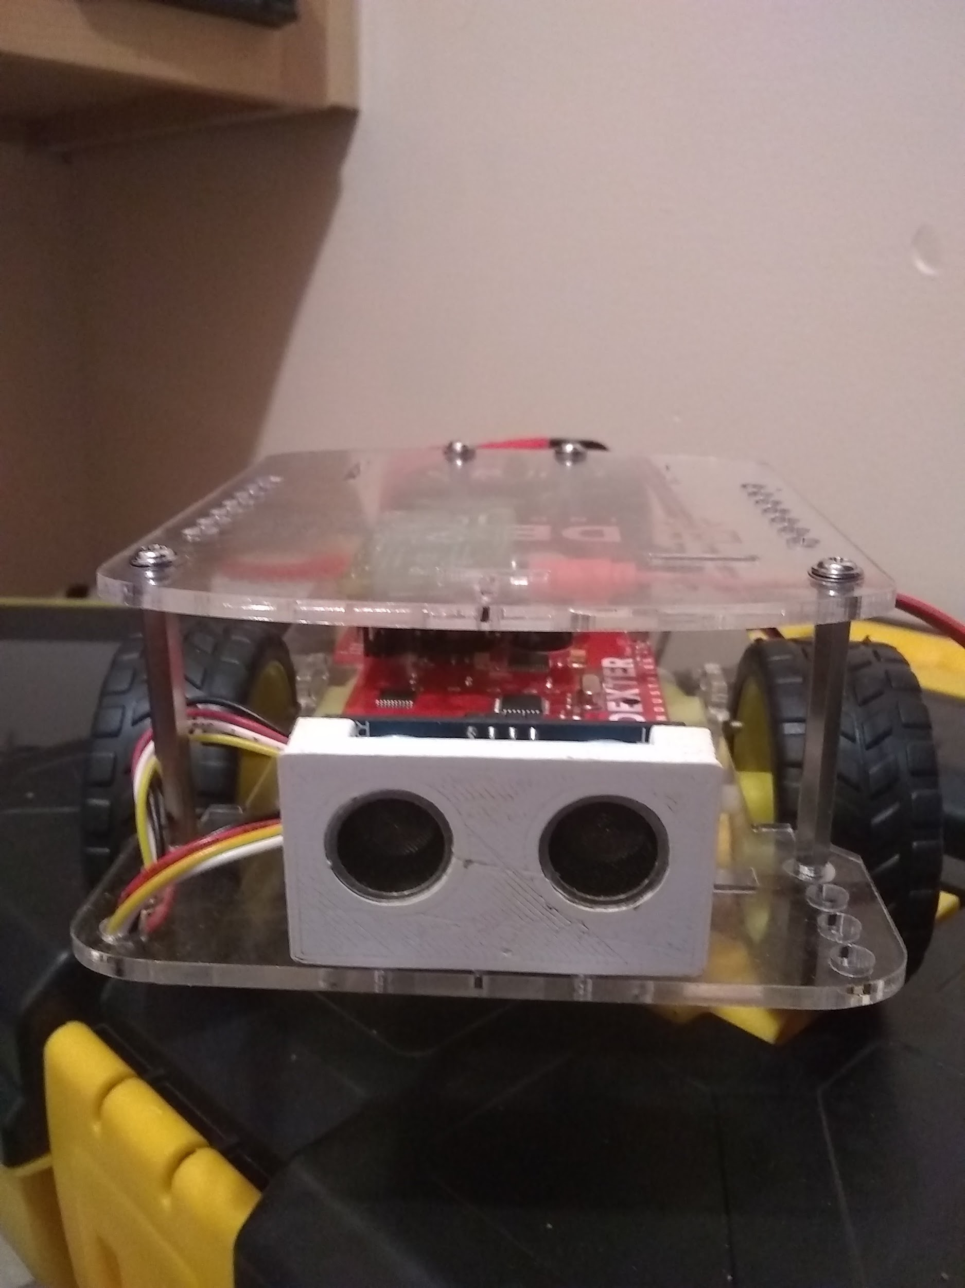 **GoPiGo using C++, Github repository: <https://github.com/kd8bxp/GoPiGo-C-code>**

**The GoPiGo2 board has an ATMEGA328P micro-controller, motor driver, voltage regulator, wheel encoders, and 4 grove connectors for external sensors, it also has**

**one servo port. It communicates with the Raspberry Pi using I2C. The Raspbian for Robots distro has a easy to use website that allows either SSH connections, or**

**VNC connections, no software is needed (other than a modern browser) on your desktop. Using the GUI you can drive the robot (over VNC). I made some simple**

**programs that run via the CLI interface (SSH). This was one for easier robots to get to work with out too much problems, there is a number of steps needed for setup.**

**The GoPiGo2 board has open source firmware, and appears to be updated via an Arduino like .ino file (I've not tried to update the firmware, since it works the way it is)**

**Aug 23 - Grand Poo Bah - Adding Telephoto Vision to Your Security Camera (The Wrong Way and the Right Way)**

**[Adding Telephoto Vision to Your Security Camera](https://docs.google.com/document/d/1j-8o4UY1RrzCM5K6Z4G2aQmC9fZDEyUXK1xpkh1y2UI/edit?usp=sharing)**

**Bah's latest obsession is tracking traffic using his security camera. Consistent with his lurid past, he will be presenting the "Wrong Way to do it first" (His "right way" parts should appear some time next year, we are guessing). He will strap his cell phone telephoto adapter onto his inexpensive PTZ camera and hold on for dear life. A good mix of basic optics and stupidity! (what some would call, outside the box). We are suggesting a cage for the great one. This also includes some rudimentary ISPY (PC Security Software) operating hints.**

**Aug 16 - Frank   
Health Arena - Network Analysis in Advancing Drug Discovery  
 15 minute video of a presentation**

**Aug 16 - LeRoy - International Space Station Tracker - M5Stack**

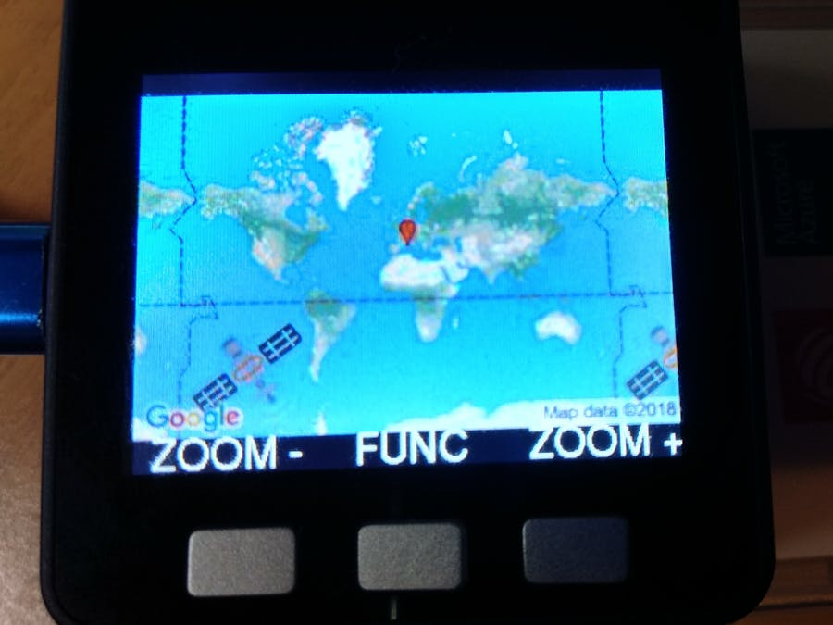

### **ISS Tracker**

**This tracker shows the current location of ISS over our planet in any moment and displays its position on a map.**

**It also permits to predict when the ISS will be over your position in the next hours or days.The source is full of reusable code (e.g. geolocation without GPS, decoding epoch time, obtain time zone,...)**

**For more infos on how to use discrete components look at Github** [**https://github.com/ccxx72/ISS-Tracker**](https://github.com/ccxx72/ISS-Tracker)**.**

### **Hardware Required**

**M5Stack**

**Aug 9 - LeRoy - WIFI Extravaganza Part II.**

**Another ESP-MESH (ESP-MESH boards): ESP-MESH** [**Aliexpress Link To Board**](https://www.aliexpress.com/item/ESP-Mesh-Networking-with-RGB-Serial-Port-WiFi-Wireless-IoT-Communication-Transmission-Module-8285-Development-Board/32850375220.html?ws_ab_test=searchweb0_0,searchweb201602_3_10152_10151_10065_10344_10130_10068_10324_10547_10342_10325_10546_10343_10340_10548_10341_315_10545_10696_10084_531_10083_10618_10307_10059_100031_10103_10624_10623_10622_10621_10620,searchweb201603_2,ppcSwitch_2&algo_expid=15e5aef3-93b2-42e5-a7be-219e4814edc0-2&algo_pvid=15e5aef3-93b2-42e5-a7be-219e4814edc0&priceBeautifyAB=0) **$2.47**

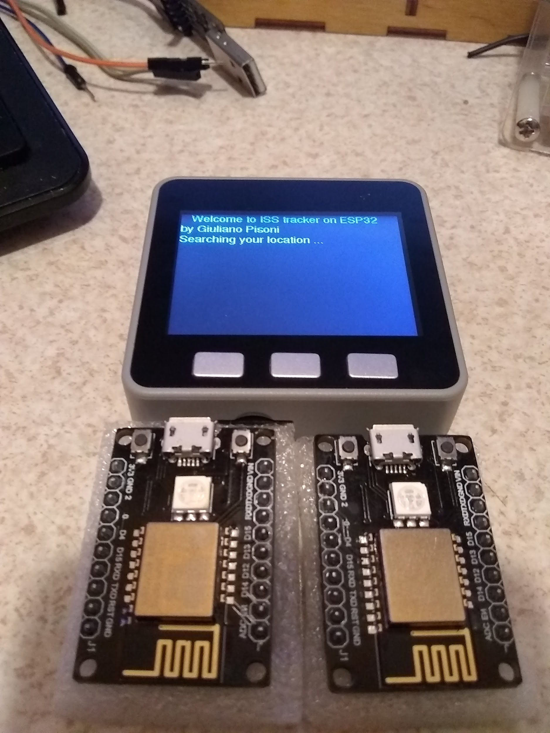

**Also Pictured above M5 Stack Core - Which is a ESP32 with many extra features, including a tft color screen, buttons, speaker, and IMU**

**Will attempt to demo a ISS Tracking program that I helped to inspire (Actually, I'll attempt to re-write the program to make it a little better)**

**Lastly - The picture below is the D1 Mini with RGB boards (7 neopixels), and we will do another ESP Mesh Demo using these boards.**

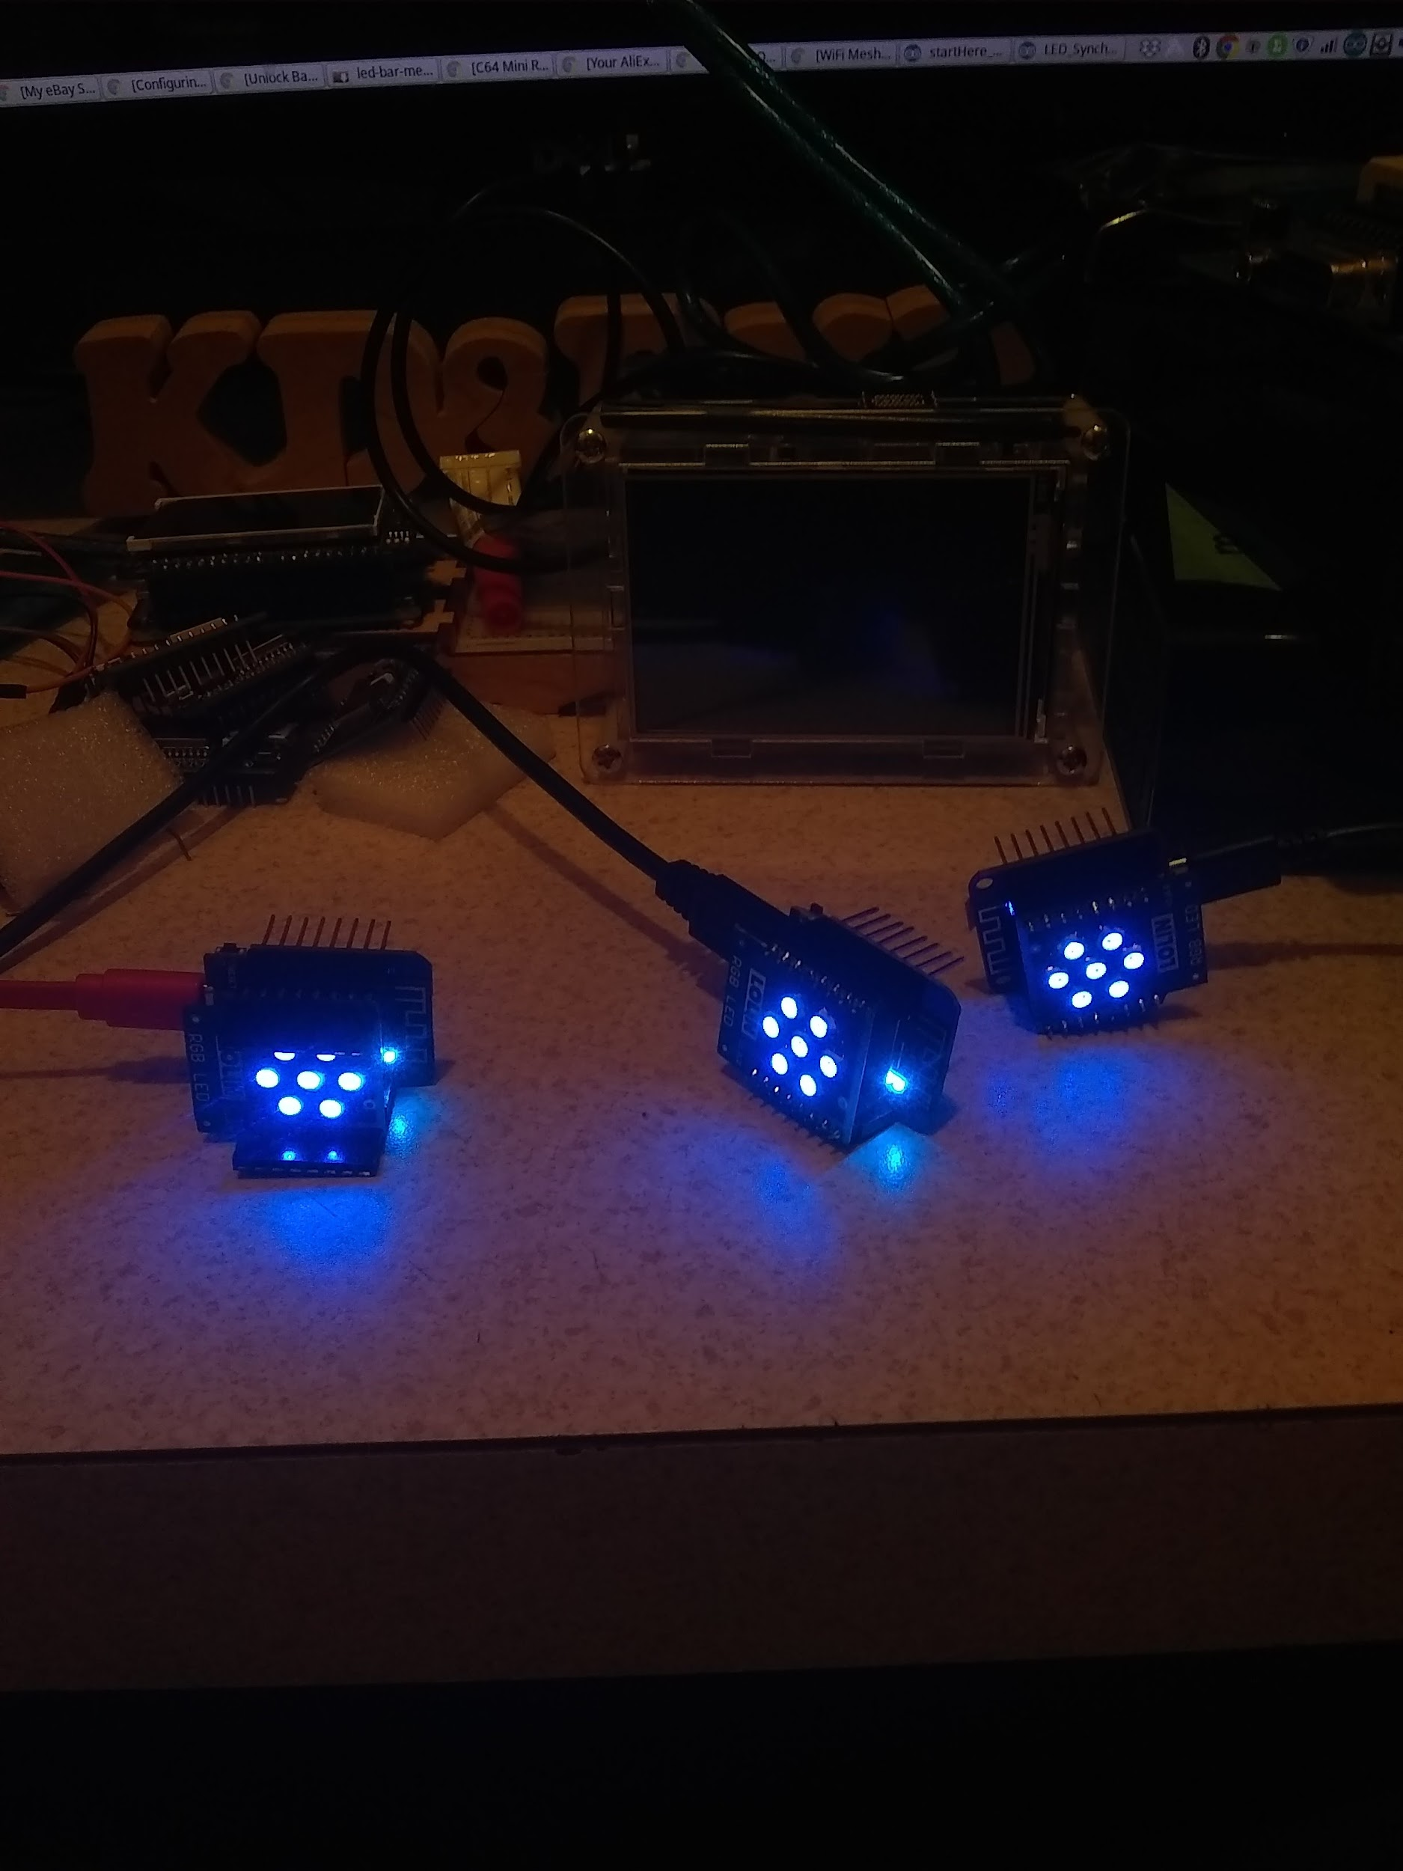 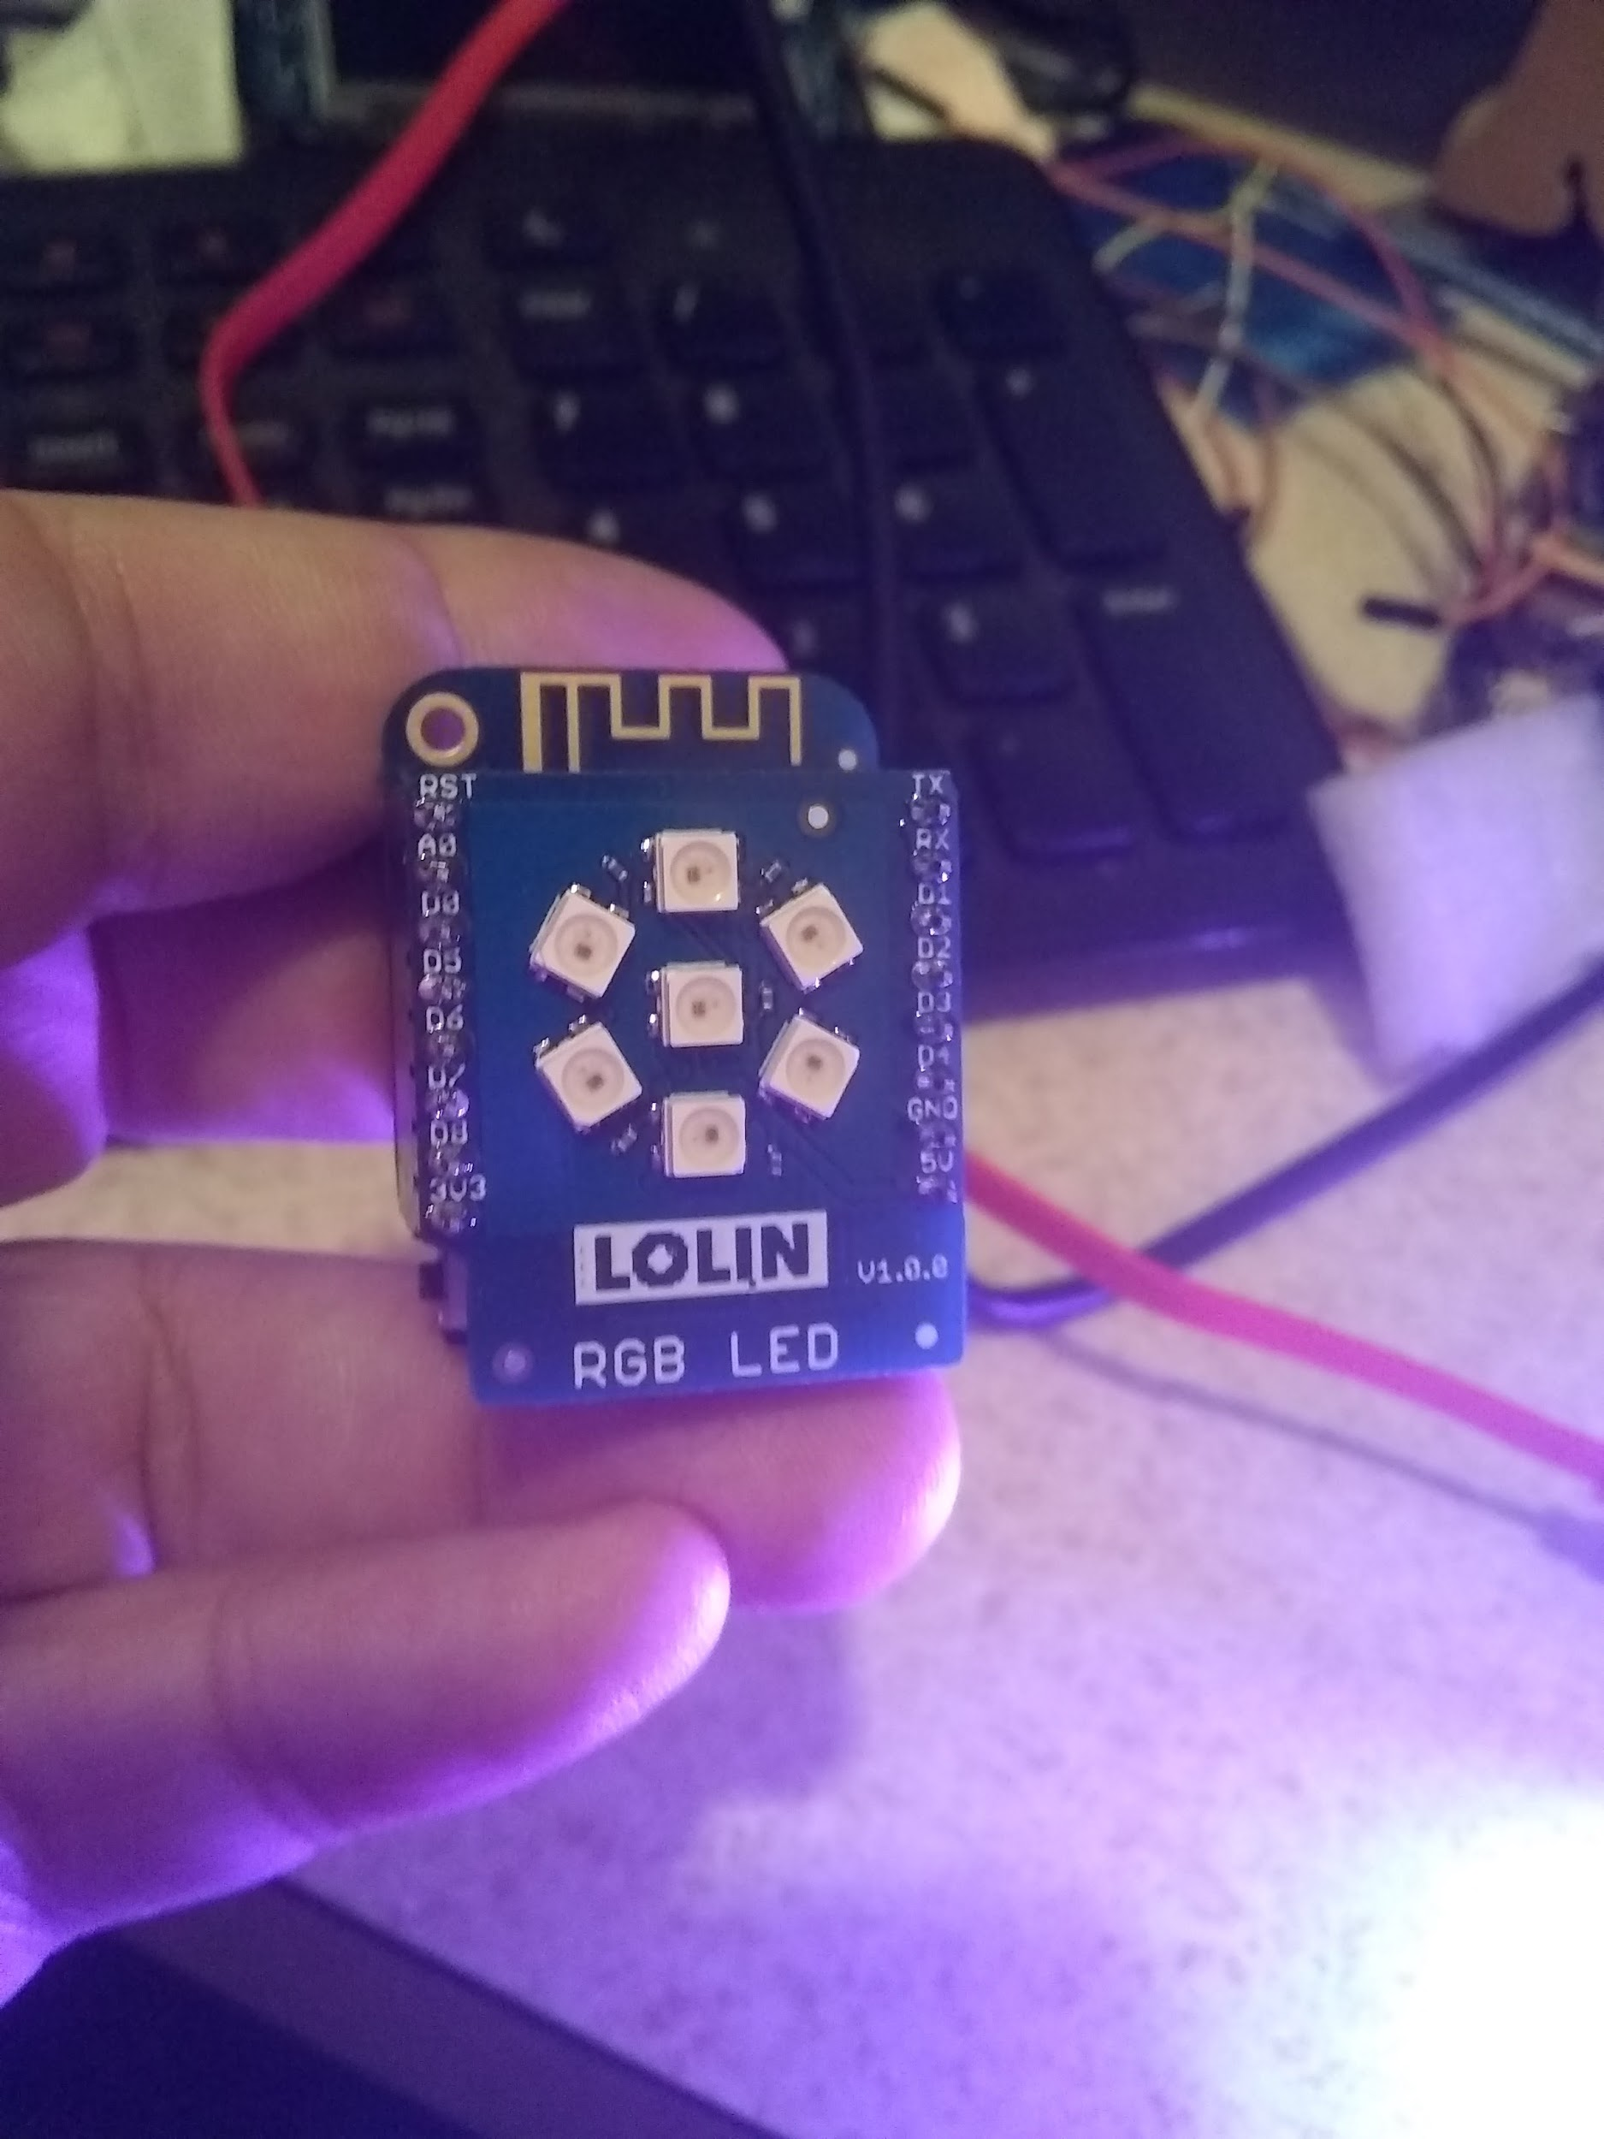

[**Ebay M5Stack Core Kit w/battery**](https://www.ebay.com/itm/M5Stack-ESP32-Mpu9250-9Axies-Motion-Sensor-Core-Development-Kit-Extensible-IoT/282918386852?hash=item41df3ffca4%3Ag%3ADLEAAOSwacVay8CL&_sacat=0&_nkw=m5stack&_from=R40&rt=nc&_trksid=p2060353.m570.l1313.TR1.TRC0.A0.H0.Xm5stack.TRS1) **$43**

**[Aliexpress Wemos (D1 Mini) Store](https://lolin.aliexpress.com/store/1331105)**

**M5Stack Core ISS Tracker Code by Giuliano Pisoni <https://github.com/ccxx72/ISS-Tracker>**

**My "Simple ISS Notification System" that helped to inspire Giuliano <https://github.com/kd8bxp/Simple-ISS-Notification-System>**

**Last Week: Aug 9 - LeRoy - Sunfounder Sloth Robot Demo**

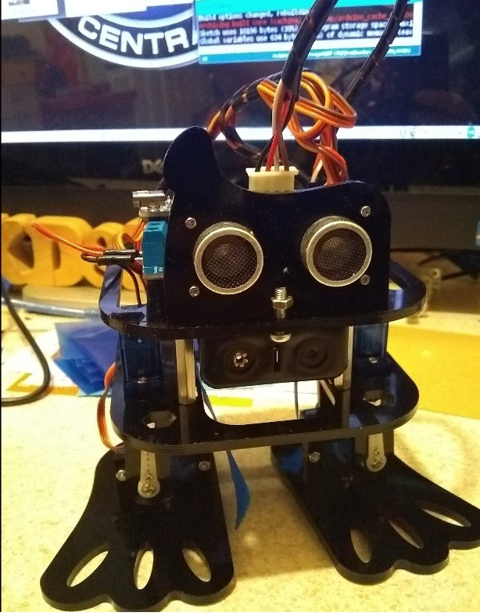

**[Google + Sunfounder Plus Article](https://plus.google.com/u/0/+LeRoyMiller/posts/SRAf2yQz5t3?cfem=1)**

**[Link to Robot Ad](https://www.aliexpress.com/item/SunFounder-DIY-4-DOF-Robot-Kit-Sloth-Learning-Kit-for-Arduino-Nano/32804633629.html?shortkey=reMfy6vA&addresstype=600)**

**Last week was a "free for all" conducted by Grand Poo Bah. The meeting included a "drive by" from Alex and a couple of distinctly low blows received by the illustrious one. The merciless beating was one of many earned by El Capitan. Poo Bah responded by threatening another visit next week. We can't stop him, cause after all, he is El Presidente!**

**P.S. Poo Bah still claims he sent the meeting announcements out! (although he was not as aggressive as he was in the meeting, due to the neck brace and all).**

**THE NEXT MEETING SHOULD BE QUITE INTERESTING AS THIS IS A SERVO PROPELLED ROBOT IS UNIQUE**

**Aug 3 - Poo Bah and YOU - Electronic Circuits - BRING YOUR SMALL CONTROL MODULES!**

**We will be looking at some standard electronic modules used around the house and in industry.**

**30A timer (12V control circuit)**

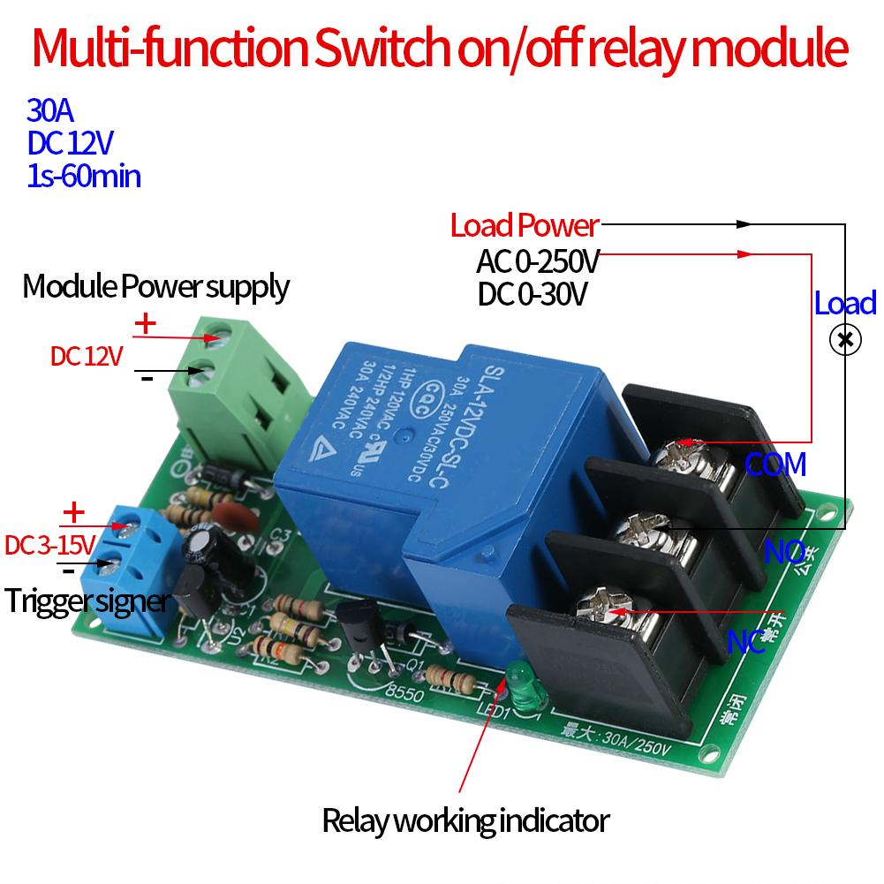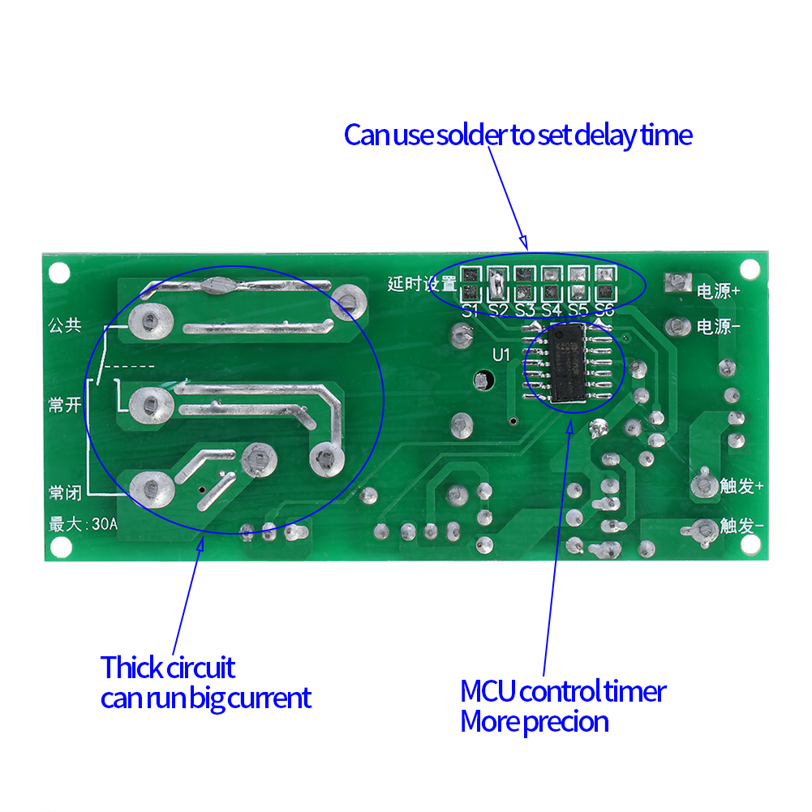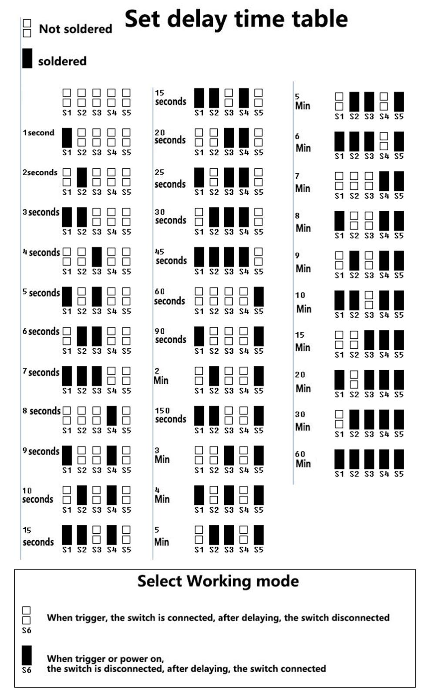

**Lamp Control Automatic Human Induction Sensor Switch Infrared PIR Body Motion**

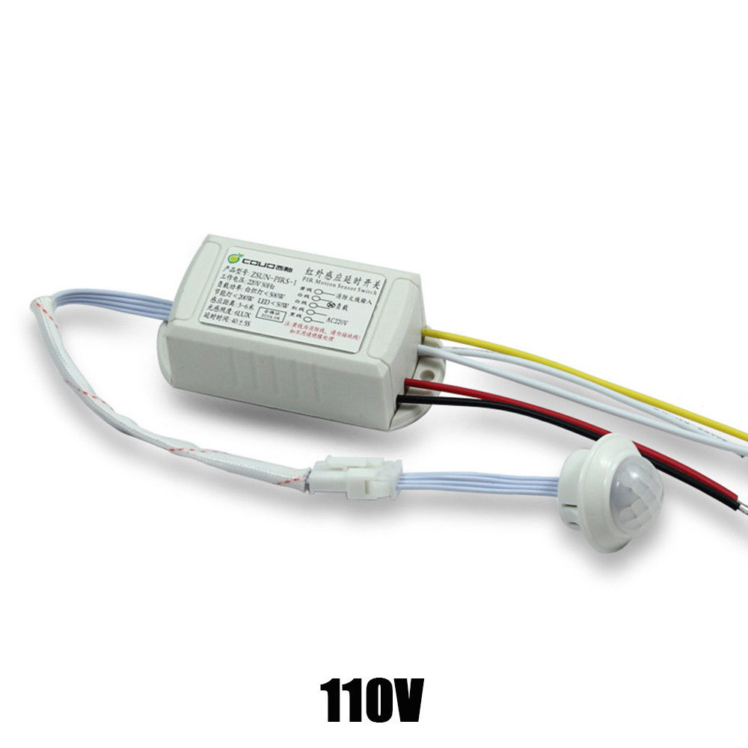

**Not: the one pictured but - appears to be similar**

**[https://www.ebay.com/itm/LED-110V-220V-100W-140-Wall-Light-Switch-Infrared-PIR-Motion-Sensor-Ultrathin/272789062234?epid=2157963884&hash=item3f837ec25a%3Ag%3AZT0AAOSw20JZgvsY&_sacat=0&_nkw=pir+110v+sensor&_from=R40&rt=nc&_trksid=m570.l1313](https://sites.google.com/site/btplciclub/goog_1011568866)**

**Electronic Ballast for LED 4 FT tube lamps (Replace your old copper ballast with electronic bassast in order to use some new LED tube lights - Read your lamp documentation).**

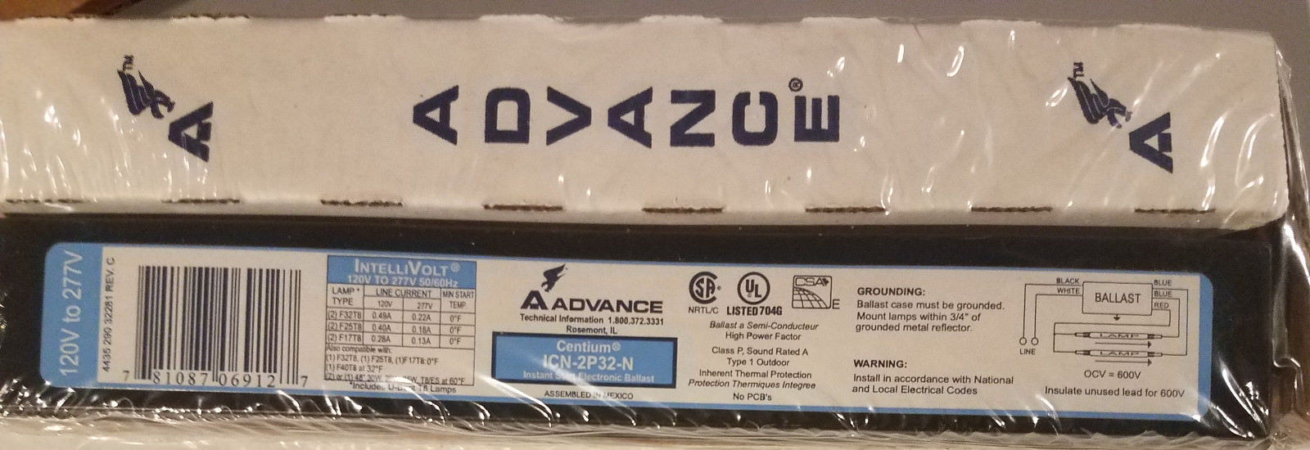

**GM8908 LCD Wind Speed Gauge Meter Anemometer NTC Thermometer**

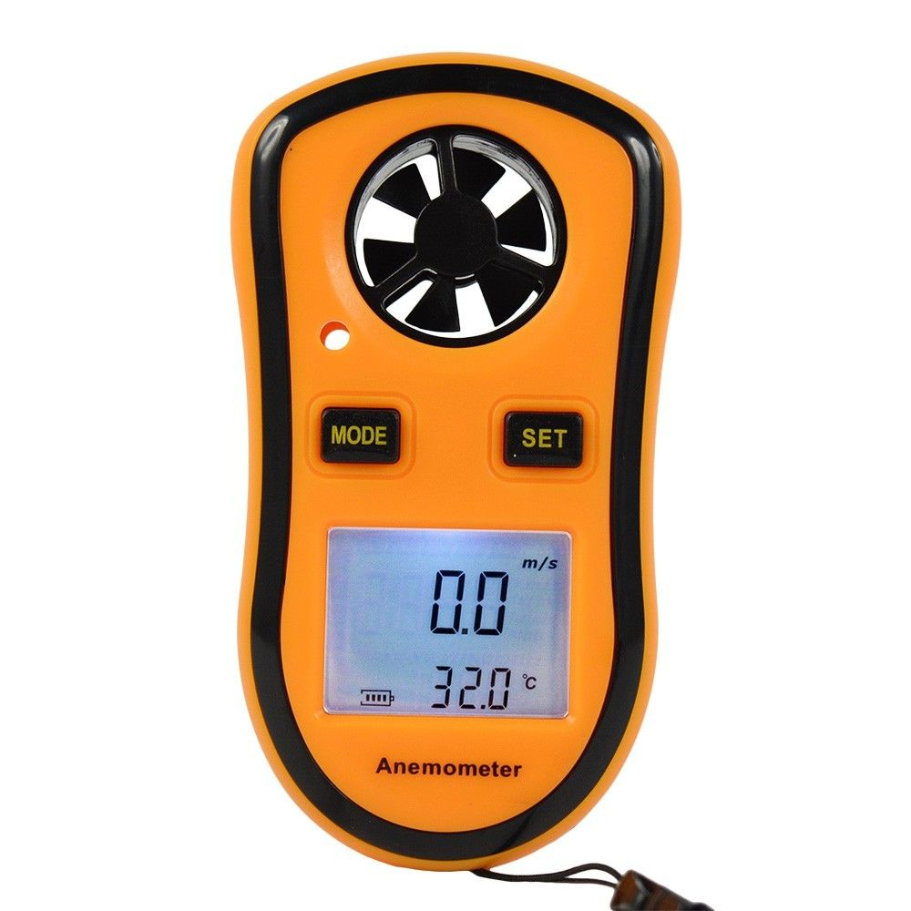

**Digital Power Saving Energy Monitor Watt Amp Volt KWh Meter Electricity Analyzer**

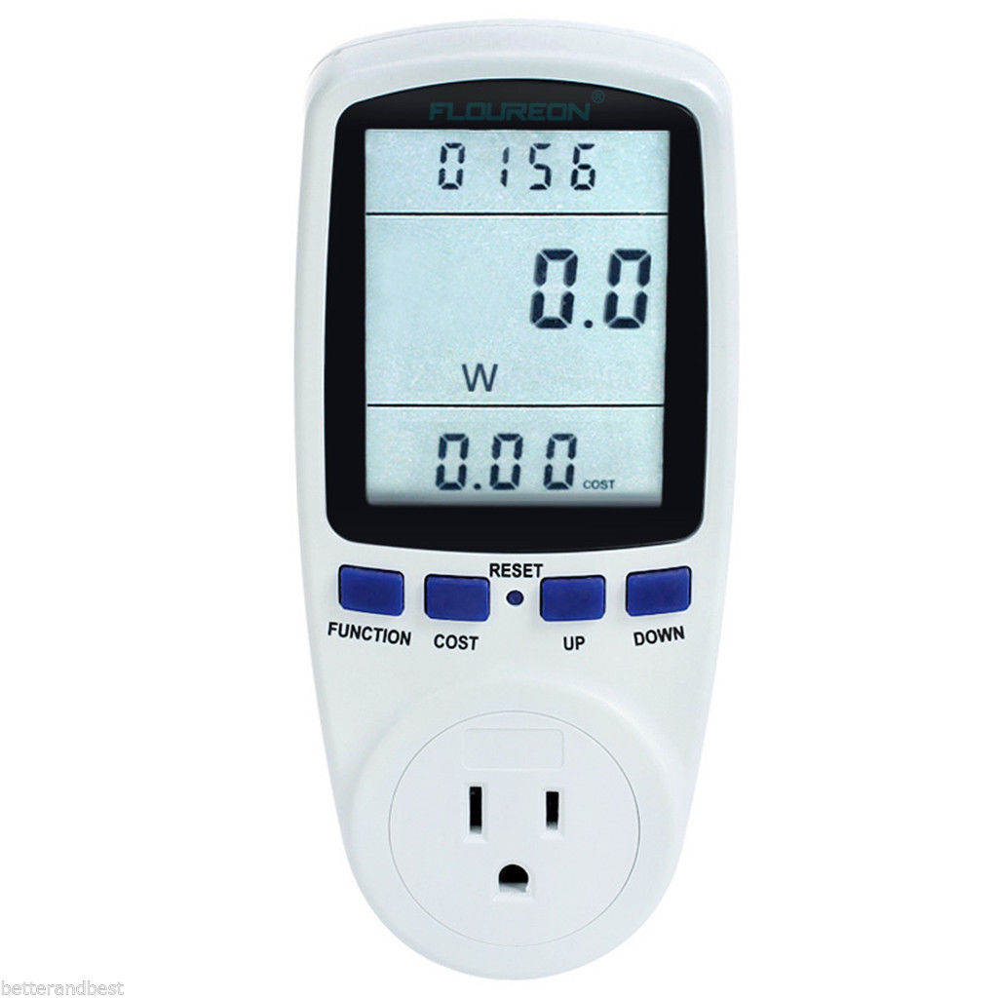

**July 26 - Steve - Arlo Wire Free Security Camera System Demo  
  
Wire Free versus Wireless - Grand Poo Bah's definition.  
  
Wireless is generally assumed to be wifi connected cameras. These cameras do not required a physical wire for communications (yes, duhhh), but you still need to connect a power supply cable to the wireless unit. So, there IS a wire.  
  
Wire Free cameras have no wires, not even a power cord. How do they do it! With very long lasting circuitry that does not eat up the battery. One way to do this is to send a picture only when the PIR system detects an object. PIR is far superior to using video motion detection (which triggers on shadows etc).   
  
  
  
  
Great features found in Grand Po Bah's $25 security camera (wireless):  
 Notification of an object triggering camera via your cell phone.  
 Continuous viewing of the camera with free Windows app like ISPY  
 720HD picture quality kinda  
 Requires 5V power adapter  
 Cheap  
 PTZ (not so much Z)  
 Reasonable indoor room monitor/alarm (includes built in siren)  
 monitor with smart phone (notification of alert or view single camera).  
   
Additional Features of Arlo Cameras:  
 Totally wireless operation for extended periods without battery charge (> 1 month, months for moderate activity).  
 REAL motion detection (no false triggering on shadows)  
  
Drawbacks:  
 Wire Free cannot monitor the camera continuously (battery will go dead). You can monitor "on demand".  
 (for many security applications this is quite acceptable)  
  
 Wireless - Outside motion detection false triggers entirely too much for security purposed.**

**July 19 - LeRoy - Wifi, Lora, 433mhz, 915mhz, 2.4Ghz Mesh Network Demos**

**Code for the demo can be found: <https://github.com/automation-technology-club/Wireless-Demo-July-19-2018>**

**In this demo we will be doing some limited range testing inside the library - a lot of the library is open, but there are also a lot of metal shelves, books and other objects. It should be a good test.**

**For the most part all we are doing is going to be blinking an LED, someone will go out in the library hit the button on the transmitter, and if a LED lights up, we will be able to relay the information back.**

**The LoRa demo is a little different as we will be sending the temperature.**

**There are 5 different "modes" - LoRa 915Mhz (RFM9x/SX127x multi-mode, we are using LoRa), ESP8266 WiFi Mesh (2.4Ghz), nRF24L01 (FSK 2.4Ghz), FS1000A (ASK 433Mhz), and finally a Moteino board with a RFM12B chip (915Mhz, multi-mode we are using FSK)**

**The RFM12B is now retired and have been replaced by the RFM69 - I have had these Moteino boards and have never used them and thought now would be a good time.**

**Some resources:**

**RFM12B <https://www.sparkfun.com/products/retired/12031>**

**nRF24L01 <http://www.lydiard.plus.com/nrf24l01_1.htm>**

**Moteino Leo (Boards I have) - <https://lowpowerlab.com/2013/04/24/moteino-leo-atmega32u4-based-moteino/>**

**ESP8266 Mesh Networking (painlessMesh) - <https://github.com/gmag11/painlessMesh>**

**LoRa - There is a lot of information about LoRa - but don't confuse it with LoRaWAN they really are two very different things.**

**Some General Information can be found here:<https://www.seeedstudio.com/RFM95-Ultra-long-Range-Transceiver-Module%2FLoRa-Module%2Fsupport-868M-frequency-p-2807.html>**

**FS1000A - There is also a lot of information about these - here is the library I used - <https://github.com/madsci1016/Arduino-EasyTransfer>**

**Some more information, they are now using RadioHead Library but otherwise the information is good: <https://microcontrollerelectronics.com/fs1000a-wireless-rf433-transmit-and-receive-module-pair/>**

**July 12 - Grand Poo Bah - 30A Off Delay Timer, Home Security Cameras**

**30 A Off Delay Timer - Air Compressors, Soldering Irons, Bath Room Fan..... 1/2 hp @ 240V**

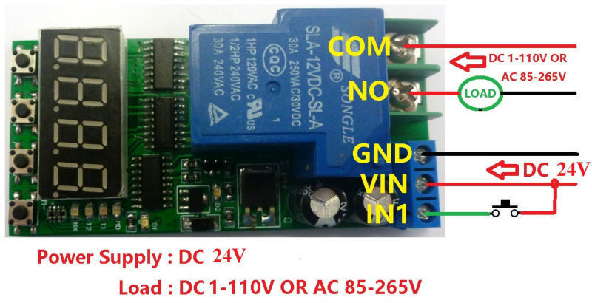

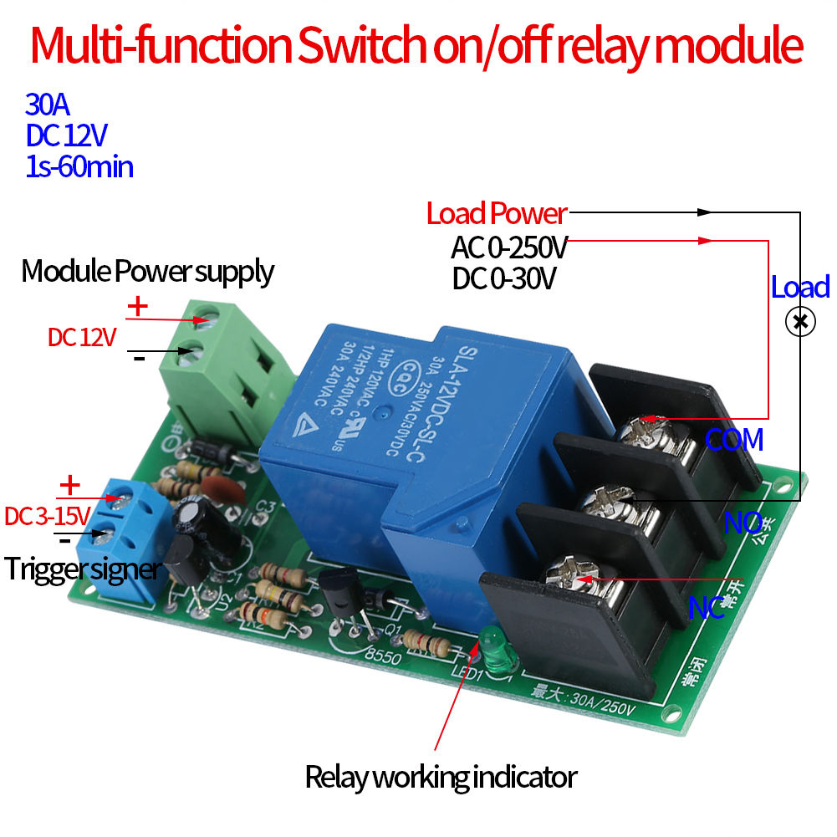

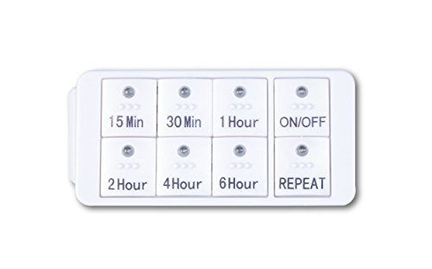

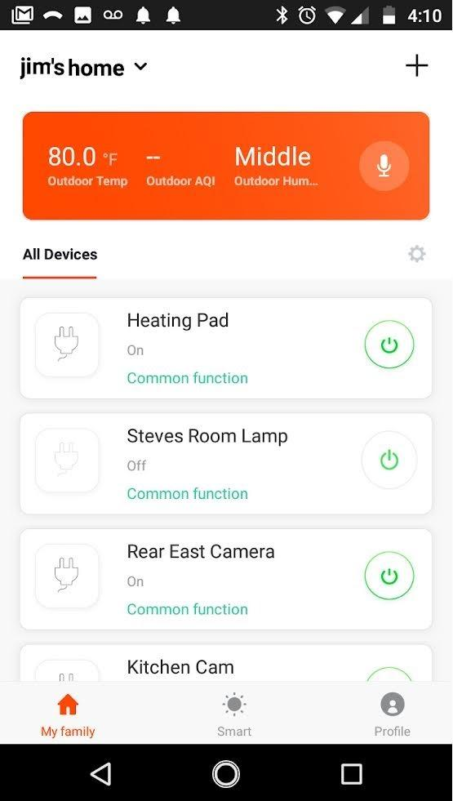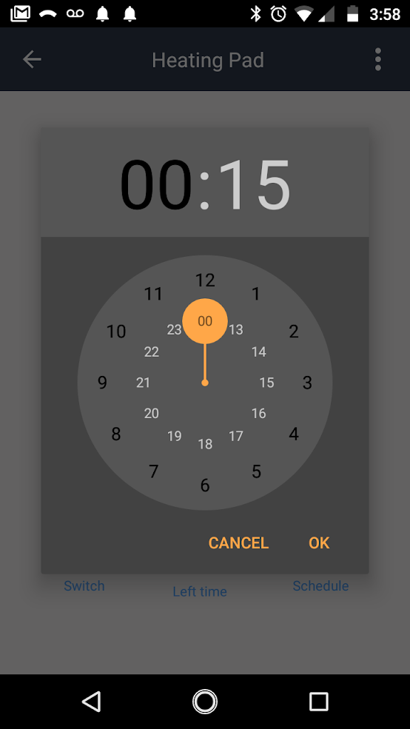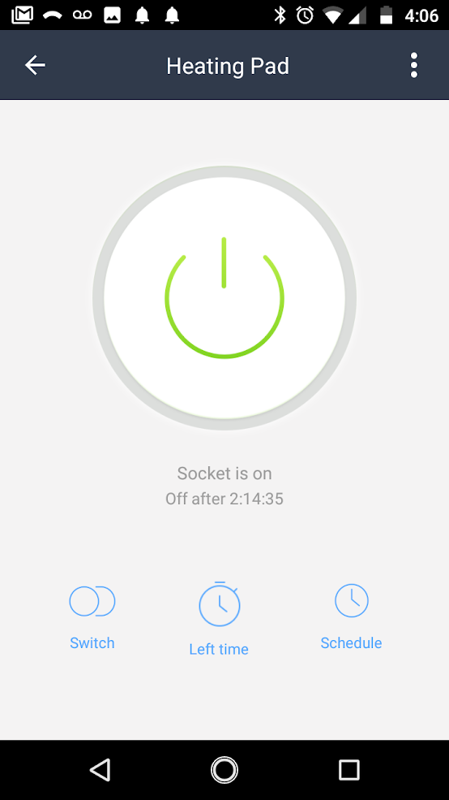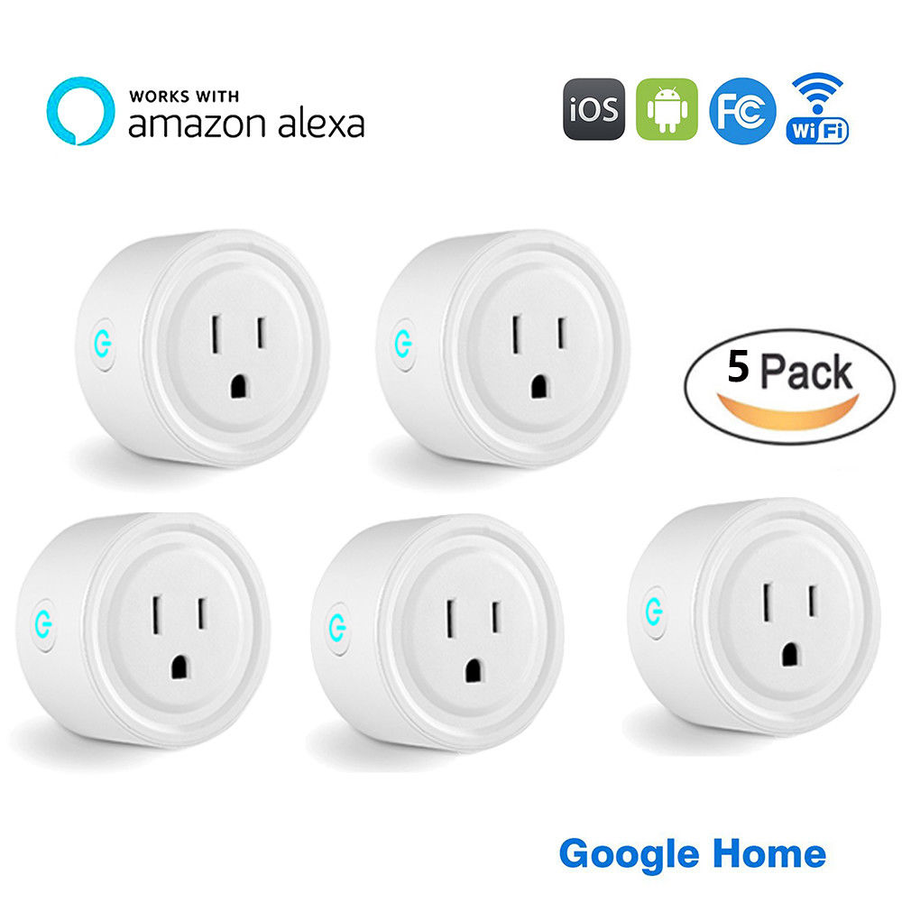

**5 PCS Switch Power Socket Voice Control (Ebay) $38.45**

**US Plug WiFi Smart Phone Remote Control**

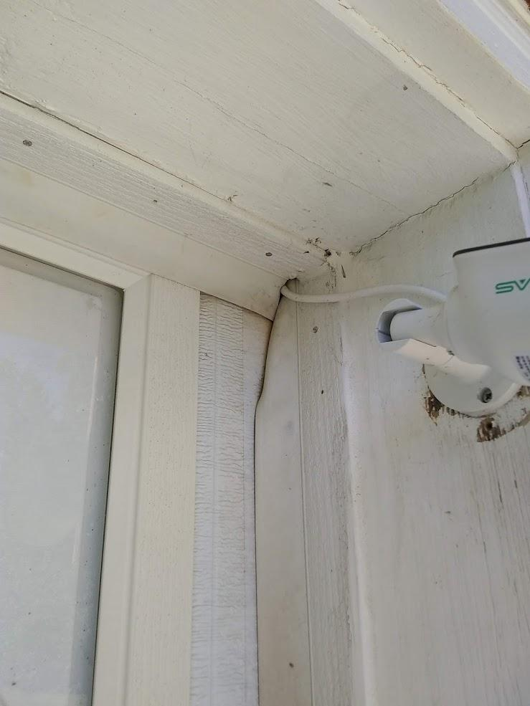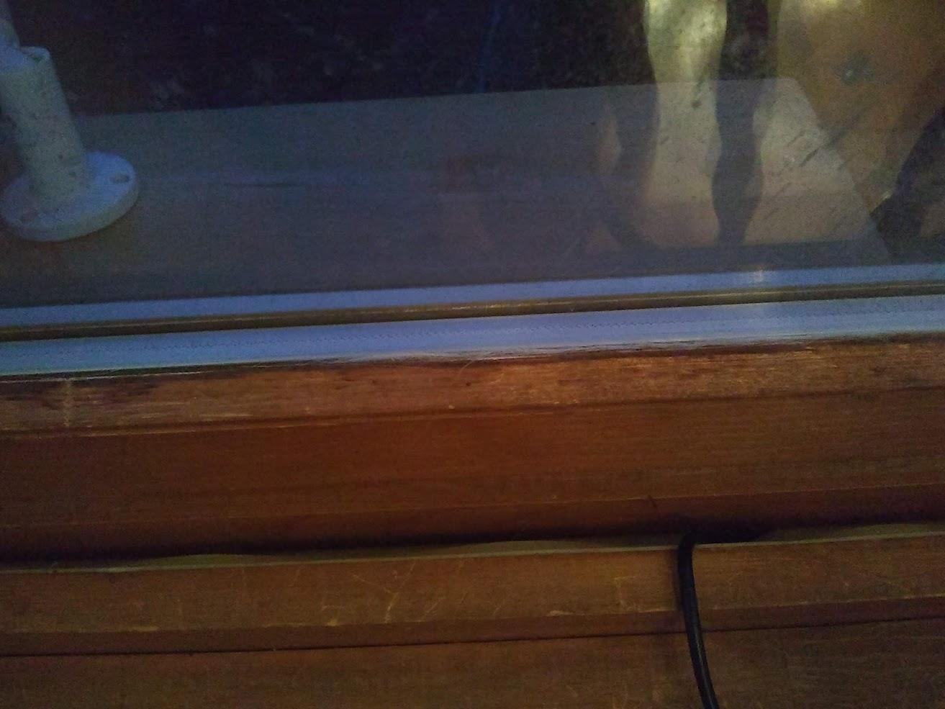

**July 5 - LeRoy - Microprocessor Clock FireBeetle ESP32 LED Matrix - SUPER CLOCK!!!**

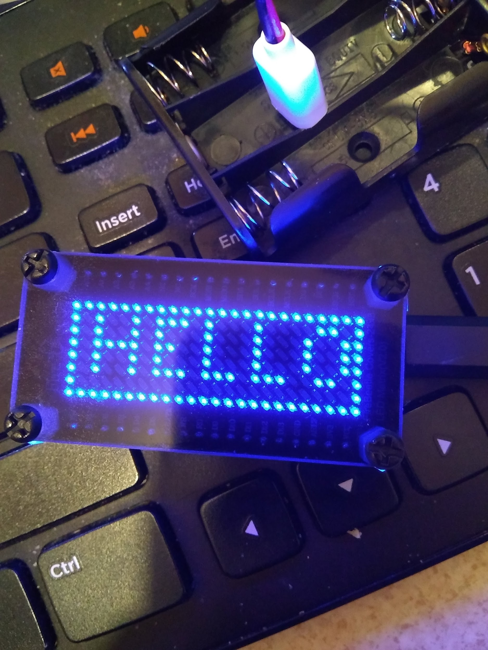 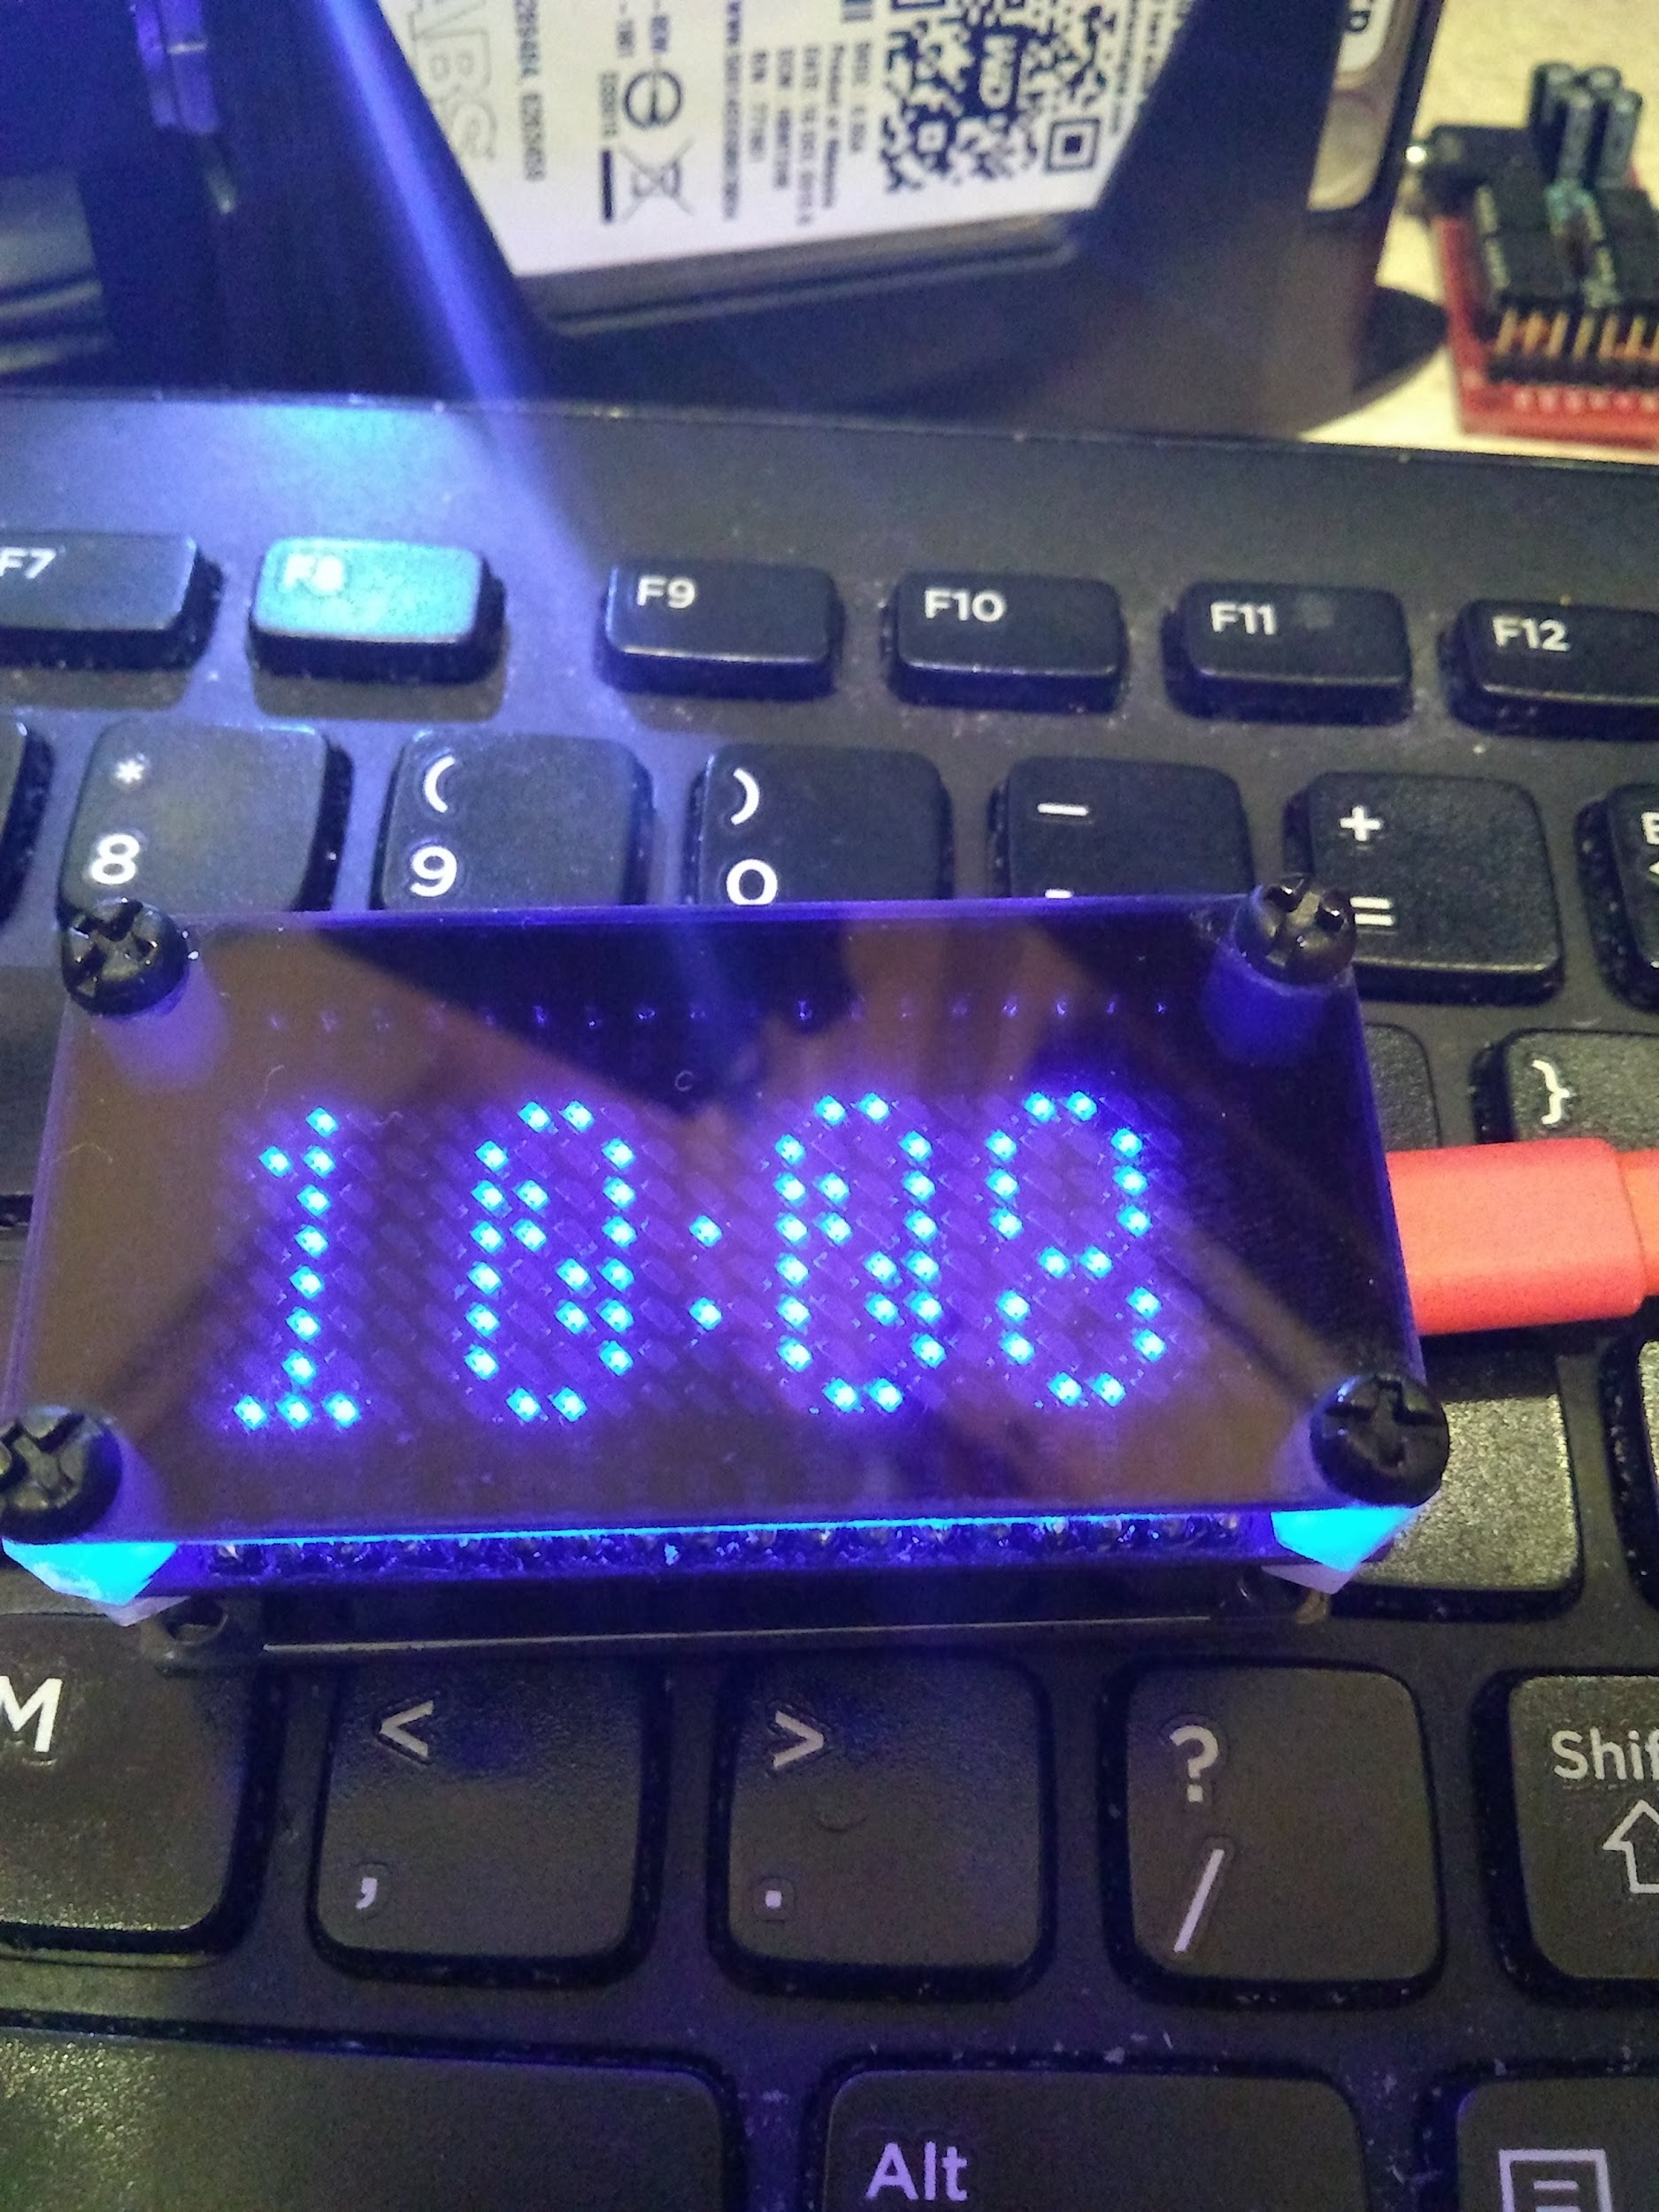 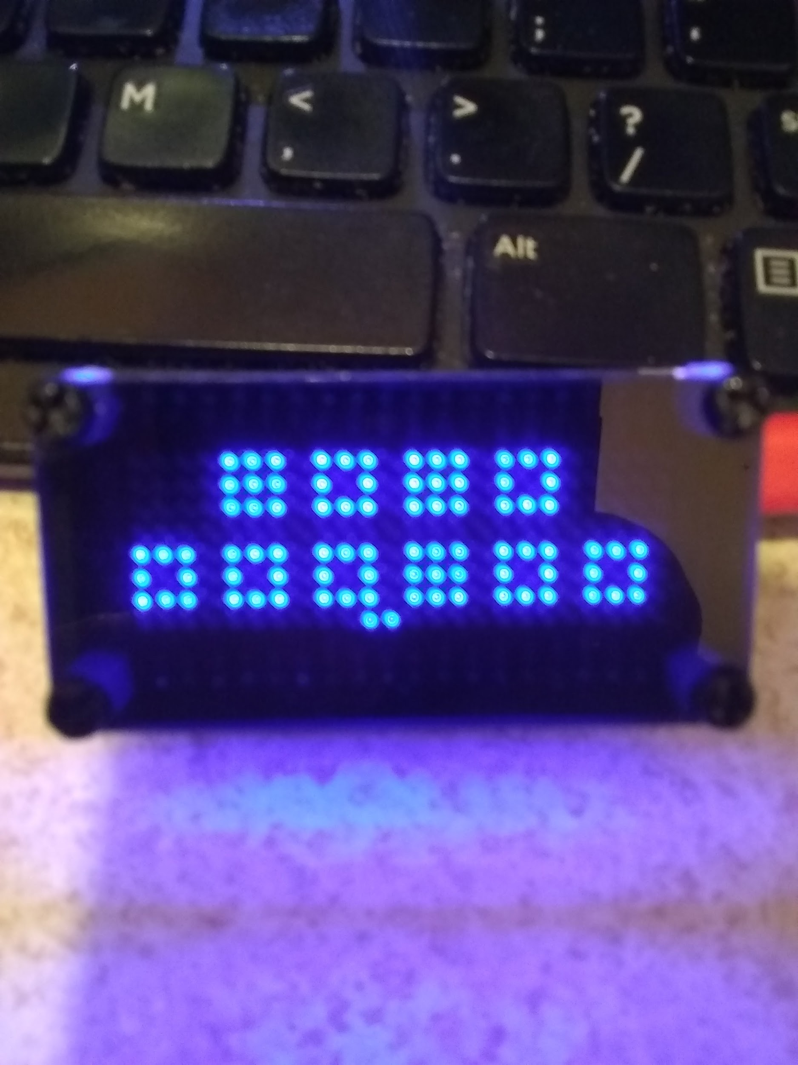

**Instructable is coming soon, but in the mean time.**

**GitHub Repository: https://github.com/kd8bxp/Super-Clock**

**Video Super Clock: https://youtu.be/zZdG5E9jIMU**

**Video Binary Mode Addition: https://youtu.be/0pFlYeIMbz0**

**Links and more info in the description of the videos. Enjoy.....**

**June 28 - LeRoy - VHF/UHF Ham Radio Repeater for ~$60 - Raspberry Pi**

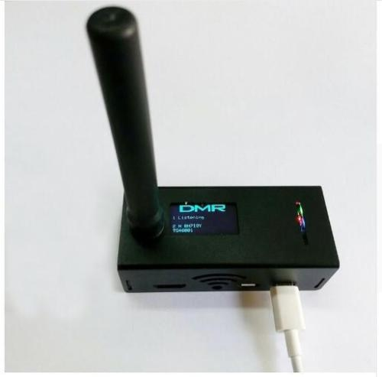 [**More Pictures Link**](https://photos.app.goo.gl/gGKxizMU6P3HS7YC9)**,**  [**eBay Listing $45 w/o Raspberry PI**](https://www.ebay.com/itm/MMDVM-Hotspot-Support-P25-DMR-YSF-for-Raspberry-pi-Antenna-Case-OLED/292564382205?hash=item441e3231fd:g:rYYAAOSwmYta-l99) **or** [**eBay Listing $50 w/o Raspberry Pi**](https://www.ebay.com/itm/2018-Antenna-Case-OLED-MMDVM-Hotspot-Support-P25-DMR-YSF-for-Raspberry-pi/183098690667?_trkparms=aid%3D555018%26algo%3DPL.SIM%26ao%3D2%26asc%3D52910%26meid%3D5dbd5423c1c5445397c84d951f423a99%26pid%3D100005%26rk%3D1%26rkt%3D12%26sd%3D292564382205%26itm%3D183098690667&_trksid=p2047675.c100005.m1851) **There are many listed on eBay under "MMDVM"**

**or DMR hotspot, or Jumbo Spot, and they can be found for less if you don't want the case, (about $40 or less).** [**eBay Listing Complete Kit w/Raspberry PI $100.00**](https://www.ebay.com/itm/Assembled-MMDVM-hotspot-Support-P25-DMR-YSF-Raspberry-pi-OLED-Antenna-Case-/122878428117?_trksid=p2349526.m4383.l4275.c10#viTabs_0)**, you can find these kits on** [**Aliexpress**](https://www.aliexpress.com/item/UHF-VHF-MMDVM-Hotspot-OLED-Antenna-Shell-Case-Kit-P25-DMR-YSF-For-Raspberry-Pi/32889286180.html?ws_ab_test=searchweb0_0,searchweb201602_5_10152_10151_10065_10344_10068_10130_5722815_10324_10342_10547_10325_10343_10546_10340_5722915_10548_10341_10545_5722615_10696_10084_10083_10618_10307_5722715_10059_306_100031_10103_10624_10623_10622_5722515_10621_10620,searchweb201603_1,ppcSwitch_5&algo_expid=87018c63-c411-418d-a366-8c0cb234e7a7-3&algo_pvid=87018c63-c411-418d-a366-8c0cb234e7a7&transAbTest=ae803_1&priceBeautifyAB=0) **for about the same prices**

**between $39 and $100. On** [**Amazon**](https://www.amazon.com/s/ref=sr_pg_2?rh=n%3A172282%2Ck%3Ammdvm&page=2&keywords=mmdvm&ie=UTF8&qid=1530075271) **they appear to be more complete kits but between $100 and $170. The above kit is half duplex, there is a full duplex kit that I've seen on eBay for around $60 - $75 with out the Raspberry PI.**

**The software they use is called PiStar, and can be downloaded** [**here**](https://www.pistar.uk/downloads/)**. There is a lot of good setup instructions and information about the software on the** [**site**](https://www.pistar.uk/index.php)**. PiStar can also be used with the NanoPi, Odroid, OrangePi SBCs.**

**W1MSG has a lot of** [**videos on how to setup your radio,**](https://www.youtube.com/channel/UCcjYjtognBaSAa-ZLk3EU2A) **and the software for the hotspot. He is using a ZumSpot which is just another version of the MMDVM Hotspot, there are dozens of different versions.**

**The hotspot works with DStar, DMR, and System Fusion, NXDN and P25 - I'll try to cover DStar and DMR since those are the radios I own. All these modes are digital voice, some can do data (both low speed and high speed).**

**1st covering a little history, then a little setup, then hopefully we'll get to see it work.**

**June 21 - Marcus - Club Review of My IoT Smart Home Design**

**We will be reviewing my IoT Smart Home Design which encompass all major components and services required for a full-stack IoT system - from the "things" to the cloud services.**

**Even though we will not do any deep dives into specific hardware, software or communication protocols. We will, however discuss many hardware devices like: ESP8266, Sonoff AC power switch, Raspberry PI, Wise LoRa Whisper, Radius Dot Beacon. And use light, motion, reed contact, humidity and temperature sensors. Also, the design utilizes the following protocols: Wifi, RS-232, MQTT, LoRa, ESP-Now, and Bluetooth Low-Energy (BLE). Furthermore, the design will leverage Microsoft's Azure IoT Hub and utilize Microsoft's Unified Windows Platform (UWP) to create the systems dashboards.**

**June 7 - Frank**

**MP3 Sound Control Over Internet using I2C and Wemos D1 mini**

**3D Printer Demo - Prusa i3 MK3**

5/31/2018 :

**3D Printer Demo - Prusa i3 MK3** [Steve's 3d Printer](https://shop.prusa3d.com/en/3d-printers/180-original-prusa-i3-mk3-kit.html?gclid=Cj0KCQjw5qrXBRC3ARIsAJq3bwrNT4b8vDofKkZs4XxUm_DJSlW8x31Q7bhczpCZfE0FDmyIdjf50wsaAhPGEALw_wcB)

The Original Prusa I3 MK3 is the successor of the award-winning Original Prusa i3 MK2/S 3D printer. Our previous model is the winner of the **3D Printer Shootout 2017 and** **2018** in prestigious [MAKE: Magazine](https://makezine.com/comparison/3dprinters/) and for more than a year, it's the best desktop 3D printer according to [3Dhubs.com Trends](https://www.3dhubs.com/trends/). MK2S is also **The Best 3D Printer for 2018** in "Workhorse" category on [3DHubs.com Guide](https://www.3dhubs.com/best-3d-printer-guide#workhorse) with score 9.3 (the highest rated printer overall).

**Overview of UN Larger Systems and Uses**

Our Guest (From England does work on larger United Nations systems used for international emergencies etc. He will give us an overview of these large systems and discuss database methods including data acquisition and storage. This is your chance to ask questions to a highly skilled person.

5/24/2018 :

**Arduino Create with Raspberry Pi**

# **You can now use Arduino to program Linux IoT devices**

ARDUINO TEAM — March 13th, 2018

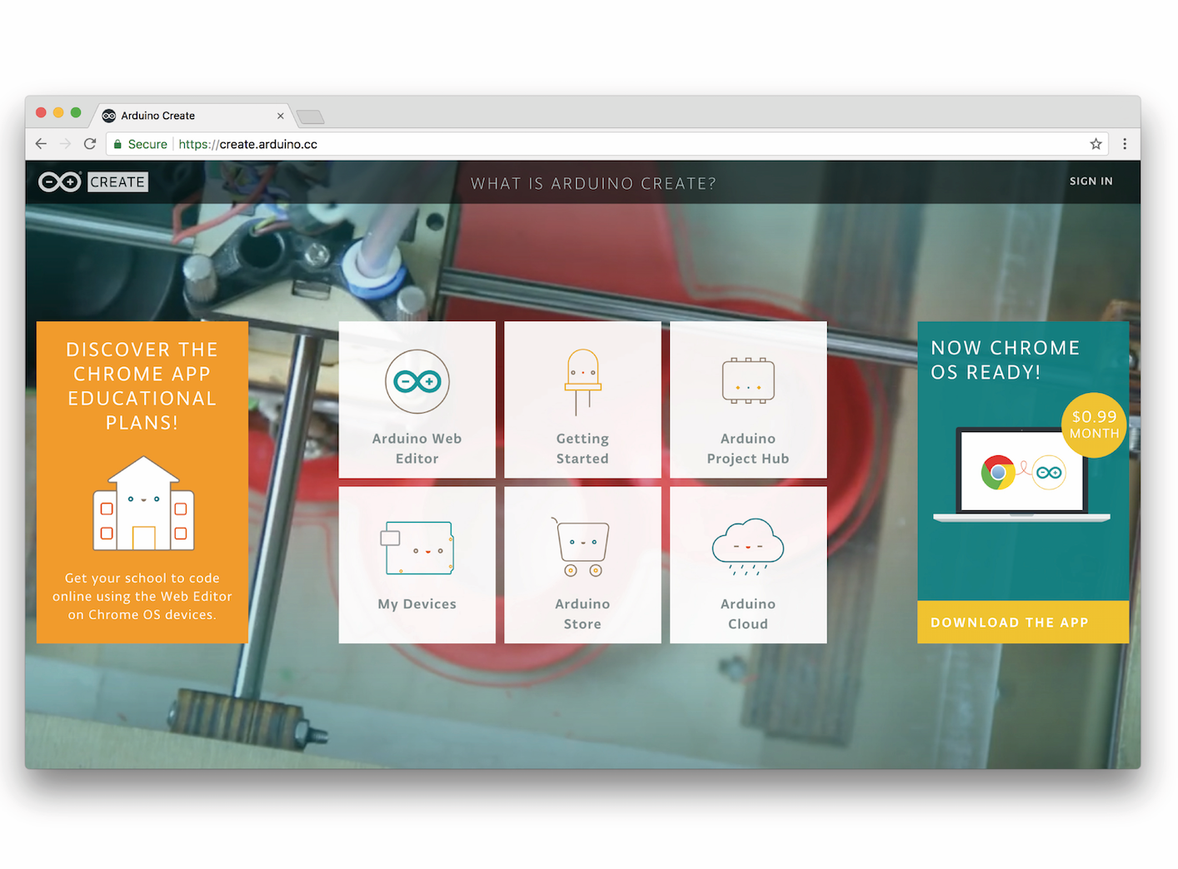

Today, at [Embedded Linux Conference 2018](https://events.linuxfoundation.org/events/elc-openiot-north-america-2018/), Arduino announced the expansion of the number of architectures supported by its [Arduino Create](https://create.arduino.cc/) platform for the development of IoT applications. With this new release, Arduino Create users can [manage and program](https://create.arduino.cc/getting-started) a wide range of popular Linux*®* single-board computers like the AAEON® UP² board, Raspberry Pi*®*and BeagleBone*®* as if they were regular Arduino boards. Multiple Arduino programs can run simultaneously on a Linux-based board and interact and communicate with each other, leveraging the capabilities provided by the new Arduino Connector. Moreover, IoT devices can be managed and updated remotely, independently from where they are located.

To further simplify the user journey, Arduino has also developed a novel out-of-the-box experience for Raspberry Pi and BeagleBone boards, in addition to Intel*®*SBCs, which enables anyone to set up a new device from scratch via the cloud without any previous knowledge by following an intuitive web-based wizard. Arduino plans to continue enriching and expanding the set of features of Arduino Create in the coming months.

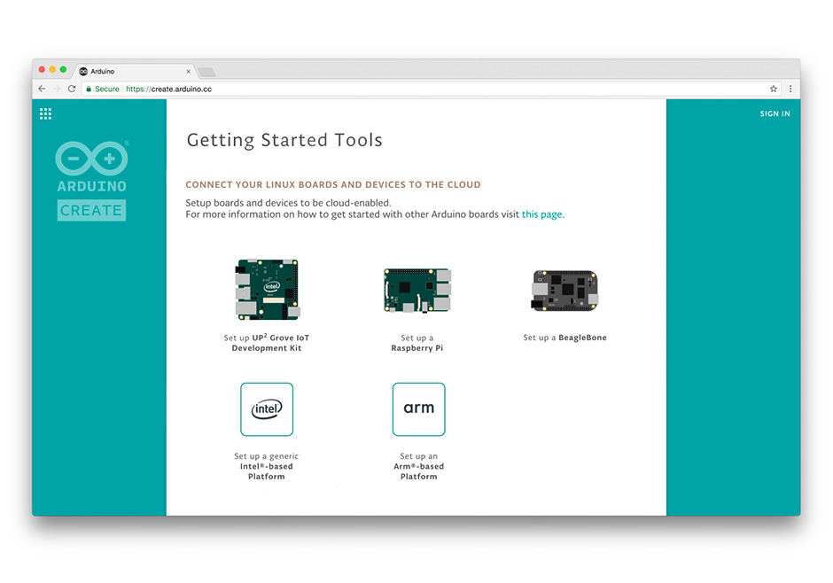

*“With this release, Arduino extends its reach into edge computing, enabling anybody with Arduino programming experience to manage and develop complex multi-architecture IoT applications on gateways*,” said Massimo Banzi, Arduino CTO. *“This is an important step forward in democratizing access to the professional Internet of Things.”*

*“At Arduino we want to empower anyone to be an active player in the digital world. Being able to run Arduino code and manage connected Linux devices is an important step in this direction, especially for IoT applications that need more computing power, like AI and computer vision*,” added Fabio Violante, Arduino CEO.

5/10/2018 :

**Marcus -** ESP-Now

For a deep dive into the ESP-NOW protocol check-out the following link:

<http://esp-idf.readthedocs.io/en/latest/api-reference/wifi/esp_now.html#overview>

ESP-NOW provides a way to allow a low power controller to directly control multiple smart lights without having to connect to the router; this method is power efficient and convenient.

ESP-Now is another protocol developed by Espressif, which enables multiple devices to communicate without using Wi-Fi. The protocol is similar to the low power 2.4GHz wireless connectivity that is often deployed in wireless mice. So, the pairing between devices is needed prior to the communication. After the pairing is done, the connection is persistent, peer-to-peer, and no handshake is required.

5/3/2018 :

**Video Demo of SJRC S70W [Grand Poo Bah in Action](https://drive.google.com/file/d/1k-8eGrwH129XiRB0OxCEOf4Q4QilGs4M/view?usp=sharing)**

[Club Demonstration Document (Jim's Folder)](https://docs.google.com/document/d/1QMtgmLRJgRU_PwoVNMZjURgIFLSzSbwVkKxnJ_jY5mY/edit?usp=sharing)

[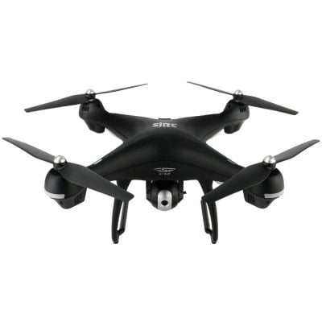](https://docs.google.com/document/d/1QMtgmLRJgRU_PwoVNMZjURgIFLSzSbwVkKxnJ_jY5mY/edit?usp=sharing)

**First-person view** (**FPV**), also known as **remote-person view** (**RPV**), or simply **video piloting**, is a method used to control a [radio-controlled vehicle](https://en.wikipedia.org/wiki/Radio-controlled_vehicle) from the driver or pilot's view point. Most commonly it is used to pilot a [radio-controlled aircraft](https://en.wikipedia.org/wiki/Radio-controlled_aircraft) or other type of [unmanned aerial vehicle](https://en.wikipedia.org/wiki/Unmanned_aerial_vehicle) (UAV). The vehicle is either driven or piloted remotely from a first-person perspective via an onboard camera, fed wirelessly to video FPV goggles[[1]](https://en.wikipedia.org/wiki/First-person_view_(radio_control)#cite_note-FPV_Goggles_For_Drones_And_Experience_The_Thrill_Of_Flying-1)[[2]](https://en.wikipedia.org/wiki/First-person_view_(radio_control)#cite_note-Best_FPV_Goggles-2) or a video monitor. More sophisticated setups include a pan-and-tilt [gimbaled](https://en.wikipedia.org/wiki/Gimbal) camera controlled by a [gyroscope](https://en.wikipedia.org/wiki/Gyroscope) sensor in the pilot's goggles and with dual onboard cameras, enabling a true [stereoscopic](https://en.wikipedia.org/wiki/Stereoscopy) view.

[SJRC S70W GPS Quadcopter Can’t Connect to Android Phone Via WiFi - Problem](https://docs.google.com/document/d/1uLKQOZVKobUVkJCNmiwmtWyuCVU6DovkCb20dFu5ZcA/edit?usp=sharing)

Description:

SJRC S70W is equipped with an advanced GPS system to locate the drone. Now you never worry about the drone flying away. The built-in high definition camera helps you take quality aerial footage. In the " follow me " mode, this drone will stay above you automatically, keeping the camera centered on you at all times and capturing your every move. With a newly created intelligent battery, you will get up to 15 minutes flight time, giving you a more extensive flight experience. The other functions such as headless mode, one key takeoff / landing, auto return ensure that even a new player can fly it successfully.

Main Features

● FPV transmission and optimized HD adjustable wide-angle camera for filming a designated spot or simply looking around

● Advanced GPS positioning system for precise positioning and safe auto return while in low voltage

● Smart return to home ( RTH ) function helps you recall the drone back easily in GPS mode

● Follow me mode ensures your drone captures you with high precision wherever you go ( within 30m )

● Altitude hold function increases flight stability to shoot clear photos

● Headless mode

● One key takeoff / landing and emergency stop

● Longer control distance and flying time

● APP download: scan the QR code on the manual

Brand: SJRC

Type: Brushed Racing Quadcopter

Model: S70W

Features: Brushed Version,Camera,WiFi APP Control,WiFi FPV

Functions: Aerial Photography,Automatic Return,Camera,Emergency Landing,Forward/backward,FPV,Headless Mode,Height Holding,Low-voltage Protection,One Key Automatic Return,One Key Follow,One Key Landing,One Key Taking Off,Turn left/right,Up/down,WiFi Connection

Size: Large

Sensor: Barometer,Gyroscope

Material: ABS/PS,Metal

Level: Beginner Level

Remote Control: 2.4GHz Wireless Remote Control,WiFi Remote Control

Channel: 4-Channels

Radio Mode: Mode 2 (Left-hand Throttle),WiFi APP

Detailed Control Distance: About 400m

Compatible with Additional Gimbal: No

FPV Distance: 100 - 150m

Transmitter Power: Built-in rechargeable battery

Battery: 7.4V 2500mAh LiPo

Flying Time: 12-15mins

Charging Time.: 300mins

Product weight: 0.6770 kg

Package weight: 2.0000 kg

Product size (L x W x H): 42.00 x 42.00 x 17.00 cm / 16.54 x 16.54 x 6.69 inches

Package size (L x W x H): 54.00 x 34.40 x 20.00 cm / 21.26 x 13.54 x 7.87 inches

Package Contents: 1 x RC Drone ( Battery Included ), 1 x Transmitter ( Battery Included ), 1 x USB Cable, 1 x English Manual, 4 x Propeller, 2 x Propeller Guard, 2 x Landing Gear, 4 x Screw for Propeller, 1 x Screwdriver

4/19/2018 :

**Using I2C to Control an SPI Device**

* Hint it's done with a 2nd controller

4/5/2018 :

Open Topic Meeting

LeRoy - Zumo and a Pixy CMUcam5 [Link](https://learn.adafruit.com/pixy-pet-robot-color-vision-follower-using-pixycam/overview)

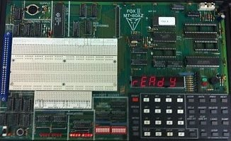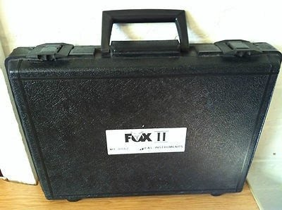

3/29/2018 :

Vicente - MT-80AZ FOX II Z80 Trainer

MT-80AZ FOX II Z80 Trainer

The FOX II is an 8-bit, Z80 based microcomputer trainer which can be used either on its own or as a base unit with any one of the FOX II microcomputer application programs.

This Z80 trainer was produced in the UK by E & L instruments In Wrexham.

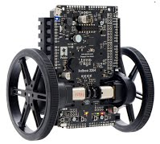

3/22/2018 :

LeRoy - Baloba Balance Robot

[Pololu Balance Robot Video](https://www.youtube.com/watch?v=WMTZy9QNtLg)

3/15/2018 :

Vicente: Arduino Voice Rocket Launcher

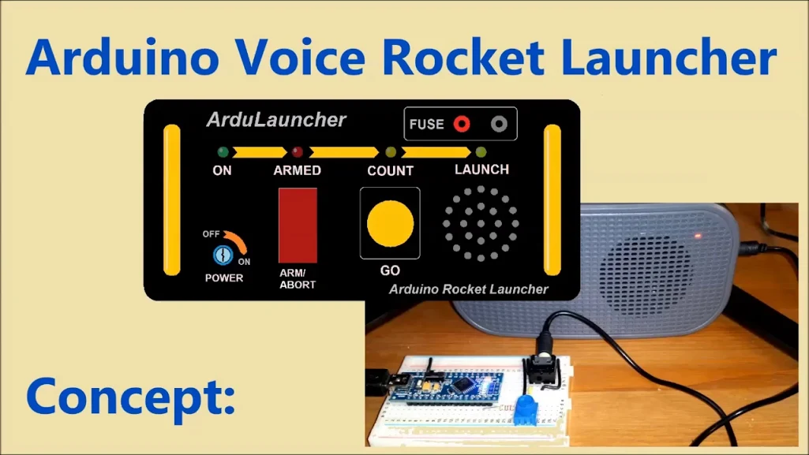

3/15/2018 :

Vicente: Arduino Voice Rocket Launcher

3/8/2018 :

LeRoy: WEMOS D1 mini with MP3 Player Demo

(Or I2C Communication Between two microcontrollers)

**This week LeRoy will do a demo of communication using the I2C bus between an Arduino Mega with MP3 shield, and**

**a D1 Mini with 5 buttons. By pushing the buttons the D1 Mini will tell the Mega which MP3 file to play.**

[**https://docs.google.com/document/d/17qPdnuz_0vcQxwqyIxbd-e1VFhrlClPlq28MblpcvN0/edit?usp=sharing**](https://docs.google.com/document/d/17qPdnuz_0vcQxwqyIxbd-e1VFhrlClPlq28MblpcvN0/edit?usp=sharing) **(work in progress)**

**Pictures: <https://photos.app.goo.gl/TYoR4XWBRE5TJUkh2>**

**Code:** <https://github.com/automation-technology-club/I2C-communication>

**'**

3/1/2018 :

Jeremy - Intro to Lock Sport Demo

Introduction to Lock Sporting. What is it? What are the basics?

3/1/2018 :

Grand Poo Bah: Trash Can Transport - Hub Motor Demo

Trash Can Transport (TCT) is a long term club project directed at delivering/returning trash cans to the street using automation technologies. The target group is the elderly. This demo will be a small step toward the completion project, integrating the latest hardware selection (electric hub motor and drive) into a prototype. Hopefully the GPB will be able to demonstrate two mounted hub motors mounted to a platform in a tail dragger configuration. Some would infer it is more likely GPBs' tail that will be draggin. GPBs, presentations are sometimes considered a method or torture.

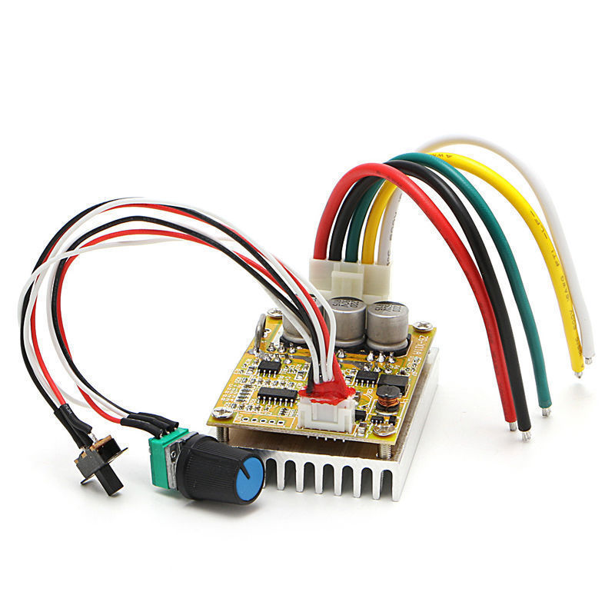T

**'**

Feb 22, 2018 - Crouton "Button" Demo - LeRoy

Crouton is a dashboard that taps into your IOT network. Crouton lets you visualize and control your IOT devices with minimal setup. Essentially, it is the easiest dashboard to setup for any IOT hardware

using only MQTT and JSON.

For this demo, I've made my own "sonoff" device, using a D1 mini, and a D1 mini relay board. I've added a push button so you can easily control your device locally without the need for the internet, or a dashboard.

The device setups a "push button" on Crouton and also displays the status of the relay (on or off). It is very simple to setup. Crouton works with all the webbrowsers I've tested so far (Firefox, Chrome, Chrome for Android, ChromeOS)

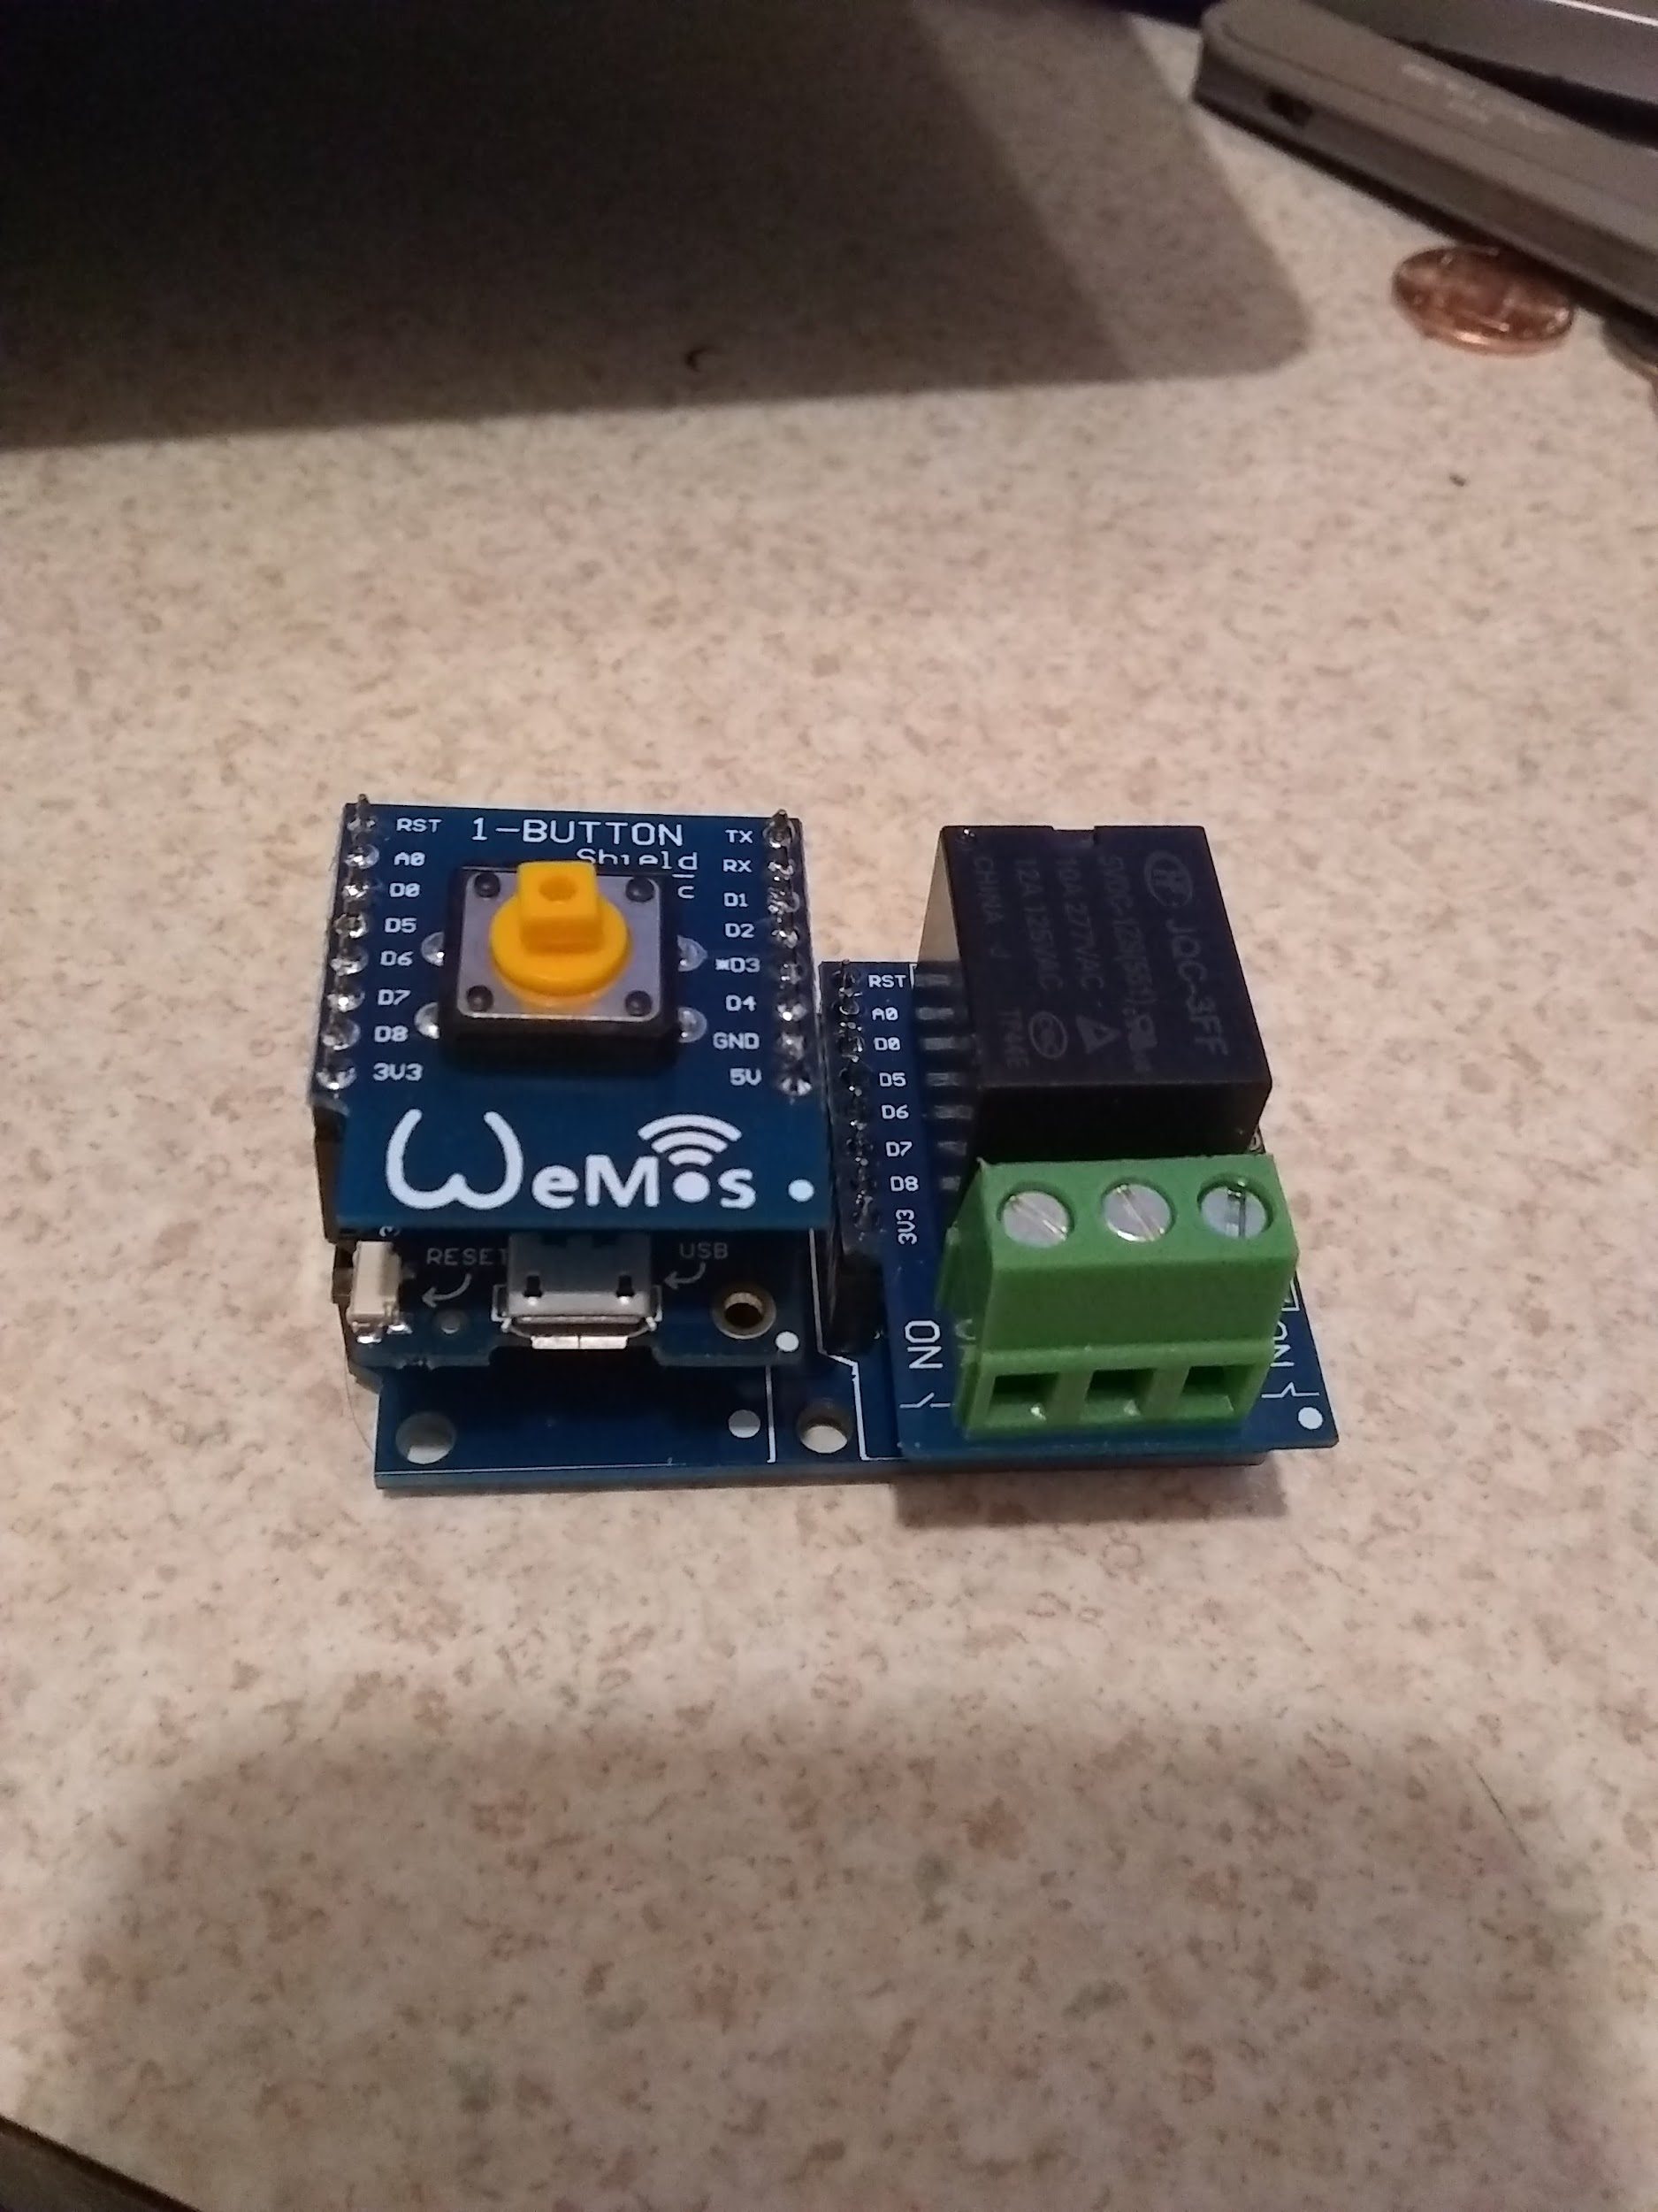

GitHub Repository: <https://github.com/automation-technology-club/Crouton-D1-Mini-Relay-Demo>

2/17/2018 :

LeRoy Connecting I/O via **LoRa Using D1 Mini - Demo**

This episode will include connecting INPUTS and Outputs using LoRa and D1 Mini Hardware. Control a LoRa output with a LoRa pushbutton.

GitHub Repository:<https://github.com/automation-technology-club/lora_temperature_demo>

Documentation: [Link to Documentation](https://docs.google.com/document/d/1FcrWj-z_tWK-HsLtbfy5d8vI9iUe61UU7hr4LCb7nRo/edit?usp=sharing)

[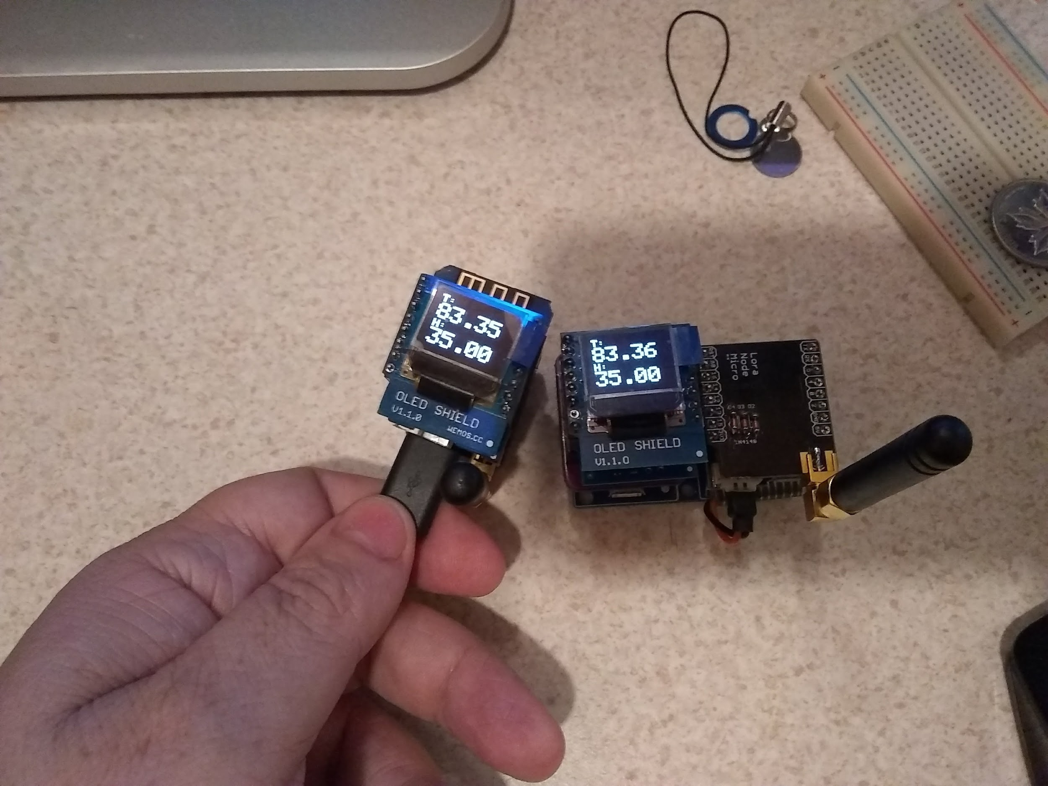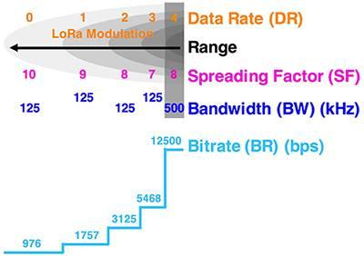](https://docs.google.com/document/d/1FcrWj-z_tWK-HsLtbfy5d8vI9iUe61UU7hr4LCb7nRo/edit?usp=sharing)

[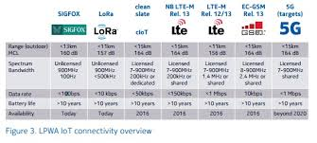](https://docs.google.com/document/d/1FcrWj-z_tWK-HsLtbfy5d8vI9iUe61UU7hr4LCb7nRo/edit?usp=sharing)

**LoRa networking**

LoRa technology's unique modulation method lies at the heart of performance characteristics that make it well suited to IoT applications: It can operate successfully at ranges exceeding 15 km in suburban settings and more than 2 km in dense urban environments. It can achieve over 10-year battery life and it can operate in networks comprising up to 1 million nodes. Further, its support for different chirp rates, or "spreading factors," gives designers the flexibility to trade data rate for range or power as needed to optimize network performance (Figure 2).

This will be a demo of multiple Lora devices sending to one device. LoRa is known for Long Range transmission of data in a low power (battery) application. These devices are intended are low throughput battery operated devices.

[Wikipedia Link](https://en.wikipedia.org/wiki/LPWAN#LoRa)

LoRa is a proprietary, [chirp spread spectrum](https://en.wikipedia.org/wiki/Chirp_spread_spectrum) (CSS) radio modulation technology for LPWAN used by LoRaWAN, Haystack Technologies, and Symphony Link.

LoRaWAN is a [media access control](https://en.wikipedia.org/wiki/Media_access_control) layer protocol for managing communication between LPWAN [gateways](https://en.wikipedia.org/wiki/Gateway_(telecommunications)) and end-node devices, maintained by the LoRa Alliance. Version 1.0 of the LoRaWAN specification was released in June 2015.

LoRaWAN defines the communication protocol and system architecture for the network while the LoRa physical layer enables the long-range communication link. LoRaWAN is also responsible managing the communication frequencies, data rate, and power for all devices. Devices in the network are asynchronous and transmit when they have data available to send. Data transmitted by an end-node device is received by multiple gateways, which forward the data packets to a centralized network server. The network server filters duplicate packets, performs security checks, and manages the network. Data is then forwarded to application servers. The technology shows high reliability for the moderate load, however it has some performance issues related to sending acknowledgements.

2/17/2018 :

Vicente - $2.00 Computer Blast from the Past -STM32.

Run - basic micro c. servo ntsc video, keyboard, serial console and more.

[STM32 Arduino TinyBASIC... Analog Plotting Video](https://plus.google.com/u/0/105972818015590775624/posts/ambzV4yWh2t?cfem=1)

LeRoy Sending Temps with LoRa Using D1 Mini - Demo  
2/10/2018 :   
GitHub Repository:   
https://github.com/automation-technology-club/lora_temperature_demo  
Documentation:   
https://docs.google.com/document/d/1FcrWj-z_tWK-HsLtbfy5d8vI9iUe61UU7hr4LCb7nRo/edit?usp=sharing  
  
Diagram of LoRa technology for IoT developers  
Image result for lora  
  
  
  
LoRa networking  
  
LoRa technology's unique modulation method lies at the heart of performance characteristics that make it well suited to IoT applications: It can operate successfully at ranges exceeding 15 km in suburban settings and more than 2 km in dense urban environments. It can achieve over 10-year battery life and it can operate in networks comprising up to 1 million nodes. Further, its support for different chirp rates, or "spreading factors," gives designers the flexibility to trade data rate for range or power as needed to optimize network performance (Figure 2).  
  
  
  
This will be a demo of multiple Lora devices sending to one device. LoRa is known for Long Range transmission of data in a low power (battery) application. These devices are intended are low throughput battery operated devices.  
  
Wikipedia Link  
  
LoRa is a proprietary, chirp spread spectrum (CSS) radio modulation technology for LPWAN used by LoRaWAN, Haystack Technologies, and Symphony Link.  
  
LoRaWAN is a media access control layer protocol for managing communication between LPWAN gateways and end-node devices, maintained by the LoRa Alliance. Version 1.0 of the LoRaWAN specification was released in June 2015.  
LoRaWAN defines the communication protocol and system architecture for the network while the LoRa physical layer enables the long-range communication link. LoRaWAN is also responsible managing the communication frequencies, data rate, and power for all devices. Devices in the network are asynchronous and transmit when they have data available to send. Data transmitted by an end-node device is received by multiple gateways, which forward the data packets to a centralized network server. The network server filters duplicate packets, performs security checks, and manages the network. Data is then forwarded to application servers. The technology shows high reliability for the moderate load, however it has some performance issues related to sending acknowledgements.

Extreme Life, Battery Operated Wireless Devices (mailbox monitor, Wireless Lamp Controller, Data Acquisition) - Vicente

[Link to Video](https://lh3.googleusercontent.com/-EG3718x-zkw/Wm9-VQEV-iI/AAAAAAABEBE/MLyj6xPNgKA8r4sHXEzr9yhV3MwdcVIxACJoC/w425-h239-n-k-rw-no/ZeroPower_Despacito_01.mp4)

Working in a long lasting battery power devices with Arduino.

To make remote light switches, door bells, mail box notifications etc..

My plan is to use cheap RF-433 AM modulators to send short messages when a push-button or micro switch is activated.

My design use a couple of MOSFET transistors.

My expectation, for a device with a several wake-ups daily, the battery will last for years...

**Dual Garage Door Monitor Using Arduino Nano****[Link to Document](https://docs.google.com/document/d/1Mx_m3hSqp3PDTBoBMxuG3G8m_UFmHwlV5S04cdkeIKM/edit?usp=sharing)**

**Bring Your Toys to AT Club: LeRoy is down for the count (Flu). I am bringing in my Arduino Nano Dual Garage Door Monitor which should keep us entertained for a few milliseconds, soooo, bring your toys in to demo.**

This includes an article from Jim's Corner. This monitor uses a pair of cheap hc-sr04 ultrasonic sensors using code derived from an internet article. The initial design is to simply output to a 5V buzzer from the Nano.

2/8/2018 : Marcus

Introduction to IoT Project Overview [Link to Project Document](https://drive.google.com/open?id=1mGPfxH83tQg2MJpyNNxqoz1bC9JnUAU1)  [Marcus's Corner](https://drive.google.com/drive/folders/1uVR_szfvRhToXoayOqBFTUDvzK0BcCYw?usp=sharing)

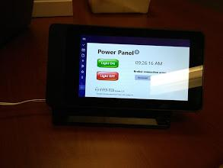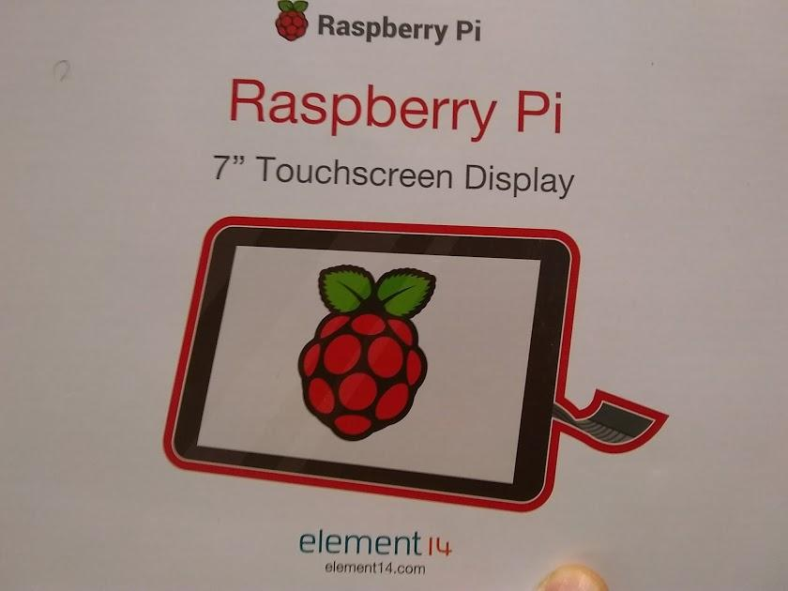

Panel - Smart Pi Touch Case

Microsoft video studio compiled for Pie

Window IoT core (free)

mosquito server in pi

mqtt to Sonoff (hackable, info anywhere)

8266 on breadboard with temp and humidity

Lucent has IoT platform - downtown

Microsoft UDT

Visual C

c sharp

uwp

visual studio

window IoP share

mqtt broker

client

sonos - arduino ide

1/25/2018 :

**IoT: Retail IoT Product Demo**  [**Demo Document**](https://docs.google.com/document/d/187_Fa60fc7_yolQoO5N_1B3F9vmh-JcZB5mri0hGrIs/edit?usp=sharing) **Tuyasmart**

[Product Information and Claims (Timer, Alexa, IoT)](https://www.ebay.com/itm/1-2-4WiFi-Smart-Phone-Remote-Control-Switch-Socket-Works-W-Amazon-Alexa-US-PLUG/272904240809?ssPageName=STRK%3AMEBIDX%3AIT&var=572087754993&_trksid=p2060353.m2749.l2648)

[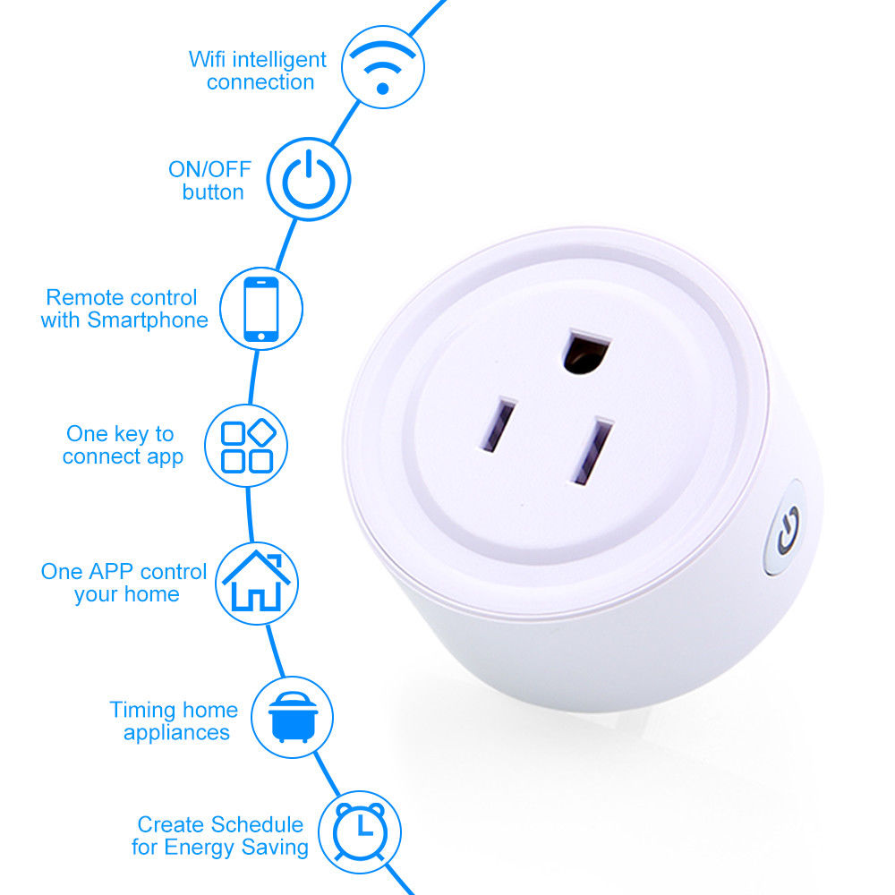](https://www.ebay.com/itm/1-2-4WiFi-Smart-Phone-Remote-Control-Switch-Socket-Works-W-Amazon-Alexa-US-PLUG/272904240809?ssPageName=STRK%3AMEBIDX%3AIT&var=572087754993&_trksid=p2060353.m2749.l2648)

e.

**[QUICK NEWS:](https://www.forbes.com/sites/kenkam/2018/01/03/your-intel-cpu-is-about-to-be-hobbled-5-30/#1ca5d67a44f4)**

**[Radar Motion Detect Modules](https://mail.google.com/mail/u/0/#sent/161297e6d73d937a?projector=1)**

**[Trash Can Transport - Control and Propulsion Rev 3 Overview](https://docs.google.com/document/d/1G91TmK42YTgoxYX0Vx24sqOLZ91nnLfnNy6mqKEtp6I/edit?usp=sharing)**

**[TCT Project - Main Club Folder](https://drive.google.com/drive/folders/0BySJuScrlj2OZlg1S2ZRczlUMGs?usp=sharing)**

**[TCT Project - Propulsion and Control Folder](https://drive.google.com/drive/folders/0BySJuScrlj2ObFNIR19LYkZWSmM?usp=sharing)**

**[Making the Internet of Things possible with a new breed of 'memristors'](https://www.eurekalert.org/pub_releases/2018-01/au-mti011018.php)**

**[Build Your Own Camera from Camera Module Board](https://www.ebay.com/sch/i.html?_from=R40&_trksid=p2047675.m570.l1313.TR0.TRC0.A0.H0.XIP+Camera+Board+Module+.TRS5&_nkw=IP+Camera+Board+Module+&_sacat=0)**

**[Bottom Line on LTE-M (LoRa similarities)](https://www.link-labs.com/blog/what-is-lte-m)**

**[AT&T plans to launch mobile 5G in a dozen cities by late 2018](https://www.fiercewireless.com/wireless/at-t-plans-to-launch-mobile-5g-dozen-cities-by-late-2018)**

**[Your Intel CPU Is About To Be Hobbled 5% To 30%](https://www.forbes.com/sites/kenkam/2018/01/03/your-intel-cpu-is-about-to-be-hobbled-5-30/#1ca5d67a44f4)**

**Ethernet over Power Lines Test - AV200 Powerline Adaptor TL-PA2010 (older)**

[**It's Not About the Board - (a note from the real world)**](http://www.dataweek.co.za/58755n) **[SV3C SV-B01 5 Mega Pixel POE Bullet Security Cameras](http://www.sv3c.com/Super-HD-5MP-H-265-POE-IP-Camera-Outdoor-Security-Camera-Bullet-Camera-SV-B01POE-5MPL-T.html)**

**[Robot Growth](http://fingfx.thomsonreuters.com/gfx/rngs/USA-MANUFACTURING-ROBOTS/0100603W07E/index.html)**

**Mixed Nuts Topics**

[**Moto E4 (good cheap phone) Review**](https://www.tomsguide.com/us/moto-e4,review-4489.html)

**1/18/2018 : LeRoy - Raspberry Pi AIY Vision** 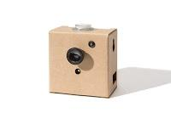

**Build your own Google Clips kit**

**Once you’ve assembled the Vision Kit, there are a number of neural networks software programs you can run. The first neural network is a “person, cat, and dog detector,” reveals Peter Malkin, Software Lead at AIY Projects. It detects if a person, cat, or dog is in the frame.**

**The second neural network is focused on facial emotions. It will detect happiness, sadness, and other sentiments.**

**The third neural network can identify 1,001 common objects, like a cup, an orange, or a chair. A label displays the name, and the level of confidence in the neural network’s inference. In the future, the hope is that users will be able to modify these neural networks. You could take the cat, dog, and person model and modify it to look for rabbits. Then build a project that works with a rabbit hutch, for instance.**

**SV3C SV-B01W-960P**

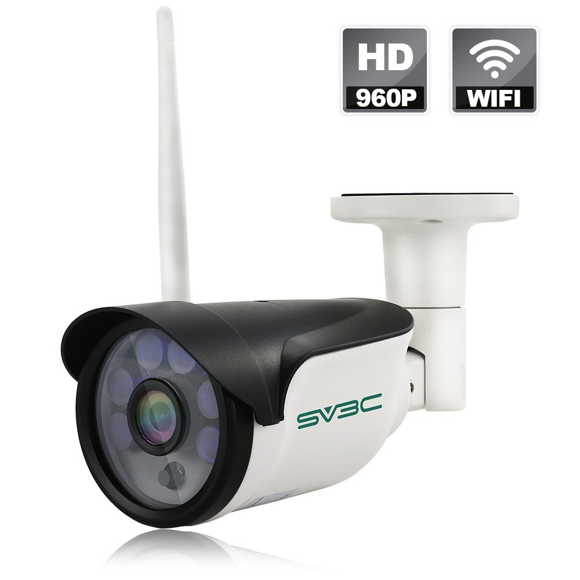

**SV3C SV-B01W-960P Security Camera - (New wave of ONVIF cameras)**

**Mr. Bahh will be sharing his experiences with the new wave on ONVIF cameras. The thrill of victory and the agony of defeat. The good, the bad, and the ugly. Wifi, Poe, 5mp, 2mp, 1mp, ptz, android connectivity, ISPY connectivity (PC - Windows based), powerline ethernet extender, wifi extender.**

### Brand New Cameras Right Out of the box for your viewing pleasure.

**SRICAM SP012 (720P)+ SP019 (1080P)(PTZ) Security Camera**

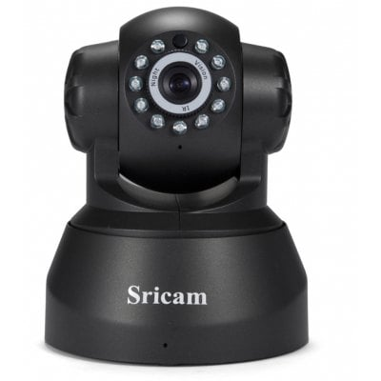

**1/10/2018 LeRoy Miller This Week:**

**Eric Bot**

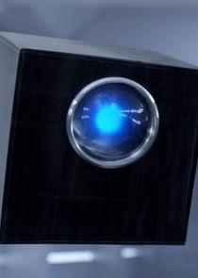

**LeRoy - 12/28/2017 Level 2 Robot Demo**

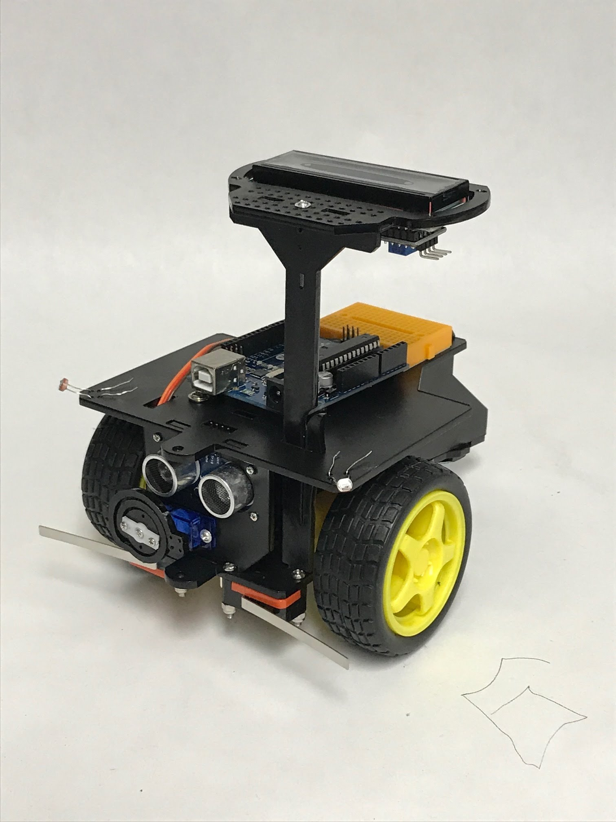

**LeRoy - 12/21/2017 Raspberry Pi demo using the Arduino and Particle Cloud IDE (Part 2) + DHT11**

**Updated the Document with some new information (Dec 20, 2017)**

***[LeRoy's Google Doc Write Up on using Arduino IDE, Particle Cloud and Pure C with the Raspberry PI](https://docs.google.com/document/d/1RfZoIqRebDUK48iS5WgfDbFuNDVCsAeVdkK4EFAZIQ0/edit?usp=sharing)***

**[Setting up the Raspberry PI for use with the Arduino IDE](https://github.com/me-no-dev/RasPiArduino)**

**[Setting up the Raspberry PI for use with the Particle Cloud](https://docs.particle.io/guide/getting-started/intro/raspberry-pi/)**

***I've added a DHT11 to my Raspberry PI Demo - Got it working with Arduino and "Pure C" - simplified my setup a bit - I now have all three demos running on one install (no need to restart the PI and have it connected to a TV) - I setup the "meeting" router already and verified it works with the PI. So should be able to run the demo headless and with just SSH.***

**Uploaded 6 videos of the Raspberry PI - PIDuino. All are under 10 mins longs (most are very short) -**

**https://www.youtube.com/playlist?list=PLvL2YQclXymelb2KHdiGP1Fj9Q0GEzfx5**

**more about using the Raspberry Pi with Particle Cloud**

**<https://docs.particle.io/datasheets/kits-and-accessories/raspberrypi-datasheet/>**

**DHT11 sensor**

**Humidity measurement range: 20% ~95%**

**Humidity measurement error: 5%**

**Temperature measurement range: 0~50**

**Temperature measurement error: 2**

**Operating voltage:3.3 V~5 V**

**Output form:digital**

| **image not displayed** |
| --- |

**Frank Hill - 12/7/2017 How to Create a Small Android App Using Android Studio**

[**https://www.youtube.com/watch?v=pRTuSPHyWqY**](https://www.youtube.com/watch?v=pRTuSPHyWqY)

**Frank Hill - 11/30/2017 Porting Garage Door Opener from Mega to Link Node R4 Platform**

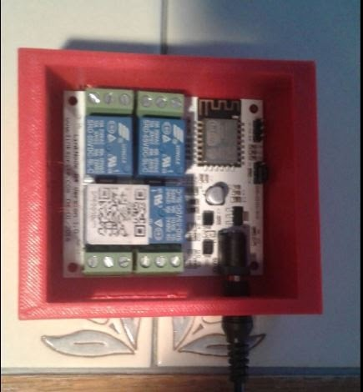

**LeRoy Miller - 11/9/2017 Google AIY Voice Kit Raspberry PI Demo [Club Google Plus Discussion Group](https://plus.google.com/communities/101659244920289753698)**

**DO-IT-YOURSELF ARTIFICIAL INTELLIGENCE**

**Google AIY Projects brings do-it-yourself artificial intelligence to your maker projects. With this AIY Voice Kit from Google, you can build a standalone voice recognition system using the Google Assistant or add voice recognition and natural language processing to your Raspberry Pi based projects. The kit includes all of the components needed to assemble the basic kit that works with the Google Assistant SDK as well as on-device voice recognition with TensorFlow. (Micro Center had deals).**

***LAST WEEKS MEETING NOTES:***

**David Steele dropped in to demo his Raspberry Pie software, known as COMETUP (Wifi Network Bootstrap for the Raspberry Pi 3) [comitup - Github](https://davesteele.github.io/comitup/)**

* **The comitup service, which automatically connects to an established Wifi Access Point, if possible. Otherwise, it will create a stand-alone Access Point with the name (SSID) 'comitup-<nnnn>', where '<nnnn>' is a unique, persistent four-digit number.**
* **Defined ZeroConf mdns address name for 'comitup-<nnnn>.local', advertising the IP address of the Raspbery Pi on Wifi.**
* **A comitup-web service, which provides a web interface for selecting and authenticating against an existing Access Point.**
* **A comitup-cli command-line utility for interacting with comitup.**
* **The ssh service is enabled by default. Be sure to change the "pi" user password**

**SPECIAL EVENT - "ROBOT ASSEMBLY GROUP" AT "RAY'S Rabbit Robots"**

**(This is a special event supported by the Automation Technology Club)**

**Saturday Nov 4, 2017 1:00pm - 6:00 pm**

**Ray's Rabbit Robots**

**1320 Hook Road**

**Middletown, Ohio 45042** **[Map](https://www.google.com/maps/place/1320+Hook+Dr,+Middletown,+OH+45042/@39.5295144,-84.4092988,17z/data=!3m1!4b1!4m5!3m4!1s0x8840679012fbc377:0x335a797ba196d451!8m2!3d39.5295103!4d-84.4071101)**

**513-320-2748**

**I will be hosting a robot assembly group on Saturday, November 4th (noon to 6 PM). This is a group of students, parents, and their club mentors. I have asked them to help me identify the confusing steps of assembling the robots, wiring the schematic, .. and general locations of improving the Rabbit Robots products.**

**I have setup tables, chairs, computers, solder stations, ... and more. Food and drinks will be provided.**

**Ray Scott**

**QUICK NEWS:**

**[5MP Update 1080P POE Bullet Security Camera SV3C](https://www.amazon.com/gp/product/B0734T9DYQ/ref=ox_sc_act_title_1?smid=A22E1JQ3DE3K79&psc=1)**

**Mixed Nuts Topics**

[**Moto E4 (good cheap phone) Review**](https://www.tomsguide.com/us/moto-e4,review-4489.html)

# **LeRoy Miller - 11/2/2017 Using a Raspberry PI Zero W for a WiFi Access Point [Google Plus Link to this Topic](https://plus.google.com/u/0/+LeRoyMiller/posts/M9V4j44GM3n?cfem=1)**

**Using a Raspberry PI Zero W for a access point was a little bit of a challenge. But in the end works really well for the robot. And I found away to filter MAC addresses, so now - only the robot, the display, and the remote (plus my computer) can connect to the AP - It's not perfect, since MAC addresses can be spoofed, but it will work - and now I may have a low cost way to create APs to use for robot competitions. - The AP is open, but rejects connection requests from devices it doesn't know. (The device may or may not keep trying thou - my phone keep trying to connect - until I told it not too).**

**I worked on this most of yesterday, and finished it after the meeting tonight. I'll be posting a "how I did it" soon.**



**LAST WEEKS MEETING NOTES:**

**Grand Poo Bah - SVC3 SC-B01-POE-1080P Security Camera****[Comparison Photo](https://docs.google.com/document/d/1Pa52llQjVqk8Tgdv-EzPWr4NTtNtTRql-yW-I2oMdSY/edit?usp=sharing)**

**This is smaller FIXED position 2MP (5MP now available) 1080P Outdoor Camera. This "wired" security camera is ONVIF complaint.**

**It has standard ONVIF type software for the Andriod and a Windows Compatible software (using MS C+). Picture quality is good and linear.**

**The SRICAM camera tends to fisheye a bit a the edges. GPB was interested because it was supposed to be ISPY compatible, this would replace my**

**aging VGA cameras with wider viewing angle with similar resolution (2MP). I am trying to replace 2 cameras with one HD camera.**

**Learn how GPB cracked this nut!**

**ISPY results. good throughput, stable, reasonable quality still picture, with marginal movie resolution (need to check this out).**

**The problem symptoms with previous problems with GPBs use of ONVIF on ISPY.**

**[Arlo Pro - Wire FREE Camera Review](https://www.youtube.com/watch?v=TreKEAYuqic)**

**[SV3C 1080P-POE-Bullet-IP-CAMERA - SV-B01POE-1080P](http://www.sv3c.com/1080P-POE-Bullet-IP-CAMERA-SV-B01POE-1080P-.html)**

**[Security Camera Guide 2017 - A Complete Guide to Wireless/Wired Cameras](https://www.youtube.com/watch?v=KTzPrh7SOhI&t=3s)**

**[What is Image Quality](https://www.youtube.com/watch?v=f7IWttAxjT8)**

**[HD SECURITY CAMERA - 1MP 1.3MP 2MP 3MP 5MP 4K UHD RESOLUTION](https://www.unifore.net/ip-video-surveillance/hd-security-camera-1mp-1-3mp-2mp-3mp-5mp-4k-uhd-resolution.html)**

**[What is ONVIF](https://www.youtube.com/watch?v=wMpXgM_M7Ss)**

**[Compare 720 to 1080](https://www.youtube.com/watch?v=veXHsqlkddY)**

**Grand Poo Bah - SVC3 SC-B01-POE-1080P Security Camera****[Comparison Photo](https://docs.google.com/document/d/1Pa52llQjVqk8Tgdv-EzPWr4NTtNtTRql-yW-I2oMdSY/edit?usp=sharing)**

**This is smaller FIXED position 2MP (5MP now available) 1080P Outdoor Camera. This "wired" security camera is ONVIF complaint.**

**It has standard ONVIF type software for the Andriod and a Windows Compatible software (using MS C+). Picture quality is good and linear.**

**The SRICAM camera tends to fisheye a bit a the edges. GPB was interested because it was supposed to be ISPY compatible, this would replace my**

**aging VGA cameras with wider viewing angle with similar resolution (2MP). I am trying to replace 2 cameras with one HD camera.**

**Learn how GPB cracked this nut!**

**ISPY results. good throughput, stable, reasonable quality still picture, with marginal movie resolution (need to check this out).**

**The problem symptoms with previous problems with GPBs use of ONVIF on ISPY.**

**[Arlo Pro - Wire FREE Camera Review](https://www.youtube.com/watch?v=TreKEAYuqic)**

**[SV3C 1080P-POE-Bullet-IP-CAMERA - SV-B01POE-1080P](http://www.sv3c.com/1080P-POE-Bullet-IP-CAMERA-SV-B01POE-1080P-.html)**

**[Security Camera Guide 2017 - A Complete Guide to Wireless/Wired Cameras](https://www.youtube.com/watch?v=KTzPrh7SOhI&t=3s)**

**[What is Image Quality](https://www.youtube.com/watch?v=f7IWttAxjT8)**

**[HD SECURITY CAMERA - 1MP 1.3MP 2MP 3MP 5MP 4K UHD RESOLUTION](https://www.unifore.net/ip-video-surveillance/hd-security-camera-1mp-1-3mp-2mp-3mp-5mp-4k-uhd-resolution.html)**

**[What is ONVIF](https://www.youtube.com/watch?v=wMpXgM_M7Ss)**

**[Compare 720 to 1080](https://www.youtube.com/watch?v=veXHsqlkddY)**

**LAST WEEKS MEETING NOTES: One of Jeremy's best sessions ever! (very organized) Big surprises for**

**normal users and some Password Manager suggestions: [Link to Jeremy's Notes](https://docs.google.com/document/d/1AcJ0eTzSf_t8lk8T7nFbfrm7HytMKIzuytHFcWL48gc/edit)**

**Expanded FIDO U2F Security Key link section and added prices in updated notes**  [**Jeremy's Corner**](https://drive.google.com/folderview?id=0BySJuScrlj2OfmJEcndkREx4MHM4aXhvZld0OFBkMjRPWTA2aVZFQUR2UjY5T21vakxkSW8&usp=sharing) **[Link to Jeremy's Notes](https://docs.google.com/document/d/1AcJ0eTzSf_t8lk8T7nFbfrm7HytMKIzuytHFcWL48gc/edit)**

**Jeremy 10/19/2017 Personal Information Security**

**Our in house security cop will discuss steps you can take to improve personal data security.**

**Jeremy 10/19/2017 Personal Information Security**  [**Jeremy's Corner**](https://drive.google.com/folderview?id=0BySJuScrlj2OfmJEcndkREx4MHM4aXhvZld0OFBkMjRPWTA2aVZFQUR2UjY5T21vakxkSW8&usp=sharing) **[Link to Jeremy's Notes](https://docs.google.com/document/d/1AcJ0eTzSf_t8lk8T7nFbfrm7HytMKIzuytHFcWL48gc/edit)**

**Our in house security cop will discuss steps you can take to improve personal data security.**

**LeRoy 10/12/2017 WiFi Robot Based on D1 Mini ESP8266 Controller** **[Leroy's Corner](https://drive.google.com/drive/folders/0BySJuScrlj2OflFGOVZUbWw0elExSnhOSkxVSjVwREZ6MVdhcHh1clBPdlRqMk1oMHY4RTA?usp=sharing)**

**Grand Poo Bah 10/5/2017 TCT - Brushless D C Motor (BLDC) Confab** **[TCT Project - Jim's Corner](https://drive.google.com/drive/folders/0BySJuScrlj2OZlg1S2ZRczlUMGs?ths=true)**

**We looked at hub motor opportunities for the TCT. We had discovered some Hoverboard motors and Vicente found some info on controls. Ray found 2 Hoverboard motors for $40. I hope to gather knowledge from club members and share what I found (training and tech info). It looks like the hub motor is a 3 phase DC motor. Unlike a stepper motor it has zero current when stopped at zero torque. You have a couple of control options. You can use counter emf from the unenergized coils or use hall effect sensors embedded in the motor. It looks like the hoverboard uses hall effect transducers. BLDC motors are showing up in higher efficiency HVAC systems for their efficiency and speed control. (Poo brought in the hover motor and the extreme weight was noted by all members that picked it up. Poo also showed a video of the of his new motor and drive in operation. The motor starts at about 1.6 volts and max speed is attained about 1.9V. It was noted that the controller seems to ramp the motor to speed. If you apply power with 5V to the speed control. It will ramp smoothly to full speed. James N showed us the magnets in the motor are actually not in the center of the motor but around the outer edge (outside the copper coils). Looks like about 30 magnets. James also indicates some of the wheels come with internal controllers.**

**[Brush Less D C (BLDC) Motor - Wiki](https://en.wikipedia.org/wiki/Brushless_DC_electric_motor)**

**[How the 3 phace DC motor works](https://www.youtube.com/watch?v=8LXPcJD6hEA)**

**[Hoverboard Wheel Insides](https://www.youtube.com/watch?v=Xv4UIHgjna0)**

**[Hoverboard Schematic Graphics](https://www.google.com/search?hl=en&biw=1093&bih=504&tbm=isch&sa=1&q=hoverboard+schematics&oq=hoverboard+sch&gs_l=psy-ab.1.0.0l2j0i8i30k1l2.13348.18188.0.20978.4.4.0.0.0.0.101.361.3j1.4.0.dummy_maps_web_fallback...0...1.1.64.psy-ab..0.4.357....0.ojAAjAwUck0#imgrc=yIJ_zJJbwCnkPM:)**

**Frank 9/7/2017** QPUMP Sump Pump Control with Database (update)*[Frank's Corner](https://drive.google.com/open?id=0BySJuScrlj2OOFFnUnh1aFEzS2s)*

**LeRoy** 9/7/2017 LoRa 915Mhz Demo [Leroy's Corner](https://drive.google.com/drive/folders/0BySJuScrlj2OflFGOVZUbWw0elExSnhOSkxVSjVwREZ6MVdhcHh1clBPdlRqMk1oMHY4RTA?usp=sharing)

I am now capable of extracting performance data from the Sump Pump application.

See the link below:

<http://www.internetcontrolsystems.com/PumpReport.aspx>

**Grand Poo Bah**

8/31/2017

**TCT (Trash Can Transport Rev2) Linear Electric Steering Mechanism Implementation (two video's 30 seconds - Poo Bah's Max).**

Another baby step for the Grand Poo Bah. You will see a demo of the manual operation of the Linear Electric Steering Mechanism. You will note the torque is not overwhelming, but the demand for full stroke operation will be limited. The steering mechanism is pulsed and will mostly be performed during motion (minimizing torque required). The prototype TCT was a dual motor tail dragger with steering adjusted in a periodic fashion yielding extremely accurate straight line operation. The current favored steering reference will be dual compasses (as in the prototype).

Frank

8/24/2017

QPUMP Sump Pump Control with Database (enhanced)

It reports it's status every 15 minutes. You can see the report at <http://www.internetcontrolsystems.com/default3.aspx>

**Original Problem**  
 A few days ago I had an occasion where my sump pump failed. After some trouble shooting, I found out that the pump was fine, however, the float switch was defective. This happened about 7:PM and unfortunately, Home-depot didn't carry the float switch. I found the switch on Amazon and ordered it. In the mean time, I thought to myself. This is a job for arduino, a relay and a water sensor. So I put together circuit using stuff from the shelf. Strangely enough it works very well.

It reports it's status every 15 minutes. You can see the report at <http://www.internetcontrolsystems.com/default3.aspx>

Grand Poo Bah Aug 24 - TCT (Trash Can Transport) *[Jim's Corner](https://drive.google.com/folderview?id=0BySJuScrlj2OflQyaE9MbWw4OWlLWU9ZU2tXZ25zeU95WWtwSTdSSDBtZFpyeXFmbHRJNEU&usp=sharing)*

This is the long standing club project mainly directed at the elderly. The objective of the trash can transport is to take the trash to the curb for pickup. This particular iteration is the key fob controlled version (manually driven). The fob, drive, pictures of the transport, motor, mechanical drive are included in Jim's Corner. This tiny step will include the replacement of the smaller wire (some would say microscopic) used to test the original drive configuration with larger wire. The new drive wiring includes polarity protection. The implementation should prove to have great entertainment value (as much of Grand Poo Bah's work).

The challenge is to find a way to automatically deliver the trash cans to the curb. Grand Poo Bah has had some prototype success in using compass controlled direction using an arduino.

**\* Today's Activities (this color)**

**Vicente**  [***Vicente's Corner***](https://drive.google.com/drive/folders/0BySJuScrlj2OeUJaM2tJaUFwbEU?usp=sharing)

**7/6/2017 Balance Ball on Beam with Using Graphite Rods** [**Folder for This Project**](https://drive.google.com/drive/folders/0B-sFhrJXj0saOF9BNmprSjhaeTQ?usp=sharing) [**Video Preliminary Test**](https://plus.google.com/u/0/photos/photo/105972818015590775624/6438995028965553314?icm=false&sqid=101659244920289753698&ssid=d4256ffd-dbc3-4cdc-9230-b6f668b7bc25)



**Ray**

**7/6/2017 I will be bringing a few of my new robot projects. (Mars Curiosity Rover, Self Balancing Robot, 6-Wheel Utility Bot, 6-Leg Walker ... and more ) I hope to see you all there.**

Vicente - Tito [*Vicente's Corner*](https://drive.google.com/drive/folders/0BySJuScrlj2OeUJaM2tJaUFwbEU?usp=sharing)*[2/16/2017 Where is the Train on the Bridge using Arduino](https://drive.google.com/drive/folders/0BySJuScrlj2OeUJaM2tJaUFwbEU?usp=sharing)*

*[(This will use one of many projects from the mind of Vicente)  
Like:   
 A spotlight pointer to spotlight a single performer on stage.  
 Strain Gauges to determine the location of a HO scale train on a bridge.  
 Tracking a metal ball on graphite rails.  
 Balancing a metal ball on graphite rails.  
 Demonstrating the superconductor like characteristics of Graphene.](https://drive.google.com/drive/folders/0BySJuScrlj2OeUJaM2tJaUFwbEU?usp=sharing)*

**Using a $3 Camera (OV7670) With an Arduino (color/object recognition)**

Like:

Laser rangefinder.

Line follower

7 segment identification

Displacement sensor using optical flow.

Object identification.

Laser spot follower

Object follower...

Thermal Scanner

Frank *[Frank's Corner](https://drive.google.com/open?id=0BySJuScrlj2OOFFnUnh1aFEzS2s)*

[Interfacing to C# coded Web Services using WEMOS D1 technology](https://www.meetup.com/Automation-Technology-Club/events/242230445/)

**C#**

**(C#** (pronounced "C sharp") is a programming language that is designed for building a variety of applications that run on the .NET Framework. **C#** is simple, powerful, type-safe, and object-oriented)

[C# More Information](https://docs.microsoft.com/en-us/dotnet/csharp/getting-started/introduction-to-the-csharp-language-and-the-net-framework)

[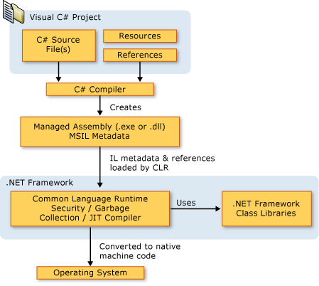](https://docs.microsoft.com/en-us/dotnet/csharp/getting-started/introduction-to-the-csharp-language-and-the-net-framework)

**WEMOS D1**

[WeMos-D1-R1-Board-ESP8266-Arduino-or-NodeMCU-OTA-Blynk-IOT-Development](http://www.ebay.com/itm/WeMos-D1-R1-Board-ESP8266-Arduino-or-NodeMCU-OTA-Blynk-IOT-Development-/331911622660?epid=847900528&hash=item4d47797004:g:740AAOSw4shX5Cwc)

| [WeMos](https://en.wikipedia.org/w/index.php?title=WeMos&action=edit&redlink=1)[[21]](https://en.wikipedia.org/wiki/ESP8266#cite_note-WeMos-21) D1[[22]](https://en.wikipedia.org/wiki/ESP8266#cite_note-22) | 12 | 0.1 in | Arduino Uno | Yes | PCB trace | Yes | 53.4 × 68.6 | Uses the ESP-12F module, Micro-USB socket, discontinued in favor of WeMos D1 R2 |
| --- | --- | --- | --- | --- | --- | --- | --- | --- |

DON

RAY

**2/16/2017 Bring your Oscilloscope to Work Day**

Like:

Mine is better than yours.

Comparison of scopes

Modern Oscilloscope opportunities

Oscilloscope Museum

**3/30/2017 Bring Your Multimeter to Work Day**

**Who has the best MultiMeter.**

**2/16/2017 SPECIAL EVENT - OPEN HOUSE AT "RAY'S Rabbit Robots"**(This is a special event supported by the Automation Technology Club)  
  
 Tuesday Feb 14, 2017 5:30 pm - 8:00 pm

Ray's Rabbit Robots  
 1320 Hook Road  
 Middletown, Ohio 45042  [Map](https://www.google.com/maps/place/1320+Hook+Dr,+Middletown,+OH+45042/@39.5295144,-84.4092988,17z/data=!3m1!4b1!4m5!3m4!1s0x8840679012fbc377:0x335a797ba196d451!8m2!3d39.5295103!4d-84.4071101)  
 513-320-2748  
  
 See:  
 Laser Engraving and Cutting Machines   
 Maker Bot 3D Printer  
 Shop Bot 3d Printer  
 Ray's collection of Robots

7/7 Raspberry Pi Subject

WILL

**Sept 15, 2016 Simple Chronograph - Play Music with Kodi and Catch Fun Stuff using Raspberry/Arduino**

ART

**8/11 Raspberry PI 3 - Raspian, IOT control from Cell Phone to GPIO demo. Apache 2.**

**(see Art's Corner - for documentation** [Art's Corner](https://drive.google.com/folderview?id=0BySJuScrlj2OTHR5T2JSZGRzYnM&usp=sharing))

LEROY'S WORK AREA

LeRoy Aug 17 - Simple Learn to use GIT (BRING Your laptops, this is a hands on demo)

I will be trying to follow this as close as I can:

<https://docs.google.com/document/d/1h0ojZ2IgoaaqFlaoHGdFKYuJxrxmrAwZUFQ3fkasvgY/edit?usp=sharing>

8/3/2017 LinkNode R4 Arduino Compatible WiFi Relay Controller

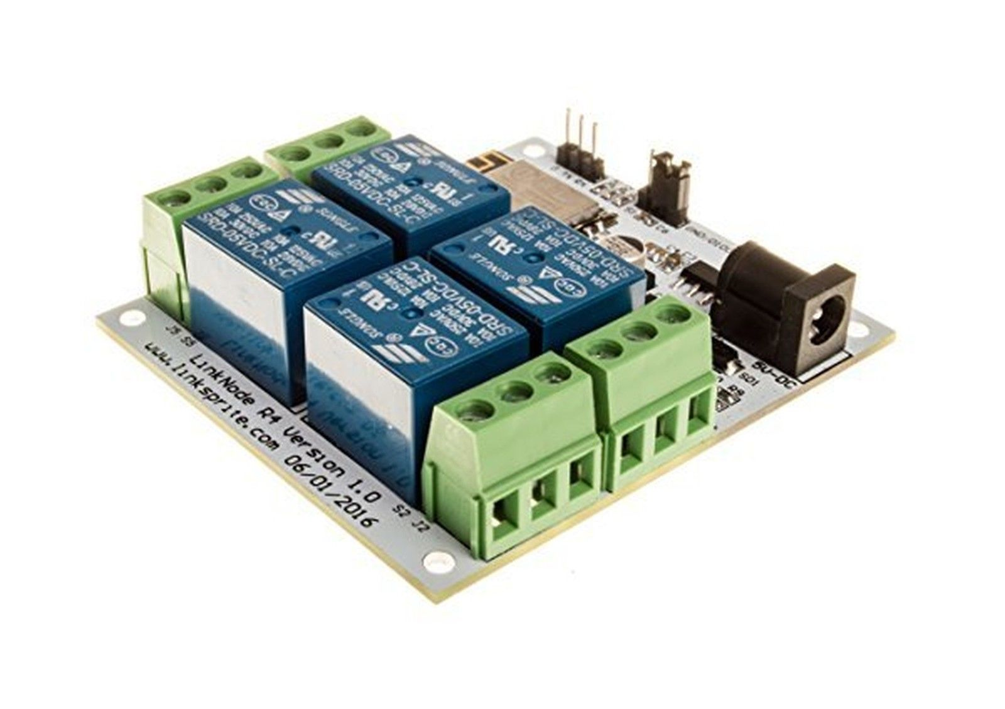

LinkNode R4 is a WiFi relay controller and it is powered by ESP-12f ESP8266 WiFi module which is compatible with Arduino programming. There are 4 relay channels and each channel allows you to control high-power devices (up to 10 A) via the on-board relay. LinkNode R4 can be used to remotely turn lights, fans and other devices on/off. The WiFi interface will allow you to associate the board with your existing WiFi network and send the commands over the network.

Features

ESP-12f ESP8266 WiFi module

4 Channel relays

277V ACï¼Œ 10A

125V ACï¼Œ 12A

4 Channel relays

Two work modes:

Program via UART

Boot from flash

4 indiator LEDs

7/27/2017 LORA Communications Demo   
[Google Plus Discussion on This Topic](https://plus.google.com/u/0/+LeRoyMiller/posts/UfL7hmPEmYD?cfem=1)

[ISM - LoRa Tutorial](http://hackaday.com/2017/07/09/ism-communications-for-arduino/) [LoRa Low Power Long Range Radio Information](https://docs.google.com/document/d/1qADBfrh_bAxfH-qQ2H97vu1hYPQrXb09tVtxGMKvNxE/edit?usp=sharing)

This demo will use 2 LORA shields.

# LPWAN

From Wikipedia, the free encyclopedia <https://en.wikipedia.org/wiki/LPWAN>

**Low-Power Wide-Area Network** (**LPWAN**) or **Low-Power Network** (**LPN**) is a type of [wireless telecommunication](https://en.wikipedia.org/wiki/Wireless_telecommunication) [wide area network](https://en.wikipedia.org/wiki/Wide_area_network) designed to allow long range communications at a low [bit rate](https://en.wikipedia.org/wiki/Bit_rate) among [things](https://en.wikipedia.org/wiki/Internet_of_things) (connected objects), such as sensors operated on a [battery](https://en.wikipedia.org/wiki/Battery_(electricity)).[[1]](https://en.wikipedia.org/wiki/LPWAN#cite_note-1)[[2]](https://en.wikipedia.org/wiki/LPWAN#cite_note-2) The [low power](https://en.wikipedia.org/wiki/Low-power_electronics), low bit rate and intended use distinguish this type of network from a [wireless WAN](https://en.wikipedia.org/wiki/Wireless_WAN) that is designed to connect users or businesses, and carry more data, using more power.

An LPWAN may be used to create a private [wireless sensor network](https://en.wikipedia.org/wiki/Wireless_sensor_network), but may also be a service or infrastructure offered by a third party, allowing the owners of sensors to deploy them in the field without investing in [gateway](https://en.wikipedia.org/wiki/Gateway_(telecommunications)) technology.

## Platforms and technologies

There are a number of competing standards and vendors in the LPWAN space, the most prominent of which include:

### **LoRa based**

### **LoRa is a proprietary,** [chirp spread spectrum](https://en.wikipedia.org/wiki/Chirp_spread_spectrum) (CSS) radio modulation technology for LPWAN used by LoRaWAN, Haystack Technologies, and Symphony Link.[[3]](https://en.wikipedia.org/wiki/LPWAN#cite_note-3)

LoRa is a [patented](https://en.wikipedia.org/wiki/Patented) (EP2763321 from 2013 and US7791415 from 2008) technology developed by Cycleo (Grenoble, France) and acquired by Semtech in 2012.[[4]](https://en.wikipedia.org/wiki/LPWAN#cite_note-4) LoRa uses license-free sub Gigahertz [radio frequency](https://en.wikipedia.org/wiki/Radio_frequency) bands like 169 MHz, 433 MHz, [868 MHz (Europe)](https://en.wikipedia.org/wiki/Short_Range_Devices#SRD860) and 915 MHz (North America).

On top of this physical layer, there are two main competing protocols:

#### **LoRaWAN**

LoRaWAN is a [media access control](https://en.wikipedia.org/wiki/Media_access_control) layer protocol for managing communication between LPWAN [gateways](https://en.wikipedia.org/wiki/Gateway_(telecommunications)) and end-node devices, maintained by the LoRa Alliance. Version 1.0 of the LoRaWAN specification was released in June 2015.[[5]](https://en.wikipedia.org/wiki/LPWAN#cite_note-5)

LoRaWAN defines the communication protocol and system architecture for the network while the LoRa physical layer enables the long-range communication link. LoRaWAN is also responsible managing the communication frequencies, data rate, and power for all devices.[[6]](https://en.wikipedia.org/wiki/LPWAN#cite_note-6) Devices in the network are asynchronous and transmit when they have data available to send. Data transmitted by an end-node device is received by multiple gateways, which forward the data packets to a centralized network server.[[7]](https://en.wikipedia.org/wiki/LPWAN#cite_note-:0-7) The network server filters duplicate packets, performs security checks, and manages the network. Data is then forwarded to application servers.[[8]](https://en.wikipedia.org/wiki/LPWAN#cite_note-8)

Platforms based on LoRaWAN include:

* ThingsConnected, a free platform provided by the [UK Digital Catapult](https://en.wikipedia.org/wiki/Catapult_centres)[[9]](https://en.wikipedia.org/wiki/LPWAN#cite_note-9)
* iFrogLab, public LoRaWAN and LoRa provider for North America and Taiwan.[[10]](https://en.wikipedia.org/wiki/LPWAN#cite_note-10)
* IoT-X, platform from Stream Technologies for public and private networks.[[11]](https://en.wikipedia.org/wiki/LPWAN#cite_note-11)
* OpenChirp, open management layer on top of LoRaWAN, developed at [Carnegie Mellon University](https://en.wikipedia.org/wiki/Carnegie_Mellon_University), for data context, storage, [visualization](https://en.wikipedia.org/wiki/Visualization_(graphics)), and [access control](https://en.wikipedia.org/wiki/Access_control).[[12]](https://en.wikipedia.org/wiki/LPWAN#cite_note-12) The primary objective is to simplify the experience of adding and operating new devices in the network, as well as improving performance for communities that share bandwidth and locality.[[13]](https://en.wikipedia.org/wiki/LPWAN#cite_note-13)[[14]](https://en.wikipedia.org/wiki/LPWAN#cite_note-14)
* The Things Network, a free and open-source LoRaWAN network provider developed and supported by a worldwide community.[[15]](https://en.wikipedia.org/wiki/LPWAN#cite_note-15)
* Everynet, provides a platform and gateways for Lora use in the Americas, Europe, China. [[2]](http://www.everynet.com/)
* ThingPark Wireless, platform from Actility based on LoRaWAN.[[16]](https://en.wikipedia.org/wiki/LPWAN#cite_note-16)
* [Senet](https://en.wikipedia.org/wiki/Senet_Inc.), public LoRaWAN provider in North America.[[17]](https://en.wikipedia.org/wiki/LPWAN#cite_note-17)

#### **Symphony Link**

Symphony Link is a wireless system developed by [Link Labs](https://en.wikipedia.org/wiki/Link_Labs) as an alternative to LoRaWAN.[[18]](https://en.wikipedia.org/wiki/LPWAN#cite_note-18) The Symphony Link gateway is an eight-channel sub-gigahertz base station that is ideal for industrial or municipal monitoring applications.[[7]](https://en.wikipedia.org/wiki/LPWAN#cite_note-:0-7)

### **Ultra Narrow Band**

UNB, [Ultra Narrow Band](https://en.wikipedia.org/w/index.php?title=Ultra_Narrow_Band&action=edit&redlink=1), modulation technology used for LPWAN by various companies including:

* [Sigfox](https://en.wikipedia.org/wiki/Sigfox), UNB-based technology and French company.[[19]](https://en.wikipedia.org/wiki/LPWAN#cite_note-19)
* [Telensa](https://en.wikipedia.org/w/index.php?title=Telensa&action=edit&redlink=1)[[20]](https://en.wikipedia.org/wiki/LPWAN#cite_note-20)
* NB-IoT, another narrow band standard initiated and completed by 3gpp with their release 13 of the series of IoT standardizations.
* NWave, proprietary technology that also forms the basis of the Weightless protocols[[21]](https://en.wikipedia.org/wiki/LPWAN#cite_note-21)[[22]](https://en.wikipedia.org/wiki/LPWAN#cite_note-22)[[23]](https://en.wikipedia.org/wiki/LPWAN#cite_note-23)
* [Weightless](https://en.wikipedia.org/wiki/Weightless_(wireless_communications)), a set of communication standards from the Weightless SIG.[[24]](https://en.wikipedia.org/wiki/LPWAN#cite_note-24)

LeRoy [Link to Leroy's Corner](https://drive.google.com/drive/folders/0BySJuScrlj2OflFGOVZUbWw0elExSnhOSkxVSjVwREZ6MVdhcHh1clBPdlRqMk1oMHY4RTA?usp=sharing)

7/20/2017 Livera Vision Board for Robots Overview with Streaming Video Demo

Livera is a combination of wifi router, web cam, accelerometer, Arduino and Raspberry Pi, within a small board size. Livera by Team HiCat is an open source hardware project which aims to bring machine vision features to the Arduino community.

– 720hd video and photo capturing&processing

– OpenCV enabled Color-Sensitive and Object-Tracking.

– Wifi enabled wireless control (this can work with the iot!)

– Image capturing and data recording onto the onboard sd card

– Mobile observation and manipulation from our custom apps( web-based and native)

– Programmable and open source.

For more information on the new Livera Robotic machine vision system jump over to the Kickstarter website for full specifications via the link below.

Source: [Kickstarter](https://www.kickstarter.com/projects/945994322/hicatlivera-start-making-your-first-machine-vision)

**Every week until 7/21 - Escape Room - type library event (project discussion) -** [Discussion for this Project (Google +)](https://plus.google.com/u/0/communities/101659244920289753698)

Based on the (scary) show on Netflix called "Stranger Things". In the show they communicate thru Christmas lights that flash according to the alphabet (see the last minute of this clip: <https://www.youtube.com/watch?v=_kn2e-bIlmE>). Is this something your group could possibly do for us? It wouldn't need to flash any special message (unless you want it to, of course).



LeRoy [Link to Leroy's Corner](https://drive.google.com/drive/folders/0BySJuScrlj2OflFGOVZUbWw0elExSnhOSkxVSjVwREZ6MVdhcHh1clBPdlRqMk1oMHY4RTA?usp=sharing)

7/13/2017 MQTT Demo

MQTT (M2M machine 2 machine)

From Wikipedia, the free encyclopedia

| [**Internet protocol suite**](https://en.wikipedia.org/wiki/Internet_protocol_suite) |
| --- |
| [**Application layer**](https://en.wikipedia.org/wiki/Application_layer) |
| * [BGP](https://en.wikipedia.org/wiki/Border_Gateway_Protocol) * [DHCP](https://en.wikipedia.org/wiki/Dynamic_Host_Configuration_Protocol) * [DNS](https://en.wikipedia.org/wiki/Domain_Name_System) * [FTP](https://en.wikipedia.org/wiki/File_Transfer_Protocol) * [HTTP](https://en.wikipedia.org/wiki/Hypertext_Transfer_Protocol) * [IMAP](https://en.wikipedia.org/wiki/Internet_Message_Access_Protocol) * [LDAP](https://en.wikipedia.org/wiki/Lightweight_Directory_Access_Protocol) * [MGCP](https://en.wikipedia.org/wiki/Media_Gateway_Control_Protocol) * [MQTT](https://en.wikipedia.org/wiki/Message_Queuing_Telemetry_Transport) * [NNTP](https://en.wikipedia.org/wiki/Network_News_Transfer_Protocol) * [NTP](https://en.wikipedia.org/wiki/Network_Time_Protocol) * [POP](https://en.wikipedia.org/wiki/Post_Office_Protocol) * [ONC/RPC](https://en.wikipedia.org/wiki/Open_Network_Computing_Remote_Procedure_Call) * [RTP](https://en.wikipedia.org/wiki/Real-time_Transport_Protocol) * [RTSP](https://en.wikipedia.org/wiki/Real_Time_Streaming_Protocol) * [RIP](https://en.wikipedia.org/wiki/Routing_Information_Protocol) * [SIP](https://en.wikipedia.org/wiki/Session_Initiation_Protocol) * [SMTP](https://en.wikipedia.org/wiki/Simple_Mail_Transfer_Protocol) * [SNMP](https://en.wikipedia.org/wiki/Simple_Network_Management_Protocol) * [SSH](https://en.wikipedia.org/wiki/Secure_Shell) * [Telnet](https://en.wikipedia.org/wiki/Telnet) * [TLS/SSL](https://en.wikipedia.org/wiki/Transport_Layer_Security) * [XMPP](https://en.wikipedia.org/wiki/XMPP) * *[more...](https://en.wikipedia.org/wiki/Category:Application_layer_protocols)* |
| [**Transport layer**](https://en.wikipedia.org/wiki/Transport_layer) |
| * [TCP](https://en.wikipedia.org/wiki/Transmission_Control_Protocol) * [UDP](https://en.wikipedia.org/wiki/User_Datagram_Protocol) * [DCCP](https://en.wikipedia.org/wiki/Datagram_Congestion_Control_Protocol) * [SCTP](https://en.wikipedia.org/wiki/Stream_Control_Transmission_Protocol) * [RSVP](https://en.wikipedia.org/wiki/Resource_Reservation_Protocol) * *[more...](https://en.wikipedia.org/wiki/Category:Transport_layer_protocols)* |
| [**Internet layer**](https://en.wikipedia.org/wiki/Internet_layer) |
| * [IP](https://en.wikipedia.org/wiki/Internet_Protocol)   + [IPv4](https://en.wikipedia.org/wiki/IPv4)   + [IPv6](https://en.wikipedia.org/wiki/IPv6) * [ICMP](https://en.wikipedia.org/wiki/Internet_Control_Message_Protocol) * [ICMPv6](https://en.wikipedia.org/wiki/Internet_Control_Message_Protocol_version_6) * [ECN](https://en.wikipedia.org/wiki/Explicit_Congestion_Notification) * [IGMP](https://en.wikipedia.org/wiki/Internet_Group_Management_Protocol) * [OSPF](https://en.wikipedia.org/wiki/Open_Shortest_Path_First) * [IPsec](https://en.wikipedia.org/wiki/IPsec) * *[more...](https://en.wikipedia.org/wiki/Category:Internet_layer_protocols)* |
| [**Link layer**](https://en.wikipedia.org/wiki/Link_layer) |
| * [ARP](https://en.wikipedia.org/wiki/Address_Resolution_Protocol) * [NDP](https://en.wikipedia.org/wiki/Neighbor_Discovery_Protocol) * [Tunnels](https://en.wikipedia.org/wiki/Tunneling_protocol)   + [L2TP](https://en.wikipedia.org/wiki/Layer_2_Tunneling_Protocol) * [PPP](https://en.wikipedia.org/wiki/Point-to-Point_Protocol) * [MAC](https://en.wikipedia.org/wiki/Media_access_control)   + [Ethernet](https://en.wikipedia.org/wiki/Ethernet)   + [DSL](https://en.wikipedia.org/wiki/Digital_subscriber_line)   + [ISDN](https://en.wikipedia.org/wiki/Integrated_Services_Digital_Network)   + [FDDI](https://en.wikipedia.org/wiki/Fiber_Distributed_Data_Interface) * *[more...](https://en.wikipedia.org/wiki/Category:Link_protocols)* |
| * [v](https://en.wikipedia.org/wiki/Template:IPstack) * [t](https://en.wikipedia.org/wiki/Template_talk:IPstack) * [e](https://en.wikipedia.org/w/index.php?title=Template:IPstack&action=edit) |

**MQTT**[[1]](https://en.wikipedia.org/wiki/MQTT#cite_note-1) (**MQ Telemetry Transport** or **Message Queue Telemetry Transport**) is an [ISO standard](https://en.wikipedia.org/wiki/International_Organization_for_Standardization) (ISO/IEC PRF 20922)[[2]](https://en.wikipedia.org/wiki/MQTT#cite_note-ISO-2) [publish-subscribe](https://en.wikipedia.org/wiki/Publish%E2%80%93subscribe_pattern)-based "lightweight" messaging protocol for use on top of the [TCP/IP protocol](https://en.wikipedia.org/wiki/TCP/IP). It is designed for connections with remote locations where a "small code footprint" is required or the network bandwidth is limited. The [publish-subscribe messaging pattern](https://en.wikipedia.org/wiki/Publish%E2%80%93subscribe_pattern)requires a [message broker](https://en.wikipedia.org/wiki/Message_broker). The [broker](https://en.wikipedia.org/wiki/Broker_(service-oriented_architecture)) is responsible for distributing [messages](https://en.wikipedia.org/wiki/Messaging_pattern) to interested clients based on the topic of a message. [Andy Stanford-Clark](https://en.wikipedia.org/wiki/Andy_Stanford-Clark) and [Arlen Nipper](https://en.wikipedia.org/w/index.php?title=Arlen_Nipper&action=edit&redlink=1) of Cirrus Link authored the first version of the protocol in 1999.[[3]](https://en.wikipedia.org/wiki/MQTT#cite_note-3)

The specification does not specify the meaning of "small code footprint" or the meaning of "limited network bandwidth". Thus, the protocol's availability for use depends on the context. In 2013, IBM submitted MQTT v3.1 to the [OASIS](https://en.wikipedia.org/wiki/OASIS_(organization)) specification body with a charter that ensured only minor changes to the specification could be accepted.[[4]](https://en.wikipedia.org/wiki/MQTT#cite_note-4) MQTT-SN [[5]](https://en.wikipedia.org/wiki/MQTT#cite_note-5) is a variation of the main protocol aimed at embedded devices on non-TCP/IP networks, such as [ZigBee](https://en.wikipedia.org/wiki/ZigBee).

Historically, the "MQ" in "MQTT" came from IBM's MQ Series [message queuing](https://en.wikipedia.org/wiki/Message_queuing) product line.[[6]](https://en.wikipedia.org/wiki/MQTT#cite_note-6) However, queuing itself is not required to be supported as a standard feature in all situations.[[7]](https://en.wikipedia.org/wiki/MQTT#cite_note-7)

Alternative protocols include the [Advanced Message Queuing Protocol (AMQP)](https://en.wikipedia.org/wiki/Advanced_Message_Queuing_Protocol), [Streaming Text Oriented Messaging Protocol (STOMP)](https://en.wikipedia.org/wiki/Streaming_Text_Oriented_Messaging_Protocol) the [IETF](https://en.wikipedia.org/wiki/IETF) [Constrained Application Protocol](https://en.wikipedia.org/wiki/Constrained_Application_Protocol),[[8]](https://en.wikipedia.org/wiki/MQTT#cite_note-8) [XMPP](https://en.wikipedia.org/wiki/XMPP)[[9]](https://en.wikipedia.org/wiki/MQTT#cite_note-9)[[10]](https://en.wikipedia.org/wiki/MQTT#cite_note-10) and [Web Application Messaging Protocol (WAMP)](https://en.wikipedia.org/wiki/Web_Application_Messaging_Protocol).

**LeRoy**  [**Link to Leroy's Corner**](https://drive.google.com/drive/folders/0BySJuScrlj2OflFGOVZUbWw0elExSnhOSkxVSjVwREZ6MVdhcHh1clBPdlRqMk1oMHY4RTA?usp=sharing) **6/22/2017 MQTT Demo**MQTT (M2M machine 2 machine)

Using Raspberry PI (setup as a speech synthesizer), desktop/laptop and ESP8266/ESP32

-Basics of MQTT

-setup and install

-usage

-Arduino usage

The Raspberry PI will be acting as both the MQTT Broker and a client, with MQTT on the laptop or Arduino/ESP8266 I am able to have the PI speak.

I plan on using a ESP32 as a wireless display, with MQTT being the service to transfer the message to the display.

**LeRoy** 6/1/2017**[Link to Leroy's Corner](https://drive.google.com/drive/folders/0BySJuScrlj2OflFGOVZUbWw0elExSnhOSkxVSjVwREZ6MVdhcHh1clBPdlRqMk1oMHY4RTA?usp=sharing)**

**Every week until 7/21 - Escape Room- type library event (project discussion) -** [Discussion for this Project (Google +)](https://plus.google.com/u/0/communities/101659244920289753698)

Based on the (scary) show on Netflix called "Stranger Things". In the show they communicate thru Christmas lights that flash according to the alphabet (see the last minute of this clip: <https://www.youtube.com/watch?v=_kn2e-bIlmE>). Is this something your group could possibly do for us? It wouldn't need to flash any special message (unless you want it to, of course).



6/1 LeRoy has rewired the entire length of the string. Unbelievable.

Mark brought in stand for display panel (to be brought in next week).

LeRoy June 15, 2017

After the Stranger Things Demo -

Raspberry PI Zero W - Speech Synthesizer using MQTT protocol

https://docs.google.com/document/d/1quqqBOtzLtbB8pyk9A38ITriP8hpgEAPWPiulyJS4P4/edit?usp=sharing

[Automation Technology FORUM](https://sites.google.com/site/btplciclub/forums)

LeRoy [Link to Leroy's Corner](https://drive.google.com/drive/folders/0BySJuScrlj2OflFGOVZUbWw0elExSnhOSkxVSjVwREZ6MVdhcHh1clBPdlRqMk1oMHY4RTA?usp=sharing)

5/18/2017 Raspberry Pi MagPi Issue 57 with AIY Hat II [Link to this topic](https://plus.google.com/+LeRoyMiller/posts/61YKfK3vXTi)

Google is launching a new initiative called [AIY Projects](https://developers.googleblog.com/2017/05/aiy-projects-voice-kit.html), which will include a number of do-it-yourself artificial intelligence reference kits for developers starting with a new Voice Kit it’s announcing today. Google hopes the first project will help developers build voice command interfaces directly into products, using them to replace, for example, apps, physical buttons and digital displays currently used to control appliances and other accessories.

The Voice Kit will be the first reference development kit for AIY Projects, allowing developers to build speech recognition into accessories either directly on the device or using cloud APIs like the new [Google Assistant SDK released late last month](https://9to5google.com/2017/04/27/google-assistant-sdk/). It will also work with [Android Things](https://9to5google.com/2016/12/13/android-things-rebrand-brillo-iot-smart-devices/) and Google is releasing a new [Developer Preview 3.1](https://developer.android.com/things/preview/download.html) build specifically to support Raspberry Pi 3 and the new Voice Kit.

LeRoy

Here is some info I was going to add on the "Official Arduino Robot"  
<https://docs.google.com/document/d/1W92P13qQYV18qdvkv7x6B3eI09uo9F-bp6QoUXyIjvg/edit?usp=sharing>

**5/4/2017 Escape Room- type library event (discussion) -**  Based on the (scary) show on Netflix called "Stranger Things". In the show they communicate thru Christmas lights that flash according to the alphabet (see the last minute of this clip: <https://www.youtube.com/watch?v=_kn2e-bIlmE>). Is this something your group could possibly do for us? It wouldn't need to flash any special message (unless you want it to, of course).

**3/23/2017 New** Rabbit Robot "Compaq Rover" Ultrasonic Demo

A demo of Rabbit Robot Compaq Rover.

4/13/2017 NFC Robot Demo (Update 3) - Arduino

Code can be found here:

<https://github.com/kd8bxp/RFID-indoor-robot-navigation>

of course the test code that I was playing around with can be found here:

<https://github.com/automation-technology-club/NFC-indoor-location-Mockup>

Near field communicationFrom Wikipedia, the free encyclopedia"

summary of near-field communication

Near-field communication (NFC) is a set of [communication protocols](https://en.wikipedia.org/wiki/Communications_protocol) that enable two electronic devices, one of which is usually a portable device such as a [smartphone](https://en.wikipedia.org/wiki/Smartphone), to establish [communication](https://en.wikipedia.org/wiki/Data_communication) by bringing them within 4 cm (1.6 in) of each other.[[1]](https://en.wikipedia.org/wiki/Near_field_communication#cite_note-1)

NFC devices are used in contactless payment systems, similar to those used in credit cards and [electronic ticket](https://en.wikipedia.org/wiki/Electronic_ticket) smartcards and allow [mobile payment](https://en.wikipedia.org/wiki/Mobile_payment) to replace/supplement these systems. NFC is used for [social networking](https://en.wikipedia.org/wiki/Social_networking_service), for sharing contacts, photos, videos or files.[[2]](https://en.wikipedia.org/wiki/Near_field_communication#cite_note-Pelly2011-2)NFC-enabled devices can act as electronic [identity documents](https://en.wikipedia.org/wiki/Identity_document) and [keycards](https://en.wikipedia.org/wiki/Keycard_lock).[[3]](https://en.wikipedia.org/wiki/Near_field_communication#cite_note-TechEnabler-3) NFC offers a low-speed connection with simple setup that can be used to [bootstrap](https://en.wikipedia.org/wiki/Bootstrap) more capable wireless connections.[[3]](https://en.wikipedia.org/wiki/Near_field_communication#cite_note-TechEnabler-3)

Last meeting notes: ozobot

3/9/2017 Stepper Motor Demo (extension of NFC demo) - Arduino

Code can be found here:

<https://github.com/kd8bxp/RFID-indoor-robot-navigation>

of course the test code that I was playing around with can be found here:

<https://github.com/automation-technology-club/NFC-indoor-location-Mockup>

Near field communicationFrom Wikipedia, the free encyclopedia"

summary of near-field communication

Near-field communication (NFC) is a set of [communication protocols](https://en.wikipedia.org/wiki/Communications_protocol) that enable two electronic devices, one of which is usually a portable device such as a [smartphone](https://en.wikipedia.org/wiki/Smartphone), to establish [communication](https://en.wikipedia.org/wiki/Data_communication) by bringing them within 4 cm (1.6 in) of each other.[[1]](https://en.wikipedia.org/wiki/Near_field_communication#cite_note-1)

NFC devices are used in contactless payment systems, similar to those used in credit cards and [electronic ticket](https://en.wikipedia.org/wiki/Electronic_ticket) smartcards and allow [mobile payment](https://en.wikipedia.org/wiki/Mobile_payment) to replace/supplement these systems. NFC is used for [social networking](https://en.wikipedia.org/wiki/Social_networking_service), for sharing contacts, photos, videos or files.[[2]](https://en.wikipedia.org/wiki/Near_field_communication#cite_note-Pelly2011-2)NFC-enabled devices can act as electronic [identity documents](https://en.wikipedia.org/wiki/Identity_document) and [keycards](https://en.wikipedia.org/wiki/Keycard_lock).[[3]](https://en.wikipedia.org/wiki/Near_field_communication#cite_note-TechEnabler-3) NFC offers a low-speed connection with simple setup that can be used to [bootstrap](https://en.wikipedia.org/wiki/Bootstrap) more capable wireless connections.[[3]](https://en.wikipedia.org/wiki/Near_field_communication#cite_note-TechEnabler-3)

FEB 2 - Collaboration Tools - Google Plus, Github

We continue our search for the best collaboration tool for the club. It looks like Google Plus may be it. It allows us to have a blog style interface that includes text and graphic with control of contributions (desirable to clubs reputation) while allowing public access to the information (meets the clubs sharing goals). Leroy has had some unrealized success in using Gmail in a similar role.

3/2/2017 Indoor Robotic navigation using NFC Tags

Code can be found here:

<https://github.com/kd8bxp/RFID-indoor-robot-navigation>

of course the test code that I was playing around with can be found here:

<https://github.com/automation-technology-club/NFC-indoor-location-Mockup>

Near field communicationFrom Wikipedia, the free encyclopedia"

summary of near-field communication

Near-field communication (NFC) is a set of [communication protocols](https://en.wikipedia.org/wiki/Communications_protocol) that enable two electronic devices, one of which is usually a portable device such as a [smartphone](https://en.wikipedia.org/wiki/Smartphone), to establish [communication](https://en.wikipedia.org/wiki/Data_communication) by bringing them within 4 cm (1.6 in) of each other.[[1]](https://en.wikipedia.org/wiki/Near_field_communication#cite_note-1)

NFC devices are used in contactless payment systems, similar to those used in credit cards and [electronic ticket](https://en.wikipedia.org/wiki/Electronic_ticket) smartcards and allow [mobile payment](https://en.wikipedia.org/wiki/Mobile_payment) to replace/supplement these systems. NFC is used for [social networking](https://en.wikipedia.org/wiki/Social_networking_service), for sharing contacts, photos, videos or files.[[2]](https://en.wikipedia.org/wiki/Near_field_communication#cite_note-Pelly2011-2)NFC-enabled devices can act as electronic [identity documents](https://en.wikipedia.org/wiki/Identity_document) and [keycards](https://en.wikipedia.org/wiki/Keycard_lock).[[3]](https://en.wikipedia.org/wiki/Near_field_communication#cite_note-TechEnabler-3) NFC offers a low-speed connection with simple setup that can be used to [bootstrap](https://en.wikipedia.org/wiki/Bootstrap) more capable wireless connections.[[3]](https://en.wikipedia.org/wiki/Near_field_communication#cite_note-TechEnabler-3)

**Jan 19, 2017 Dash Cell Data Modem (Cellular Connectivity for the Internet for Things)**

It's a cell modem that is programmable with arduino IDE and has GPIO on it. I wanted to do a demo of it a year ago but never did anything because it wasn't working. I just paid for some data so sometime this month (Dec 27 to Jan 26) we need to do a demo of it (and hopefully it will still work)... It cost .40 cents a month to keep the sim activated, data is a little more, but $5 a year isn't bad to just keep it sitting around. I was thinking something fairly simple like a remote temperature sensor, maybe send a message to it and have it send the temperature back or something like that.

Working on putting some documentation up, and the sketch on github. Meanwhile, [http://www.hologram.io](http://www.hologram.io/)  for information about the DASH device, and the APIs.

Other useful information:

<https://community.hologram.io/t/webhooks-examples/225/3>

<https://community.hologram.io/t/recommended-temperature-sensor-tutorials/446>

The dash device is about the size of the Arduino Nano, with a Cell Modem on board. The pin layout is different, and it's a far more capable device then the Nano. My demo will show one way to send a message to the device (using the Hologram SMS api) and have the device do

something based on the message contained in the SMS message. (Turn on a LED, Send a temperature back, etc) I will also show how to get the device to send a message to the HOLOGRAM Webhook api, and how the webhook can interact with other sites to act on the data sent to it

(In the case of the demo, I'll have it send a type of SMS message with the Temperature and Humidity to my cell phone). I also build a small website (again using the HOLOGRAM REST API to send a message to the Dash device) Using this type of API just about any app can

communicate with the dash. Time permitting we may modify the sketch to use thingspeak.

There is quite a bit of setup to get this to work, but once you understand how the device works and communicates to hologram.io - it's not that bad to make it work.

My Documentation: <https://automation-technology-club.github.io/dash_demo/>

Project/Demo Files: <https://github.com/automation-technology-club/dash_demo>

MOVI is an easy to use speech recognizer and voice synthesizer Arduino shield

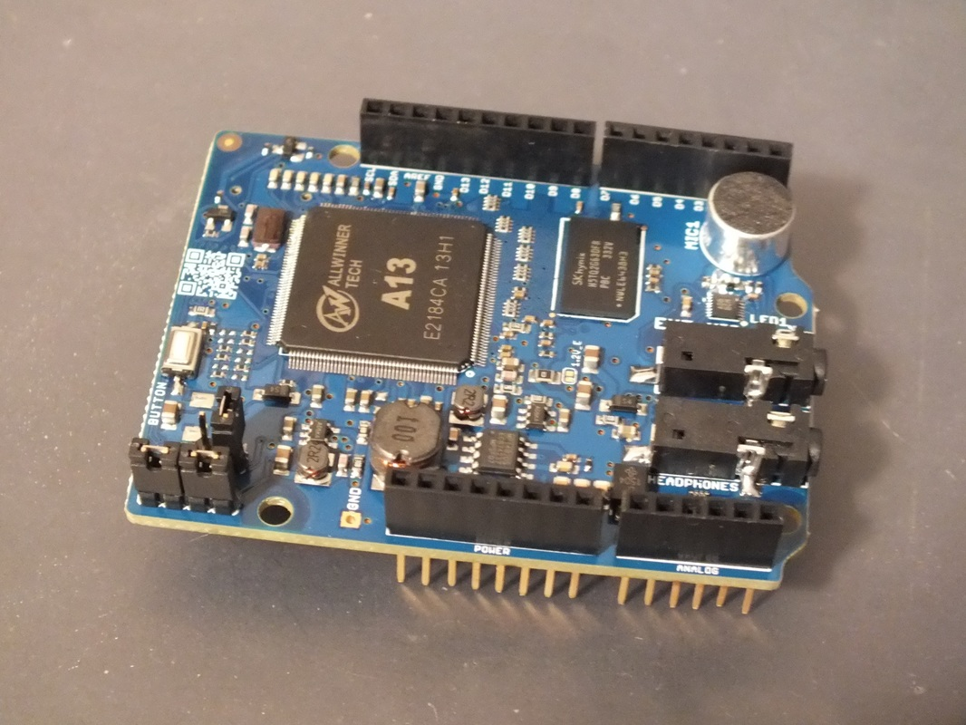

Easily program up to 150 full-sentence voice commands from Arduino IDE with the speech recognizerMOVI is speaker independent.

You can carry on programmed conversations with projects with the speech synthesizerMOVI is privacy friendly:

No Internet or PC connection required. It is compatible with most Arduino compatible boards

**Dec 8, 2016 Snake Vision Robot using Thermal Sensors and Arduino**

Build instructions and pictures: <http://www.instructables.com/id/Snake-Vision-Robot-Using-Two-MLX90614-No-Contact-T/>

code: <https://github.com/kd8bxp/Snake_Vision_Robot>

**LeRoy**

**4/27/2017**

1) Flashing Siren Demo

2) testing ngrok with wemos mini running a "hello" server,

3) installing libraries in the Arduino IDE

**LeRoy** **[Link to Leroy's Corner](https://drive.google.com/drive/folders/0BySJuScrlj2OflFGOVZUbWw0elExSnhOSkxVSjVwREZ6MVdhcHh1clBPdlRqMk1oMHY4RTA?usp=sharing)**

**5/11/2017 Arduino Robot Demo - Google AIY Demo - How to set up Google+**  [**Official Arduino Robot Information**](https://docs.google.com/document/d/1W92P13qQYV18qdvkv7x6B3eI09uo9F-bp6QoUXyIjvg/edit)

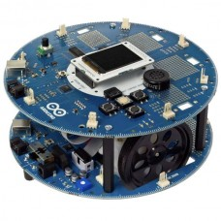

The Arduino Robot is a robust little robot that is sure to please Arduino enthusiasts, tinkerers and beginner roboticists alike.

The official Arduino Robot features two separate microcontroller boards: a robot brain to control the higher level decision making functions and a motor cortex to handle its motor control functions. This is a powerful combination that enables the Arduino Robot to enrich the experience of beginners while providing a rich feature set for advanced tinkerers to enjoy.

Everyone will enjoy programming the Arduino Robot's higher level brain functions while advanced users can also tinker with the lower level cortex.

Both microcontroller boards are based on the Arduino Leonardo platform and each has its own ATmega32u4 processor with 32KB of FLASH, 2.5KB of SRAM and 1KB of EEPROM. Each microcontroller board has USB connectivity and is fully programmable.

Each of the Arduino Robot's microcontrollers can be programmed independently by using the world famous Arduino IDE. A set of robot libraries is provided to make programming easy for beginners. Advanced roboticists will appreciate the Arduino Robot's clever design.

The Arduino Robot's brain is referred to as the Control Board and is located on the upper deck. It has an extensive User Interface with a full color graphic LCD display, audio speaker, analog potentiometer and a five button keypad.

The Arduino Robot Control Board has 64KB of extra EEPROM memory and an SD card reader for plenty of onboard memory. The Arduino Robot's brain even has a compass to help it navigate the real world.

The Arduino Robot's upper deck provides eight pre-soldered analog input connectors for I/O expansion and plenty of solder pads for advanced purposes. Additional pads are available to solder up to six more digital I/O connectors on this deck. Three I2C connectors are also available on this deck.

The lower deck of the Arduino Robot is the Motor Board. Think of it as a motor cortex. It handles many of lower level details of motion freeing the Arduino Robot's brain for higher thinking.

The Motor Board comes with a built in NiMH battery charger so your Arduino Robot is power friendly. All four rechargeable AA batteries and a 9V Adapter are included. The power system features an efficient DC to DC power convertor that provides steady 5V regulated power to the entire robot while keeping batteries running longer.

There is an easy access on and off switch just in case you have a teeny tiny bug in your latest program and need to stop your Arduino Robot quickly.

The Arduino Robot Motor Board has a small trimmer potentiometer to calibrate the wheels so that the robot runs straight. A set of five IR Infrared sensors are provided for line following and edge detection. This board also provides four connectors that can be used as analog input or digital I/O. It also has one I2C connector.

Both of the Arduino Robot's microcontroller boards are connected via a 10 pin cable that allows the Motor and Control processors to communicate with each other over embedded serial ports. The 10 pin cable also carries the power supply and additional information such as the battery charge level.

The official Arduino Robot has is a great robot for anyone wanting to learn about robotics. It has features that even advanced roboticists can appreciate. It is ideal for anyone who wants a robot that is ready to play right out of the box. It includes everything needed to get started. You just need to charge the batteries to begin your adventure.

**References**

* [Gettings Started with the Arduino Robot](http://arduino.cc/en/Guide/Robot)
* [Arduino Robot Hardware Reference](http://arduino.cc/en/Main/Robot)
* [Arduino Robot Library Reference](http://arduino.cc/en/Reference/RobotLibrary)
* [Arduino IDE Software](http://arduino.cc/en/Main/Software)

FRANK

1/5/2017 Demo of Amazon Echo (voice recognition garage door opener)

* Plays all your music from Amazon Music, Spotify, Pandora, iHeartRadio, TuneIn, and more using just your voice
* Fills the room with immersive, 360º omni-directional audio
* Allows hands-free convenience with voice-control
* Hears you from across the room with far-field voice recognition, even while music is playing
* Answers questions, reads audiobooks and the news, reports traffic and weather, gives info on local businesses, provides sports scores and schedules, and more using the Alexa Voice Service
* **Controls lights, switches, and thermostats with compatible WeMo, Philips Hue, Samsung SmartThings, Wink, Insteon, Nest, and ecobee smart home devices**
* Always getting smarter and adding new features, plus thousands of skills like Uber, Domino's, and more

**1/26/2017 Intel Joule Processor: Development Software Demo - MS Windows 10**

**7/28/2016**

**Build a Website using Visual Studio 2015, IIS 7.5 and** [**ASP.NET**](http://asp.net/)

**Put up a web site quick.**

**Add web pages easily.**

**Setting up DNS.**

9/1 Build Class to handle Arduino real time I/O access multiple items

**TBA (Part 2) RTOS (Real Time Operating System) Demo on Bitty Rover**

"Tips for rapid integration of Arduino Mega Sketches using FreeRTOS"

**temp sensor compass lcd display analog inputs ultrasonic sensor Serial Print functionality**

Describe and demonstrate how to evaluate an existing sketch and how to configure that sketch to share the processor and resources and also meet real-time commitments.

**Frank**

**5/4/2017 Sump Pump Control with WeMo and Database**

This will be an enhanced sump pump control system (very enhanced). Frank has enhanced his control scheme to upload data to a server via Wifi using Wemo(1). Not surprising (for Frank) the Wemo device can be controlled by Amazon Echo. (Envision Frank issuing voice commands to his sump pump from his fortified Strato Fortress Lounge Chair). A database on the server allows a multitude of functions including, troubleshooting of sump pump operations, history of operation, etc. This method allows a secure method of WiFi communications (which should let Frank and Jeromy sleep better and allow the Grand Poo Bah better meeting naps)

A few days ago I had an occasion where my sump pump failed. After some trouble shooting, I found out that the pump was fine, however, the float switch was defective. This happened about 7:PM and unfortunately, Home-depot didn't carry the float switch. I found the switch on Amazon and ordered it.

In the mean time, I thought to myself. This is a job for arduino, a relay and a water sensor. So I put together circuit using stuff from the shelf. Strangely enough it works very well.

(1) **WeMo** is a series of products from [Belkin International](https://en.wikipedia.org/wiki/Belkin_International), Inc. that enables users to [control home electronics](https://en.wikipedia.org/wiki/Home_automation) from anywhere. The product suite includes a switch, motion sensor, Insight Switch, light switch, camera and [app](https://en.wikipedia.org/wiki/Smartphone_app). The WeMo Switch can be plugged into any home [outlet](https://en.wikipedia.org/wiki/Electrical_outlet), which can then be controlled from an [iOS](https://en.wikipedia.org/wiki/IOS) or [Android](https://en.wikipedia.org/wiki/Android_(operating_system)) smartphone running the WeMo App, via home [WiFi](https://en.wikipedia.org/wiki/WiFi) or [mobile phone](https://en.wikipedia.org/wiki/Mobile_phone) network.

The WeMo Motion Sensor can be placed anywhere, as long as it can access the same WiFi network as the WeMo devices it is intended to control. It can then turn on and off any of the WeMo devices connected to the WiFi network as people pass by.

The WeMo Insight Switch provides information on power usage and cost estimation for devices plugged into the switch.

The WeMo Light Switch is for use where a light is controlled by a single light switch. Multi-way switching is not supported at this time.

The WeMo App controls the WeMo devices from anywhere in the world as long as the WeMo devices’ wireless network is connected to the Internet. WeMo devices can also be controlled using [IFTTT](https://en.wikipedia.org/wiki/IFTTT) technology. WeMo devices can also be controlled by voice through the [Amazon Echo](https://en.wikipedia.org/wiki/Amazon_Echo).[[1]](https://en.wikipedia.org/wiki/Belkin_Wemo#cite_note-1)

Jeremy

Web API Demo Code - Client

Future- How to set up a proxy in reverse for inexpensive camera.

GrandPooBah

**2/9/2017 TCT Propulsion** [**TCT Propulsion Folder**](https://drive.google.com/open?id=0BySJuScrlj2ObFNIR19LYkZWSmM)

11/24 TCT Project - Guidance

This will be step 1 of the Guidance series for the TCT (Trash Can Transport) scale to full size.

VIDEOS:

https://www.youtube.com/watch?v=-XSXfqd1N58

https://www.youtube.com/watch?v=-XSXfqd1N58

9/1 https://www.youtube.com/watch?v=v2jpnyKPH64

CODE:

https://www.arduino.cc/en/Tutorial/Sweep

Jim's Corner: (Servo Folder)  
 ServoSeries

ServoCompassSeries

CompassGuidance

**3/30/2017 TCT Propulsion System Using 43A drive - Arduino**

**This is a TCT (Trash Can Transport) item.**

**This will be the prototype for the propulsion system for the TCT Robot. This will use the 43A drive to power a Zip Scooter Motor to be powered from a 12V source. The objective is provide high torque/low speed driving mechanism. The chain drive mechanism (reduction) and the DC motor should be able to produce the enough torque to move our cans up the hill. This is another step in what some would call the lightning like development of this project (most would NOT say this).**

**4/20/2017 TCT (Trash Can Transport) Key Fob Propulsion Remote** [**Poo's Key Fob Controller Document**](https://docs.google.com/document/d/1AaQmwKiLiiIFLeP8Kk19p4IfnDybd08enQUj-TCrXoc/edit?usp=sharing) [**TCT Propulsion Folder**](https://drive.google.com/drive/folders/0BySJuScrlj2ObFNIR19LYkZWSmM?usp=sharing) [**TCT Project Folder**](https://drive.google.com/drive/folders/0BySJuScrlj2OZlg1S2ZRczlUMGs?usp=sharing) **Poo's sub sonic TCT project is on the move. This session will integrate a key fob style remote for the Trash Can Transport propulsion system. This will include testing of the DC Drive/Motor chain drive system with the use of a 4 button Key Fob remote. The DC drive was tested using a DC battery powering a water pump a couple of meeting ago. This will include the first test of the entire propulsion system (4 wheel wagon, chain drive, dc motor, DC drive, and wireless controller). This implementation is intended to be a prototype for the "base" TCT system propulsion system.**

**The next step in this project will be to mount the steering mechanism and control board and integrate the additional 2 Key Fob control buttons for steering.**

**The base level unit will allow forward/reverse propulsion and left/right steering (very limited angle). Additional features will include auto steering (compass defined) which has been tested with a small model.**

**TCT Compass Guidance**

**\* Initial Testing**

**reputability**

**problem with accuracy**

**20151030 Implement Compass Based Guidance with good results using TBR90 Clown Victoria Shriner Rover Prototype**

**Nov 19 Compass Code included in TCT software in Jim's Corner (It's crude, it's bloated, will clean up after Star Wars Day).**

**Nov 26 Completed Round Trip (with pushbutton turn).**

**Problem note: Car near path severely distorts travel path (< 3 ft)**

**Dec 3 Completed 10 round trips (200ft) hitting 8" circle on every trip (push button to turn).**

[Jim's TCT Code for Arduino Mega](https://docs.google.com/document/d/1XpnJRXdUnCCaVvrCkzMm7sM4uw0aziR0rlmvHPXR8lY/edit?usp=sharing)  
 Introduction of Full Size Hardware for Drive Mechanism  
 3/3 Mounted 52 tooth gear on drive wheel.  
 4/28 Motor Coupling (first pass)  
 7/21 Coupling Complete - Received 15kg servo, thinking of break proof linkage for steering.